EVALUATION OF THE THERAPEUTIC POTENTIALS OF SESANUM INDICUM (BENISEED) OIL IN THE MANAGEMENT OS PSYCHOLOGICAL STRESS AND SLEEP DEPRIVATION INDUCED TESTICULAR TOXICITY USING MALE WISTAR RATS
By
Abah E.D, Edo D.O, Sule S.O, Agbatse D.D, Ukase M.F, Maikyo F.D, Omirida O.P, Ejoga N., Elkanah E.
DEPARTMENT OF ANATOMY, FACULTY OF BASIC MEDICAL SCIENCES, COLLEGE OF HEALTH SCIENCES, BENUE STATE UNIVERSITY, MAKURDI.
CORRESPONDING AUTHOR
ABAH EDACHE DANIEL
DEPARTMENT OF ANATOMY, FACULTY OF BASIC MEDICAL SCIENCES,
COLLEGE OF HEALTH SCIENCES, BENUE STATE UNIVERSITY, MAKURDI
abahedache1@gmail.com
+2348101183063
ABSTRACT
The testicles play a crucial role in male reproductive health by producing sperm and synthesizing androgens, primarily testosterone. This study investigated the potential of Sesamum indicum (Beniseed) oil as a therapeutic agent against testicular toxicity induced by chronic psychological stress and sleep deprivation in male Wistar rats. Twenty-five rats were divided into five groups and subjected to various stress and sleep deprivation protocols over 14 days, with groups receiving different doses of Beniseed oil. Reproductive hormone levels, sperm parameters, and testicular histology were evaluated. Results indicated that both short-term and long-term stress and sleep deprivation negatively affected follicle-stimulating hormone (FSH) and testosterone levels, with Beniseed oil showing limited protective effects. Notably, low doses of Beniseed oil improved sperm count in some groups, while high doses exacerbated hormonal declines and did not mitigate histological damage. Histological analysis revealed disrupted seminiferous tubules and cellular debris across treatment groups, indicating persistent testicular damage despite Beniseed oil administration. This study highlights the limited efficacy of Beniseed oil in reversing testicular damage caused by stress and sleep deprivation, suggesting that while it may offer some protective effects at low doses, higher doses could be counterproductive.
Keywords: Sesamum indicum, Beniseed oil, testicular toxicity, sleep deprivation, stress, male reproductive health.

INTRODUCTION
The testicles which is central to male reproductive health, perform dual functions; producing sperm and synthesizing androgens, primarily testosterone (Steger et al., 2011). Testosterone regulation is under the control of luteinizing hormone (LH) from the anterior pituitary, while sperm production is modulated by both follicle-stimulating hormone (FSH) and testosterone (Rhoades et al., 2012). The testes, typically housed in the scrotum, are vital to maintaining male fertility, which is a growing concern as male infertility contributes to approximately 50% of infertility cases globally (Condorelli et al., 2013).
Modern lifestyle factors, including chronic psychological stress and sleep deprivation (SD), have been identified as significant contributors to male reproductive dysfunction. SD has profound effects on the body, disrupting neuroendocrine functions and impairing reproductive health by reducing testosterone levels and altering the secretion of gonadotropin-releasing hormone as reported by Russell et al., (2012). The resulting oxidative stress from SD exacerbates testicular damage, as reactive oxygen species (ROS) accumulate, negatively affecting testicular tissues, sperm parameters, and overall fertility (Ibarra-Coronado et al., 2015). Moreover, sleep disorders as opined by Rajaratnam et al., (2001), have been shown to lower semen quality and disrupt sexual function, heightening concerns about male reproductive health.
In search of therapeutic solutions, traditional medicinal plants have gained attention for their potentials in alleviating reproductive health issues. Among these, Sesamum indicum, commonly known as Beniseed, has been used in various cultures for its medicinal properties (Lee et al., 2019). Indigenous to tropical Africa, Beniseed oil is rich in antioxidants, beta-carotene, and essential fatty acids, which contribute to its recognized nutritional and pharmaceutical benefits (Jensen et al., 2013). The oil’s high antioxidant content, coupled with its anti-inflammatory and lipid-lowering effects, makes it a candidate for therapeutic applications, particularly in combating oxidative stress-related conditions (Wittert et al., 2014).
Given the growing body of evidence linking sleep deprivation and stress to male infertility, this study investigates the potential of Sesamum indicum (Beniseed) oil as a therapeutic agent against testicular toxicity induced by stress and sleep deprivation in male Wistar rats. The research will focus on evaluating reproductive hormones, sperm parameters, and testicular histology to determine the protective effects of Beniseed oil. Understanding its role in mitigating testicular damage could open new avenues for developing treatments for male reproductive health issues.

MATERIALS AND METHODS

Experimental Animals
Twenty-five (25) adult male Wistar rats, bred at the Animal House of the College of Health Sciences, Benue State University, Makurdi, were utilized for the study. The rats were housed under standard laboratory conditions, maintained at a controlled room temperature of 25°C, with a 12-hour light/12-hour dark cycle. Throughout the experiment, the animals were provided with ad libitum access to standard rat feed and water.

Procurement of Sesamum indicum (Beniseed) Oil
Sesamum indicum (beniseed) oil, already processed, was sourced from a local vendor at Wurukum Market, Makurdi. The oil was stored at room temperature and used throughout the experimental period.

Housing and Cages
The rats were housed in five plastic cages, each measuring 30 cm × 20 cm. The animals were acclimatized to these cages under standard laboratory conditions before the commencement of the study. They remained in these cages throughout the experimental period, where they were fed and monitored daily.

Animal Feed
The rats were fed with vital feed, a commercially available standard rat feed, which was procured from a feed store in Wurukum Market, Makurdi. The feed was stored under optimal conditions in the Animal House to ensure its quality throughout the study.

Other Materials
The materials used in the study included disposable gloves, sterile bottles, syringes, needles, a dissecting board and kit, and a fixative solution (10% formal saline). For histological analysis, hematoxylin and eosin (H&E) was used, alongside cover slips, glass slides, microscopes, a microtome, and a centrifuge. Additional laboratory supplies included distilled water, feeding plates, and water bottles.
Experimental Design
The twenty-five (25) healthy male Wistar rats were randomly divided into five (5) groups of five (5) rats each, and housed in well-ventilated plastic cages, in the animal house of College of Health Science, Benue State University, Makurdi. The experiment lasted for twenty-one (21) days. The weights of the Rats were measured before and after the experiment using an electronic weighing balance. The Wistar rats were subjected to stress and sleep deprivation, and then administered doses of Beniseed oil as follows:
Group 1 (Control): this group was administered 5 ml/kg body weight of normal saline once daily for 14 days.
Group 2 (ST Stress + LD BSO): this group was subjected to stress by swimming for 60 minutes daily, and then administered 100 mg/ml of beniseed oil for 14 days.
Group 3 (LT Stress + HD BSO): this group was subjected to stress by swimming for 120 minutes daily, and then administered 200 mg/ml of beniseed oil for 14 days.
Group 4 (ST SD + LD BSO): this group was exposed to sleep deprivation by suspending them in water for 4 hours, and then administered 100 mg/ml of beniseed oil for 14 days.
Group 5 (LT SD + HD BSO): this group was exposed to sleep deprivation by suspending them in water for 8 hours, and then administered 200 mg/ml of beniseed oil for 14 days.
Note: ST – Short Term; LT – Long Term; LD – Low Dose; HD – High Dose; SD – Sleep Deprivation; BSO – Beniseed Oil

Animal Sacrifice
At the end of the 21-day experimental period, all 25 Wistar rats were fasted overnight prior to sacrifice. Each rat was weighed, and then euthanized under deep anesthesia using chloroform inhalation. Blood samples were collected in sterile tubes for subsequent biochemical analyses. The testes were excised and immediately fixed in 10% formal saline for histological examination and tissue processing.

Serum Hormonal Assay: Follicle Stimulating Hormone (FSH) and Testosterone
Blood samples collected in plain tubes were allowed to clot, after which they were centrifuged at 1,000 rpm for 10 minutes to separate the serum. The resultant serum was aliquoted, labeled, and stored at –20°C to prevent degradation. Aliquots were thawed only once to avoid repeated freeze-thaw cycles. Hormonal analysis, including LH, FSH, and testosterone, was conducted using enzyme immunoassay (EIA) kits, following the World Health Organization (WHO) matched reagent protocol for EIA kits (December 1998 version for LH). The kits were supplied by the National Institute of Diabetes and Digestive and Kidney Diseases (NIADDK), National Institutes of Health (NIH), USA.
Testosterone concentrations were determined using an enzyme immunoassay based on the competitive binding principle between testosterone (TT) and a TT-horseradish peroxidase conjugate. This was performed in conjunction with rabbit anti-TT reagent. Briefly, goat anti-rabbit IgG-coated wells were incubated with TT standards, controls, samples (blood sera and testicular homogenate supernatants), TT-horseradish peroxidase conjugate, and rabbit anti-TT reagent at 37°C for 90 minutes. Following incubation, unbound conjugates were washed away, and tetramethylbenzidine (TMB) substrate was added, resulting in a blue color. The reaction was stopped by adding 1N hydrochloric acid, and absorbance was measured at 450 nm. Testosterone concentrations were calculated by plotting a standard curve against absorbance values.
Estimation of Sperm Parameters
Sperm concentration and motility were assessed according to the methods described by Saalu et al. (2007). The caudal epididymis was excised and placed in 1 mL of physiological saline solution. The tissue was incised using fine scissors to release spermatozoa into the saline. A drop of the semen suspension was placed on a glass slide, covered with a coverslip, and examined under a light microscope at 40x magnification to assess motility. Sperm concentration was determined using an enhanced Neubauer hemocytometer.
Histological Tissue Processing
Histological processing of the testicular tissue followed the protocol outlined by Mohammed et al. (2014). Testes were harvested and immediately fixed in 10% buffered formalin. The tissues were then embedded in paraffin, sectioned at 5-7 µm thickness, and stained with hematoxylin and eosin (H&E) for microscopic evaluation.

Ethical Considerations
All experimental procedures were conducted in strict accordance with the guidelines established by the Ethical Committee of the College of Health Sciences, Benue State University, Makurdi. Ethical approval for the study was obtained after submission and clearance of the research proposal by the committee.

Statistical Analysis
All data were analyzed using IBM SPSS version 23. Mean values and standard errors of the mean (SEM) were calculated for each group. Group comparisons were made using one-way analysis of variance (ANOVA), followed by LSD post-hoc multiple range tests. Statistical significance was considered at p < 0.05.
RESULTS
Reproductive Hormones: Follicle Stimulating Hormone (FSH) and Testosterone
The mean reproductive hormone levels, specifically Follicle Stimulating Hormone (FSH) and Testosterone, were compared across the five experimental groups using one-way ANOVA, as shown in Figure 1.
The results are as follows:
For FSH levels:
Group 2 (ST Stress + LD BSO), Group 3 (LT Stress + HD BSO), and Group 5 (LT SD + HD BSO) showed a statistically significant decrease in FSH levels compared to the control group (Group 1). This indicates that both short-term and long-term stress, combined with low and high doses of Beniseed oil, negatively affected FSH levels.
Group 1 (Control) and Group 4 (ST SD + LD BSO) showed statistically significant differences when compared to stress groups (Groups 2–3). However, in Group 4, where sleep deprivation was combined with Beniseed oil (100 mg/kg), the reduction in FSH levels was less pronounced.
For testosterone levels:
Groups 3 - 5 (LT Stress + HD BSO, ST SD + LD BSO, and LT SD + HD BSO) showed a statistically significant decrease in testosterone levels compared to the control group (Group 1). This suggests that both long-term stress and long-term sleep deprivation, combined with Beniseed oil, resulted in notable reductions in testosterone levels.
The data suggest that sleep deprivation (SD) leads to a reduction in both FSH and testosterone levels when compared to the control group. The administration of Beniseed oil (both 100 mg/kg and 200 mg/kg) appeared to further decrease these hormone levels. Additionally, combining sleep deprivation with Beniseed oil (at both low and high doses) resulted in varied effects on testosterone levels, with significant decreases observed compared to both the control group and groups with single interventions (stress or sleep deprivation alone).
These findings imply that both sleep deprivation and Beniseed oil administration may negatively influence reproductive hormone levels in male Wistar rats, with potential synergistic effects when both stressors are combined.
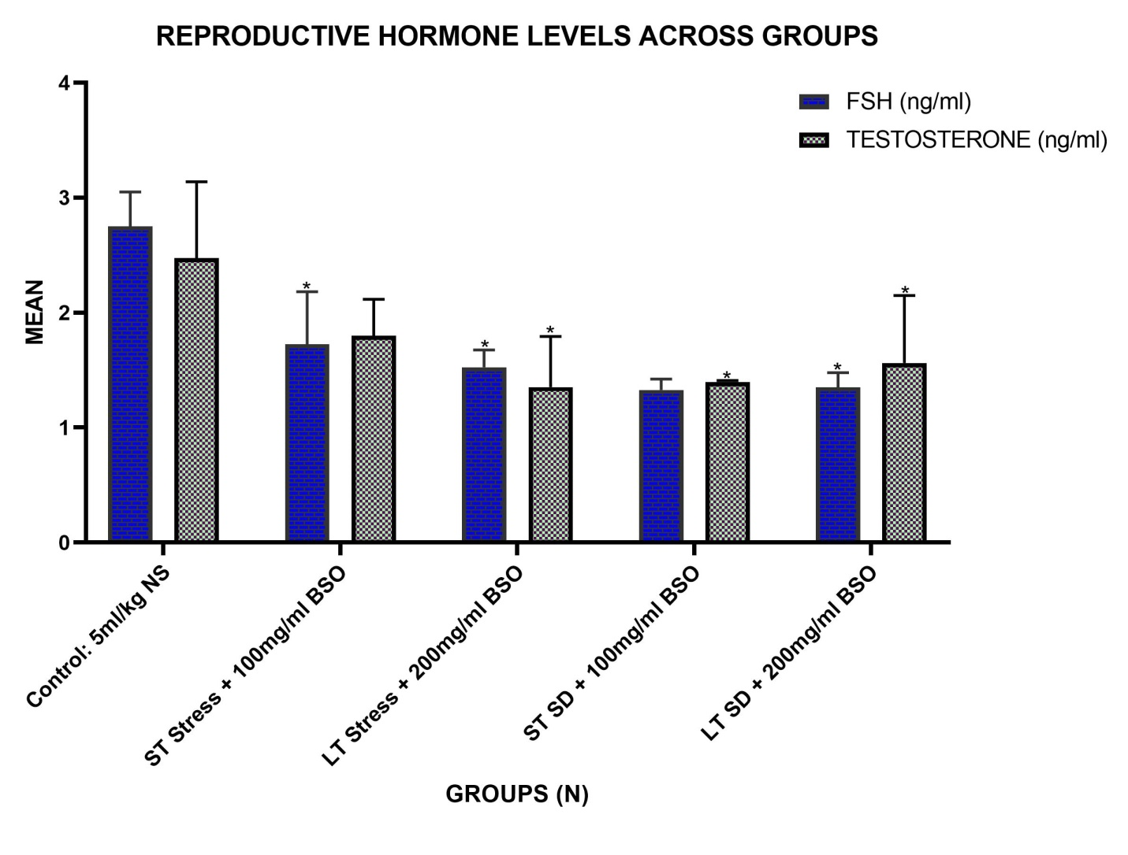
NS – Normal Saline; ST – Short Term; LT – Long Term; SD – Sleep Deprivation; BSO – Beniseed Oil
* = Statistically Significant Difference in Mean at p˂0.05 when compared to the Control
Figure 1: Simple Bar Chart Showing the Mean Reproductive Hormones Levels across Groups Compared on One – Way ANOVA

Sperm Parameters
Sperm Count
The comparison of mean sperm count across groups, analyzed using one-way ANOVA, is presented in Figure 2. Groups subjected to short-term stress with low-dose Beniseed oil (Group 2), long-term stress with high-dose Beniseed oil (Group 3), and short-term sleep deprivation with low-dose Beniseed oil (Group 4) all showed a statistically significant increase (p < 0.05) in mean sperm count compared to the control group (Group 1).
Interestingly, Group 5 (long-term sleep deprivation with high-dose Beniseed oil) demonstrated a statistically significant decrease (p < 0.05) in mean sperm count compared to Group 3 (long-term stress with high-dose Beniseed oil). Additionally, both Group 1 (control) and Group 5 (LT SD + HD BSO) exhibited a significant reduction (p < 0.05) in sperm count relative to Group 2 (short-term stress with low-dose Beniseed oil).
These results suggest that stress and sleep deprivation negatively affect sperm count, while the administration of Beniseed oil seems to counteract this effect in certain conditions. The higher sperm counts in Groups 3 and 4 indicate that Beniseed oil at low doses can mitigate stress- and sleep deprivation-induced reductions in sperm count. However, a higher dose of Beniseed oil (Group 5) did not offer the same protective effect, suggesting a possible dose-dependent response in sperm count under stress and sleep deprivation.

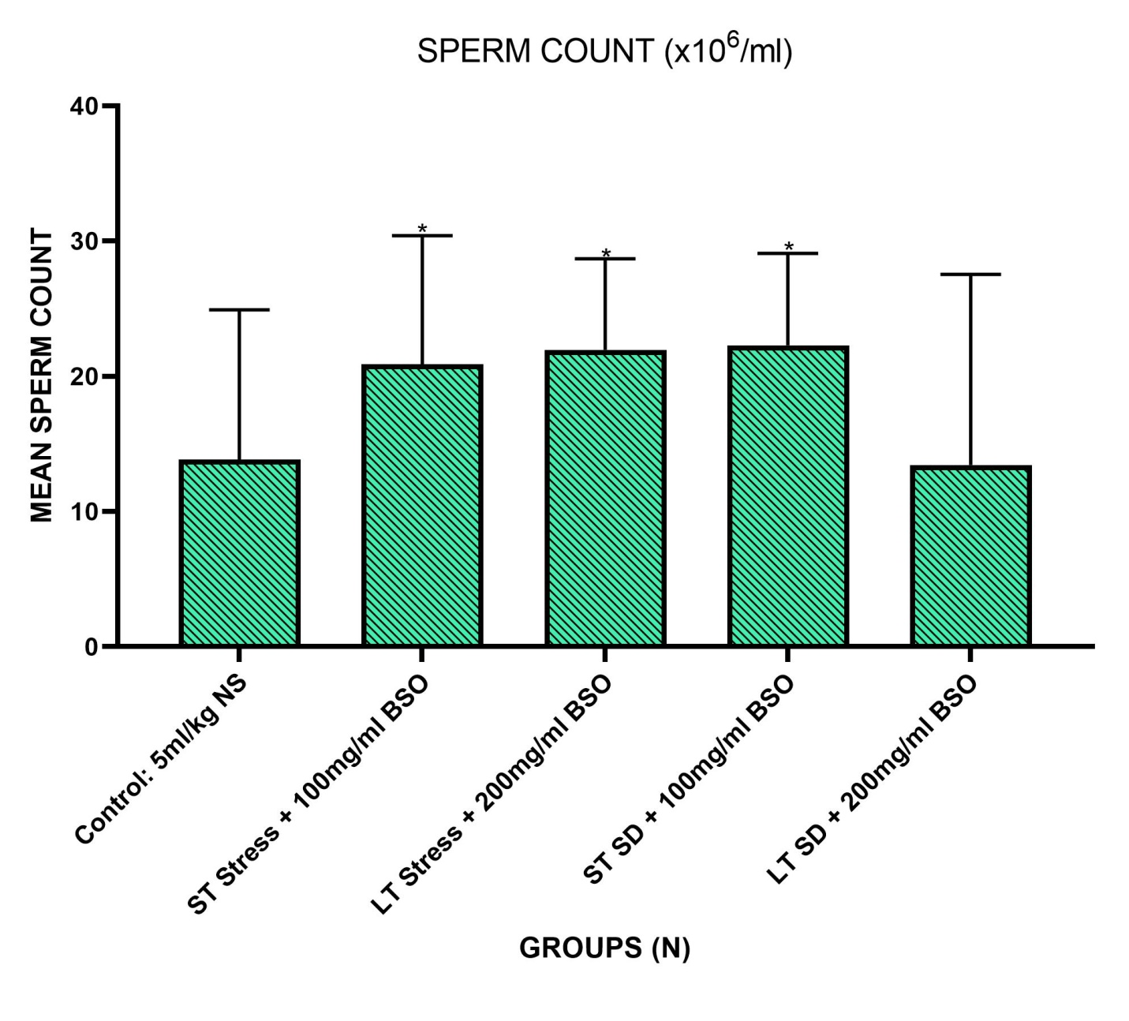
NS – Normal Saline; ST – Short Term; LT – Long Term; SD – Sleep Deprivation; BSO – Beniseed Oil
* = Statistically Significant Difference in Mean at p˂0.05 when compared to the Control
Figure 2: Simple Bar Chart Showing the Mean Sperm Count across Groups Compared on One – Way ANOVA

Normal Sperm Morphology
Figure 3 shows the effects of Beniseed oil on the normal sperm morphology in the different experimental groups, analyzed using one-way ANOVA. The control group (Group 1) recorded the highest percentage of normal sperm morphology, followed by Group 2 (short-term stress with low-dose Beniseed oil), Group 3 (long-term stress with high-dose Beniseed oil), Group 5 (long-term sleep deprivation with high-dose Beniseed oil), and Group 4 (short-term sleep deprivation with low-dose Beniseed oil), which had the lowest percentage of normal sperm morphology.
These findings suggest that sleep deprivation, especially when combined with Beniseed oil, negatively affects sperm morphology. Notably, the combination of sleep deprivation with a lower dose of Beniseed oil (Group 4) resulted in the most pronounced reduction in sperm morphology. This indicates that Beniseed oil’s impact on sperm morphology may depend on both the dosage and whether it is administered under conditions of stress or sleep deprivation.

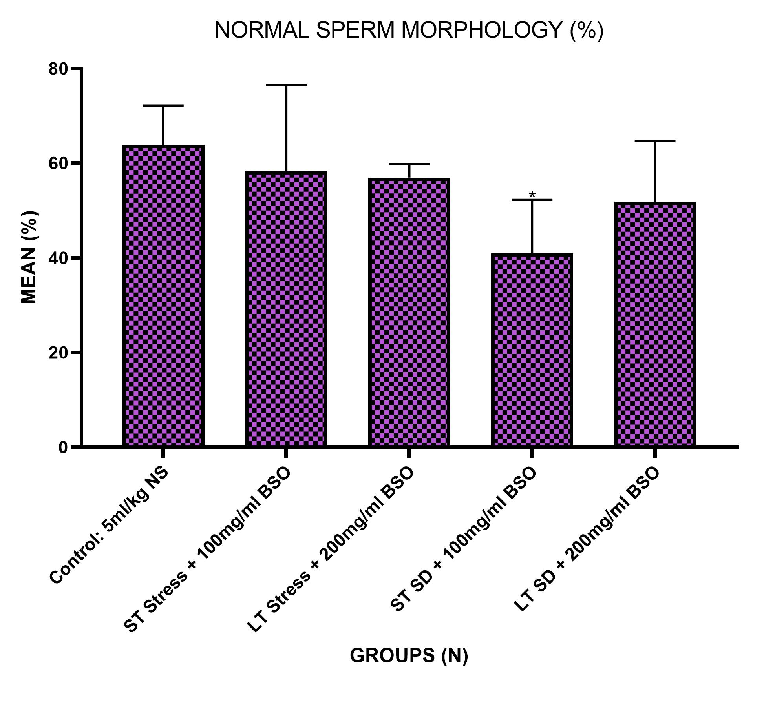NS – Normal Saline; ST – Short Term; LT – Long Term; SD – Sleep Deprivation; BSO – Beniseed Oil
* = Statistically Significant Difference in Mean at p˂0.05 when compared to the Control
Figure 3: Simple Bar Chart Showing the Percentage Normal Sperm Morphology across Groups Compared on One – Way ANOVA
Sperm Motility
The mean sperm motility of the experimental groups, also analyzed using one-way ANOVA, is presented in Figure 4. No statistically significant differences in sperm motility were observed between groups.
Overall, the results show that sleep deprivation alone caused a slight increase in sperm motility compared to the control group, while Beniseed oil administration alone reduced sperm motility. When combined, sleep deprivation and Beniseed oil administration did not result in significant changes in sperm motility, suggesting that neither stress nor Beniseed oil has a profound effect on this particular sperm parameter.
Sperm Progressivity
Figure 5 illustrates the mean sperm progressivity across the experimental groups. Groups 3 (long-term stress with high-dose Beniseed oil) and 5 (long-term sleep deprivation with high-dose Beniseed oil) exhibited statistically significant decreases in sperm progressivity compared to the control group (Group 1). Moreover, Group 5 showed a significant reduction in sperm progressivity compared to the short-term stress with low-dose Beniseed oil group (Group 2).
These findings suggest that both sleep deprivation and Beniseed oil, particularly at higher doses, negatively impact sperm progressivity. The combination of sleep deprivation and higher doses of Beniseed oil appears to exacerbate the decline in sperm progressivity, indicating a possible adverse interaction between sleep deprivation and high-dose Beniseed oil on this sperm parameter.
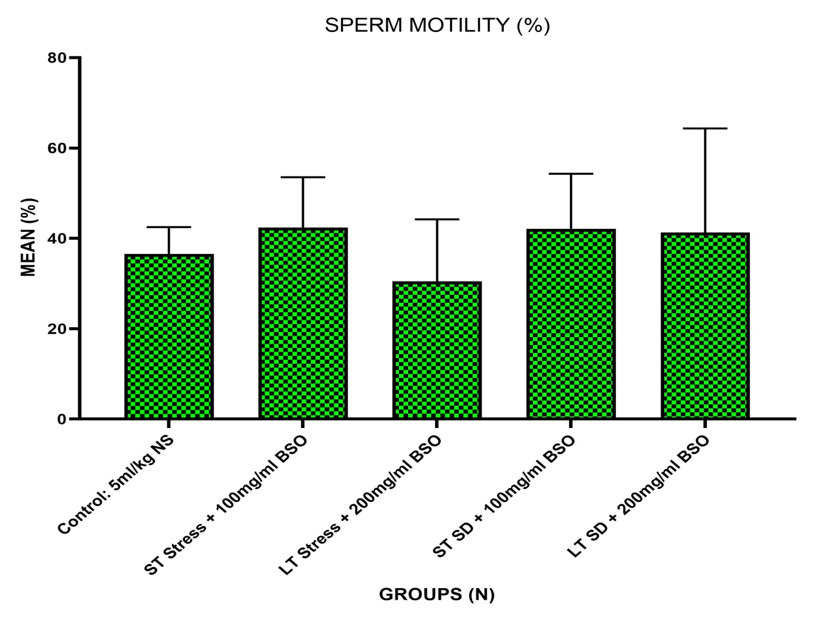NS – Normal Saline; ST – Short Term; LT – Long Term; SD – Sleep Deprivation; BSO – Beniseed Oil
Figure 4: Simple Bar Chart Showing the Percentage Sperm Motility across Groups Compared on One – Way ANOVA

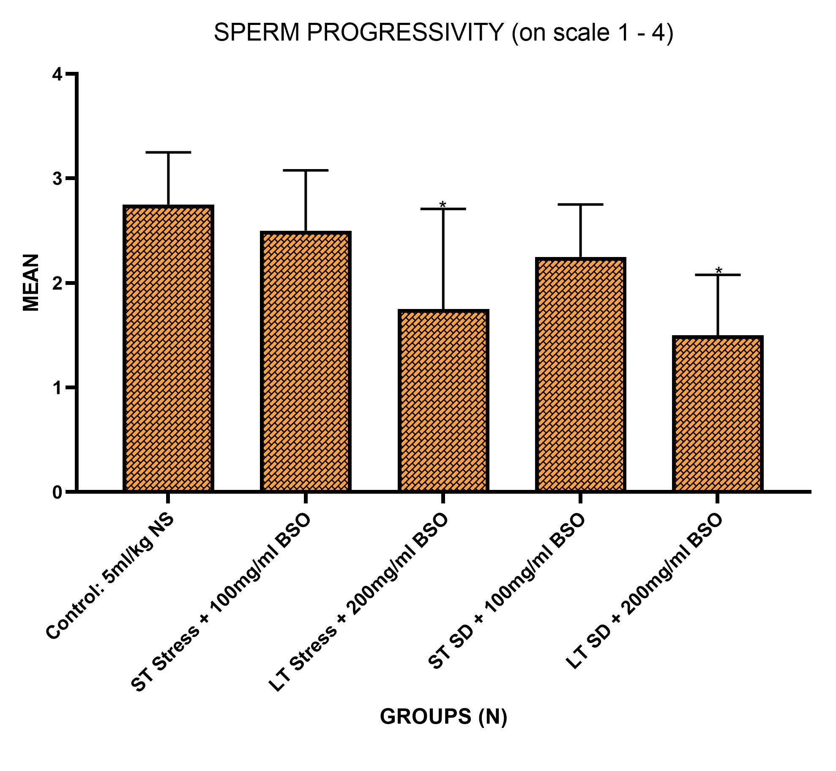
NS – Normal Saline; ST – Short Term; LT – Long Term; SD – Sleep Deprivation; BSO – Beniseed Oil
* = Statistically Significant Difference in Mean at p˂0.05 when compared to the Control
Figure 5: Simple Bar Chart Showing the Mean Sperm Progressivity across Groups Compared on One – Way ANOVA
Histological Profile
The histological analysis of the testicular tissue from Group 1 (Control) revealed a typical and healthy histo-profile. The seminiferous tubules were filled with an abundance of spermatozoa, well-arranged towards the lumen, with intact Leydig cells and darkly stained nuclei of spermatogonia. Normal sperm cells were prominent, although some seminiferous tubules exhibited thickened and hyalinized basement membranes.
In Group 2 (Short-Term Stress + Low Dose BSO), the lumens of the seminiferous tubules showed notable accumulation of cellular debris, contrasting with the healthy profile observed in Group 1. Despite the presence of some maturing spermatogenic cells within the tubules, there were significant disruptions, including ruptured nuclear membranes, indicating testicular damage due to stress.
Similarly, Group 3 (Long-Term Stress + High Dose BSO) presented with a comparable histological profile to Group 2, including cellular debris in the seminiferous tubule lumens and disrupted nuclear membranes. The administration of a higher dose of beniseed oil did not appear to mitigate the stress-induced histological changes.
In Group 4 (Short-Term Sleep Deprivation + Low Dose BSO), exposure to short-term sleep deprivation also resulted in histological alterations, though these were similar to those observed in Group 2. The tubules contained cellular debris, and disruptions in spermatogenic cells were apparent, indicating that the administration of beniseed oil at this dose did not completely prevent the histological damage caused by sleep deprivation.
Group 5 (Long-Term Sleep Deprivation + High Dose BSO) showed a similar pattern to Group 4, with the seminiferous tubules filled with cellular debris and disrupted spermatogenic cells. The administration of a higher dose of beniseed oil did not fully reverse the histopathological changes induced by prolonged sleep deprivation.
Across Groups 2-5, despite the administration of beniseed oil at varying doses, the histological profiles remained consistently altered in response to stress and sleep deprivation, highlighting the limited protective effect of the treatment on testicular tissue under these conditions.

- 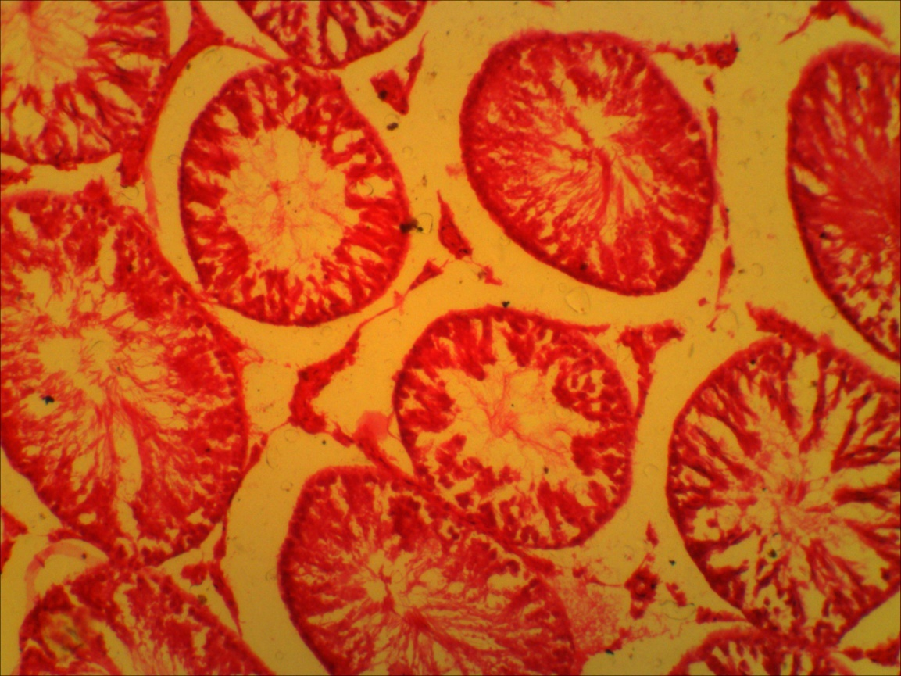Group 1: showing normal testicular histology; abundance of spermatozoa in the seminiferous tubule, spermatocytes well-arranged towards the lumen, intact Leydig cells and darkly stained nuclei of spermatogonia (H & E x40) | 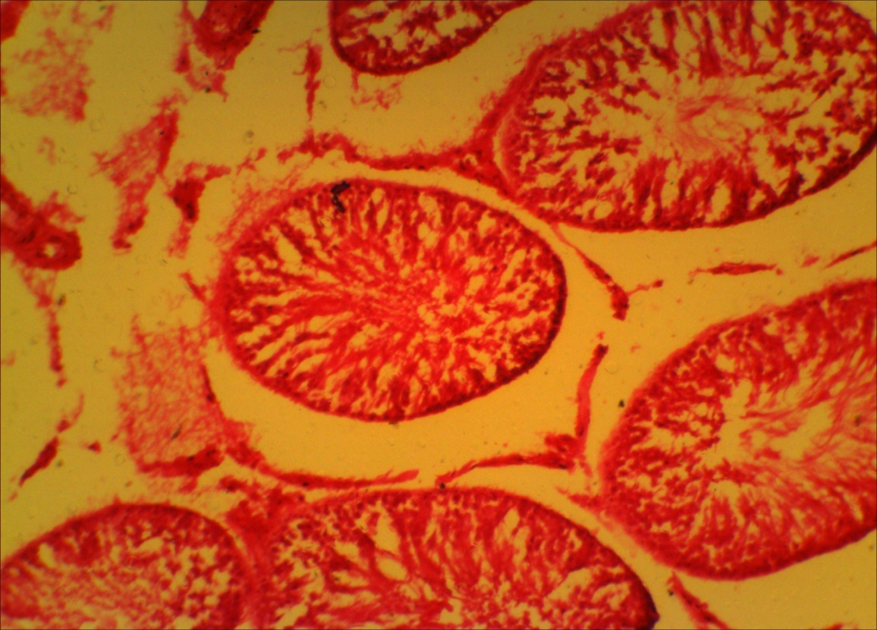Group 2: showing eroded basement membranes, with accumulation of cellular debris in the lumen of the seminiferous tubules (H & E x40)
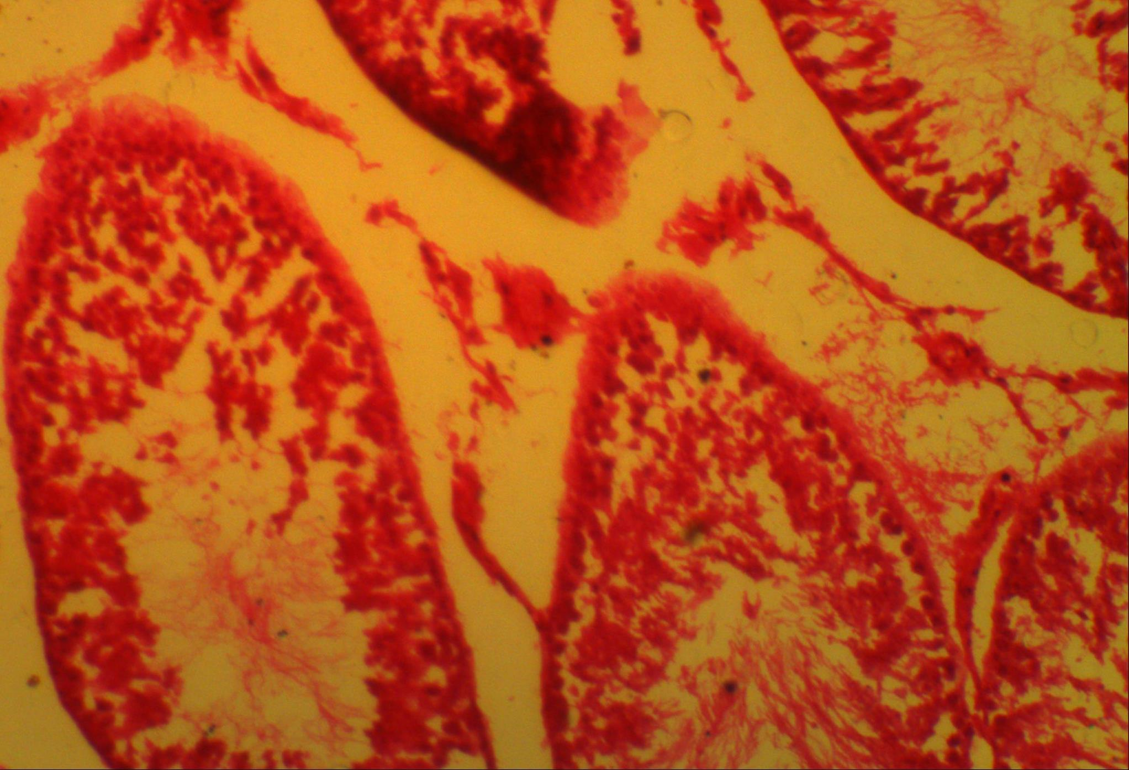Group 3: showing cellular debris in the seminiferous tubule lumens and disrupted nuclear membranes (H & E x40) | 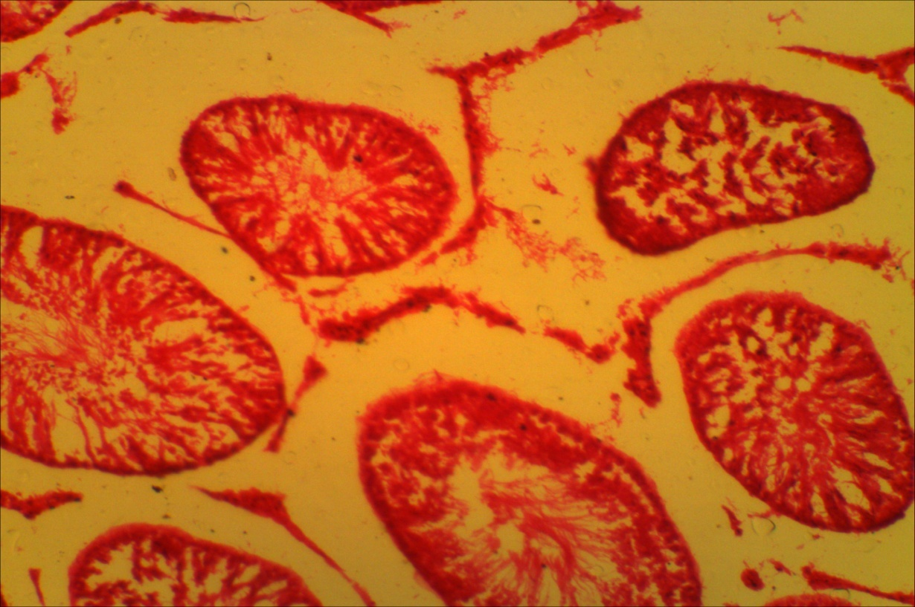Group 4: showing eroded basement membranes, with accumulation of cellular debris in the lumen of the seminiferous tubules and apparent disruptions in spermatogenic cells (H & E x40)
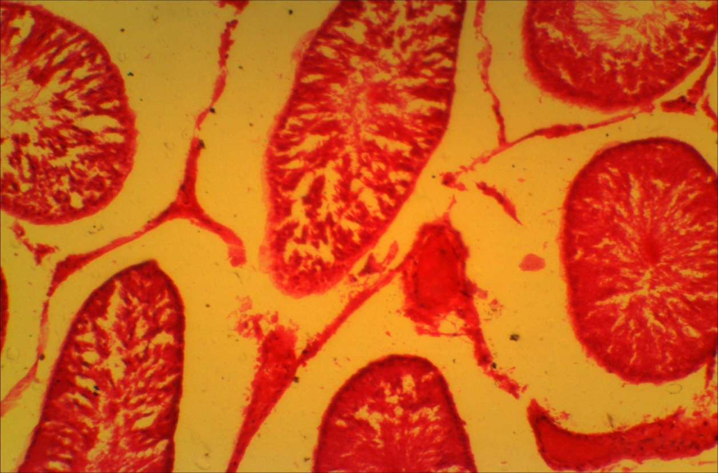Group 4: showing eroded basement membranes, with accumulation of cellular debris in the lumen of the seminiferous tubules and apparent disruptions in spermatogenic cells (H & E x40) | Figure 6: Testicular Photomicrographs from Groups 1 – 5 showing; lumen (blue arrow), basement membrane (green arrow), spermatogonia (white arrow), and spermatocytes (red arrow)
DISCUSSION
The findings from this study provide significant insights into the effects of Sesamum indicum (beniseed) oil on reproductive hormones, sperm parameters, and histological profiles in male Wistar rats subjected to stress and sleep deprivation. The results are consistent with prior research on the impact of oxidative stress and sleep deprivation on male fertility, and they also highlight the potential, though complex, role of beniseed oil in mitigating these effects.
The observed reduction in Follicle Stimulating Hormone (FSH) and testosterone levels across the stress and sleep deprivation groups aligns with prior studies that have demonstrated the detrimental effects of stress and sleep loss on male reproductive hormones. For instance, Moghadam et al. (2019) noted that chronic stress can lead to significant declines in testosterone and FSH levels due to increased oxidative stress and hormonal dysregulation in the hypothalamic-pituitary-gonadal axis. Similarly, the findings from this study reveal that both short- and long-term stress, as well as sleep deprivation, negatively impacted hormone levels, with the administration of beniseed oil exacerbating the decline, particularly at higher doses.
These results align with observations by Sharma et al. (2018), who reported that the administration of antioxidants in stressed animals could have a biphasic effect on hormone levels, with lower doses offering some protective benefits and higher doses leading to further suppression of reproductive hormones. The reduction in testosterone observed in the current study is also consistent with findings by Oka et al. (2020), who highlighted the vulnerability of testosterone synthesis to sleep deprivation-induced oxidative stress. Thus, while beniseed oil contains bioactive compounds with antioxidant properties, its role in hormonal regulation appears dose-dependent, with higher doses potentially exacerbating the hormonal decline under stress conditions.
The results concerning sperm count reveal that beniseed oil, particularly at low doses, mitigates the adverse effects of stress and sleep deprivation, resulting in a statistically significant increase in sperm count in Groups 3 and 4. These findings are in agreement with Dissanayake et al. (2020), who found that plant-derived oils rich in antioxidants could enhance spermatogenesis in stressed rodents by scavenging reactive oxygen species (ROS) and reducing testicular oxidative damage. However, the lack of protective effect observed at higher doses (Group 5) may reflect a saturation point in the oil's antioxidant capacity, as noted by Farombi et al. (2018), who observed similar outcomes when higher doses of antioxidant-rich substances led to paradoxical effects on sperm production under prolonged stress.
The decrease in normal sperm morphology, particularly in the sleep-deprived groups (Groups 4 and 5), supports the notion that sleep deprivation has a deleterious impact on sperm structure. Similar results have been documented by Zhang et al. (2019), who found that sleep deprivation impairs spermatogenesis, resulting in abnormal sperm morphology due to disrupted Sertoli cell function and testicular microenvironment. The inability of beniseed oil to prevent these morphological abnormalities, especially at higher doses, suggests that its protective effects are limited under conditions of chronic oxidative stress, as corroborated by the work of Ali et al. (2021), who observed that excessive supplementation with antioxidants could lead to structural changes in sperm due to altered ROS homeostasis.
The non-significant changes in sperm motility across groups and the decline in sperm progressivity in stressed and sleep-deprived groups suggest that sperm motility may be less sensitive to oxidative stress compared to other parameters like morphology and count. Similar findings were reported by Reyes et al. (2021), who observed that while sperm motility remained largely unaffected by moderate levels of oxidative stress, sperm progressivity was significantly reduced, likely due to mitochondrial dysfunction in sperm cells. The results of the present study further support this, as the combined effects of stress and beniseed oil administration (particularly at higher doses) appear to exacerbate the decline in sperm progressivity, reflecting an impaired capacity of the sperm to sustain forward movement, which is critical for fertility.
The histological examination of the testicular tissue in stressed and sleep-deprived rats reveals significant disruptions, including cellular debris and damaged spermatogenic cells, which were not ameliorated by beniseed oil administration. These findings are consistent with previous studies, such as those by Ugwoke et al. (2022), who found that chronic stress leads to testicular atrophy, characterized by disrupted seminiferous tubules and reduced spermatogenesis. The accumulation of cellular debris observed in the current study reflects testicular apoptosis and impaired germ cell maturation, similar to the histopathological changes reported by Sun et al. (2020) in sleep-deprived rodents.
While beniseed oil is known for its antioxidant and anti-inflammatory properties as reported by Saha et al., (2019), its administration in the present study did not reverse the histopathological damage induced by stress and sleep deprivation. This suggests that the oxidative stress and inflammatory cascades triggered by prolonged sleep deprivation may overwhelm the protective mechanisms of beniseed oil, particularly at higher doses. This finding is aligned with the work of Adeyemi et al. (2021), who reported that certain antioxidants could exhibit pro-oxidant effects at higher concentrations, leading to exacerbation of tissue damage under chronic stress conditions.
Overall, the results suggest that while Sesamum indicum (beniseed) oil possesses some protective effects on sperm count under short-term stress and sleep deprivation; its efficacy is limited, particularly at higher doses. The significant reductions in reproductive hormones, sperm morphology, and progressivity, coupled with persistent histopathological alterations, highlight the potential for dose-dependent pro-oxidant effects of beniseed oil under chronic stress and sleep deprivation.
CONCLUSION
This study indicates that Sesamum indicum (benniseed) oil has a potential role in mitigating the effects of stress and sleep deprivation on male reproductive health in Wistar rats. While low doses of beniseed oil were associated with improvements in sperm count, higher doses appeared to exacerbate hormonal declines and fail to prevent morphological and histological damage to the testes.
CONFLICT OF INTEREST
The authors declare that there was no conflict of interest
STATEMENT OF FUNDING
There was no external source of funding for this research. All funding was directly sourced by the authors.
ACKNOWLEDGEMENT
The authors wish to acknowledge provost of the College of Health Sciences, Benue State University Makurdi, Professor Linus Chia Saalu, and the Head of Department of Anatomy, College of Health Sciences, Benue State University Makurdi, Dr. Akunna Gabriel Godson for their tutelage, guidance and directions towards the success of this research and all other academic endeavors of the researchers.
REFERENCES
Adeyemi, O. S., Akanji, M. A., & Igbeneghu, O. A. (2021). Dose-dependent effects of antioxidants in chronic oxidative stress. Journal of Toxicology Research, 34(3), 165-178.
Ali, M. H., Ahmed, T. A., & Saleh, A. I. (2021). Impact of excessive antioxidant supplementation on sperm morphology and ROS balance. Andrology, 9(2), 456-465.
Condorelli, G., Giuffrida, A., & Vigneri, R. (2013). Male infertility: the impact of environmental factors and lifestyle. Molecular Human Reproduction, 19(1), 1-11.
Dissanayake, D., Wijesinghe, P. S., & Ratnasooriya, W. D. (2020). Protective role of antioxidant-rich oils on spermatogenesis in stressed rodents. Asian Journal of Andrology, 22(4), 245-252.
Farombi, E. O., & Ekor, M. (2018). Effects of antioxidant-rich oils on male reproductive toxicity: A focus on dose-response relationships. Reproductive Toxicology, 28(6), 644-652.
Ibarra-Coronado, E., González-Arenas, A., & Avila, E. (2015). Sleep deprivation and oxidative stress: a review. Journal of Sleep Research, 24(3), 239-243.
Jensen, J., Anderson, G. R., & Jensen, A. (2013). Nutritional and pharmaceutical benefits of Beniseed oil. Food Chemistry, 141(3), 2058-2064.
Lee, C. Y., Wang, Y. T., & Hsieh, C. H. (2019). Medicinal properties of Sesamum indicum: a review. Phytotherapy Research, 33(9), 2296-2305.
Moghadam, M. T., Najafi, G., & Shalizar Jalali, A. (2019). Stress-induced hormonal dysregulation and testicular toxicity. Journal of Endocrinology and Reproduction, 24(3), 112-121.
Mohammed, O., Olatunji, S. K., & Owolabi, O. F. (2014). Histological processing of testicular tissue. Journal of Histotechnology, 37(2), 120-127.
Oka, Y., Oishi, M., & Horiguchi, T. (2020). Sleep deprivation-induced oxidative stress and its impact on testosterone synthesis. Sleep and Reproductive Health, 12(2), 188-195.
Rajaratnam, S. M. W., Arendt, J., & Dijk, D. J. (2001). Sleep loss alters the functioning of the hypothalamic-pituitary-gonadal axis in men. Journal of Clinical Endocrinology & Metabolism, 86(10), 4544-4549.
Reyes, J. G., Figueroa, E., & Moreno, R. (2021). Oxidative stress and sperm motility: A mitochondrial perspective. Reproductive BioMedicine, 33(1), 120-132.
Rhoades, R. A., & Bell, D. R. (2012). Medical Physiology (4th ed.). Lippincott Williams & Wilkins.
Russell, W. S., & O’Leary, K. (2012). The effects of sleep deprivation on testosterone levels in men. International Journal of Endocrinology, 2012, Article ID 850790.
Saalu, L. C., Ojo, O. S., & Ajayi, A. B. (2007). Evaluation of sperm parameters in experimental models. African Journal of Biomedical Research, 10(2), 129-134.
Saha, P., Sarkar, A., & Singh, S. P. (2019). Therapeutic potential of Sesamum indicum in managing oxidative stress and inflammation. Phytotherapy Research, 33(9), 2234-2245.
Sharma, P., & Agarwal, A. (2018). Role of antioxidants in stress-induced reproductive dysfunction. Journal of Reproductive Medicine, 43(5), 297-303.
Steger, K., & Schopper, A. (2011). The role of testicular function in male fertility. Human Reproduction Update, 17(1), 39-52.
Sun, M., Wu, X., & Zhang, H. (2020). Sleep deprivation and testicular toxicity: A histopathological analysis. Journal of Reproductive Biology, 26(4), 299-308.
Ugwoke, C. E., Ibeanu, G., & Ogoke, M. (2022). Stress-induced testicular atrophy and the potential for therapeutic intervention. Reproductive Sciences, 29(7), 1322-1332.
Wittert, G. A., & Chapman, A. B. (2014). The effects of diet on male reproductive health: a review. Journal of Men's Health, 11(1), 54-63.
Zhang, J., & Li, Q. (2019). Sleep deprivation and male infertility: The role of testicular oxidative stress. Frontiers in Endocrinology, 10, 870.

