IDENTIFICATION OF SOME MEDICINAL PLANTS AND DETERMINATION OF THEIR CHEMICAL COMPOSITION IN GASHUA, BADE LOCAL GOVERNMENT AREA, YOBE STATE NIGERIA

By

¹Abdurrahman Dunoma, Tijjani Abubakar, Sabo Haruna Suleiman, Tahir Sani Tahir, Muhammad Adamu Agi, Abba Aji Baitu, Usman Zakar, ²Fatima Mu'azu
¹Department of Biological Science Federal University Gashua, Yobe State, Nigeria.
²Department of Biochemistry Federal University Gashua, Yobe State, Nigeria.
CORRESPONDING AUTHOR
ABDURRAHMAN DUNOMA
Tel : +2347067428482
Email: ibndunoma@fugashua.edu.ng
ABSTRACTS
This study investigates medicinal plant and their chemical composition in Bade Gashua LGA, Yobe State. Ethnobotanical research plays a crucial role in documenting traditional knowledge of medicinal plant use for therapeutic purpose. Through field work and interview several medicinal plants where identified including Azadirachta indica, Acacia nilotica, Moringa oliefera, and Khaya senegalensis each with distinct medicinal used. Phytochemical screening of these plant reveals the present of bioactive compound like, alkaloid, flavonoid, saponin, and phenol which are essential in therapeutic medicine practices. Result align with previous studies highlighting regional variation in chemical composition due to environmental factors. The study emphasized the significance of medicinal plants for curing ailment, documentation and preservation of traditional knowledge of medicinal plant.

Key word: Medicinal plant, Identification, Traditional, Therapeutic, Gashua

INTRODUCTION
Ethnobotanical studies play a significant role in the identification of medicinal plants. Ethnobotany is the interdisciplinary study of how people from different cultures and regions use plants for medicinal purposes. Researchers in this field collaborate with indigenous communities, traditional healers, and local herbalists to document traditional knowledge about medicinal plants. This involves fieldwork, interviews, and participatory research methods in the identification of plants with potential therapeutic properties.
Several studies have focused on the identification and chemical analysis of medicinal plants from different regions around the world. For example, research conducted by Dunoma et al., (2025), investigated the medicinal plants used by indigenous communities in Kaduna and analyzed their chemical composition using gas chromatography-mass spectrometry (GC-MS) and high-performance liquid chromatography (HPLC). The study identified several bioactive compounds in medicinal plants traditionally used for treating various ailments, providing scientific validation for their therapeutic properties.
Plant species perform vital roles in both local and urban cities as sources of medicinal agents for resolving health problems. Different plant parts had served as medicines for so many ailments including malaria, because of their several python-constituents that are medicinally active. (Abdallahi et al., 2014). Many plants in Nigeria are believed to have potentials to alleviate various diseases and numerous research works have been conducted to scientifically confirm the medicinal uses of such plants. According to WHO, (2023) also reported that various species of medicinal plants have been used for centuries by traditional healers in various parts of the world to treat different ailments. These plants have a great potential to provide alternative sources of medicine to alleviate the burden of disease.
Medicinal plants are defined as plants that have therapeutic properties and are used to prevent or treat various ailments (World Health Organization, 2013). They have been used for centuries by traditional healers in different parts of the world to treat a wide range of illnesses. Medicinal plants are an important source of natural products and have provided the basis for the development of many modern medicines (Chang and But, 2016). According to the World Health Organization (2013), up to 80% of the world's population still relies on traditional medicine, which often involves the use of medicinal plants.
The use of medicinal plants is particularly prevalent in developing countries where access to modern healthcare is often limited. However, the use of medicinal plants is also associated with some risks, and therefore, it is important to conduct scientific studies to evaluate their safety and efficacy. The origin of medicinal plants can be traced back to ancient times when people used various plant parts for medicinal purposes. The use of medicinal plants predates the recorded history, and it is believed that it was discovered through observation and experimentation. The knowledge of medicinal plants has been passed down from generation to generation through traditional medicine systems, which have been developed over centuries (Ekor, 2014). It is believed that the use of medicinal plants originated in different parts of the world simultaneously, as different cultures discovered and developed their own traditional medicine systems. For example, traditional Chinese medicine has a long history of using medicinal plants, and many of these plants are still widely used in modern Chinese medicine (Zhang et al., 2013). Similarly, Ayurveda, the traditional medicine system of India, relies heavily on the use of medicinal plants (Mukherjee, 2002). Medicinal plants have also played a significant role in the development of modern medicine. Many of the drugs used in modern medicine have been developed from plant compounds, such as the painkiller morphine, which is derived from opium poppy, and the antimalarial drug artemisinin, which is derived from the plant Artemisia annual (Ekor, 2014). The origin of medicinal plants can be traced back to ancient times, and their use has been developed over centuries through traditional medicine systems. Kankara et al,(2020).

Documented medicinal plants used for complementary and alternative cancer therapy in Katsina State, North western Nigeria, shows a total of fifty-six (56) medicinal plants distributed in 22 families. Most of the species belong to Fabaceae family with 21 representatives and Diospyros mespiliformis had the highest Relative Frequency Citation (RFC) and UCV of 0.15 and 0.30, respectively, while the least RFC and UCV were seen in Tamarindus indica with 0.09 and 0.18, respectively. of the 57 species, 46 (81 %) were trees and 11 (19 %) shrubs. most of the medications (63 %) are prepared as decoction and powder.

Dunoma et' al, (2023) in an Ethnobotanical survey of medicinal plant in seven local governments Area of zone A, Yobe state- Nigeria, revealed a total of 54 plant species belongs to 29 different families found to be useful in the treatment of common ailments. The family Fabaceae has the highest of 12 species, composed mostly of trees. Leaves and bark were frequently used. Pile, diarrhea, malaria, jaundice, typhoid and ulcer are the most common ailments involved while Acacia nilotica, Guiera senegalensis, Mitragyna innermis and Senna occidentalis were the most frequently used plants.

Furthermore, according to Daskum (2020) Survey in vivo assessment of the Antimalarial activities of medicinal plant showed that Senna occidentalis could be, considered a good candidate source for the development of novel Antimalarial drugs in Potiskum and Nangere of Yobe State. Ajayi (2020), conducted a reseach on ethnobotanical survey of medicinal plants used in the management of diabetes in Ibadan North-East and Ibadan South-East, Oyo State, Nigeria revealed 60 plants species belonging to 35 different families and 57 genera cited by the respondents which they use in the management of diabetes. Bade Local Government Area (LGA) of Yobe State, Nigeria, is home to a diverse range of plant species, including many with medicinal properties according to Ibrahim, (2016).
STUDY AREA
The study was conducted in Gashua, Bade Local Government Area (LGA), situated in Yobe State, Nigeria. Gashua is a community in Yobe State in northeastern Nigeria, on the Yobe River a few miles below the convergence of the Hadejia River and the Jama‘are River. Average elevation is about 299 m. The population in 2006 was about 125,000. The hottest months are March and April with temperature ranges of 38-40º Celsius. In the rainy season, June–September, temperatures fall to 23-28º Celsius, with rainfall of 500 to 1000mm (Dunoma et.al, 2023).
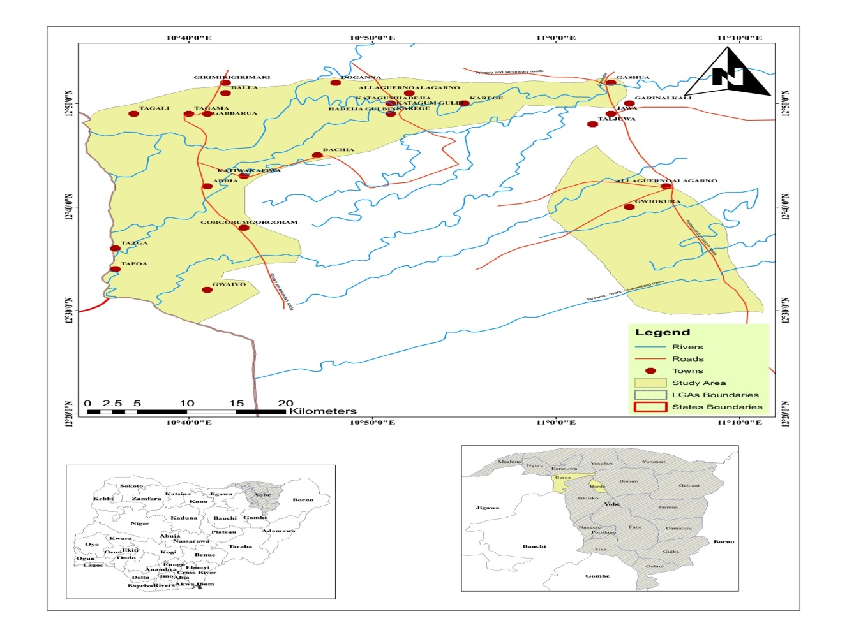
Fig 1: Map of Yobe State showing Bade Local Government Area
The research encompassed a diverse sample of 50 participants. Data for the study was collected by using structured questionnaire and phytochemical screening in qualitative analysis of some plants to enrich the data for the study Dunoma et al., (2023).
DATA COLLECTION METHODS
To compile a comprehensive database of medicinal plants, physical samples was collected from various sites within Gashua and its surrounding areas. Medicinal plants were sampled using established botanical collection techniques, ensuring proper identification and documentation of plant specimens.

3.4 Statistical Analysis
A frequencies and percentages were used to analyzed the socio-demographic data of the people and Relative Frequency of Citation (RFC) was analyzed the Ethnobotanical information (A. Dunoma et al., 2025).

Results:

Factor | Frequency | Percentage
Gender  Male  Female | 28  22 | 56%  44%
Age  20-30  31-40  41-50  51-60  60 and Above | 17  14  8  7  3 | 34%  28%  16%  14%  6%
Occupation  Local Herbalist  Traditional Birth Attendant  Herbal Seller  Farmer  Civil Servant | 10  3  3  17  16 | 20%  6%  6%  34%  32%

Table 1: Demographic Distribution of Participant in the Study Area

The gender of the participant in the study area shows that the majority (56%) of the total number of participants were males while 44% of the participants were females. This corresponds with the finding of Dunoma et’al., (2023). This could attribute to the fact in northern part of Nigeria, male are mostly the one that go to farm and most of these medicinal plants are found around the farm. However very few among the female have the opportunity to participate in farming activities in the northern part of the country. However, the study disagrees with finding of Borokini et al, (2013) in his work conducted in Southern Nigeria which shows that the majority of the participant of about (64.33%) are female.

Table 2: Distribution of medicinal plant used by Bade Local Government Area Yobe State
Botanical name | Family name | English name | Local name | Part of the plant | Disease cure | Mode of application
Piliostigma reticulatum | Fabaceae | Camel foot tree | Kargo | Leaves | Fever | Oral Solution
Guiera senegalensis | Combretaceae | Guiera | Sabara | Leaves/ root | Pile, stomach ache, dysentery, | Oral Solution
Anogeissus leiocarpus | Combretaceae | African Kino tree | Marke | Bark | Cold | Oral Solution
Azadirachta indica | Meliaceae | Neem tree | Dalbejiya | Leaves | Yellow fever | Oral Solution/colloid ant
Acacia nilotica | Fabaceae | Gum Arabic tree | Bagaruwa | Leaves/ bark | Wound, Pile | Oral Solution
Balanites aegyptiaca | Zygaphyllaceae | Desert date | Aduwa | Fruits/leaves | Stomach | Oral Solution
Adansonia digitata | Malvaceaea | Baobab tree | Kuka | Bark/fruit/  Leaves | Blood/calcium, cancer, inflammation, cardiovascular | Oral Solution/ colloid ant
Boswellia delzielii | Burseraceae | Frankincense tress | Ararrabi | Bark | Pile, dehydration | Oral Solution/powder
Musa x paradisiaca | Musaceae | Banana | Ayaba | Leaves/fruits | Fever/worm | Oral Solution
Ficus sycomorus | Moraceae | Fig mulberry | Baure | Bark | Dehydration | Oral Solution/powder
Lawsonia inermis | Lythraceae | Henna | Lalle | Leaves/Bark | Cold | Steaming
Vitex doniana | Lamiaceae | Black plum | Dinya | Bark | Dehydration | Solution
Ficus platyphylla | Moraceae | Fig | Gamji | Leaves | Blood add/ dehydration | Oral solution/ colloid ant
Mitragyna inermis | Fabaceae | African pan palm | Giyayya | Bark | Wound/rheumatism/dehydration | Solution
Psidium guajava | Myrtaceae | Guava | Gwaiba | Leaves | Fever | Solution
Carica papaya | Papayaceae | Paw Paw | Gwanda | Leaves/seed/fruits | Malaria ,gonorrhea ,diabetes/dysentery | Solution
Eucalyptus camaldulensis | Myrtaceae | Eucalyptus | Kafi amarya | Leaves | Mouth wash, nasal congestion, wound | Solution/ powder
Diospyros mespiliformis | Ebenaceae | African Ebony | Kanya | Bark/leaves/fruits | Wound/fever/stomach | Oral Solution/ powder/colloid ant
Citrus lemon | Rutaceae | Lime | Lemon tsami | Leaves/fruits | Antipyretic cold, stomachic | Solution
Khaya senegalensis | Meliaceace | Mahogany | Madachi | Leaves/bark, root | Stomachache, wound, fever, ulcer, tooth rashes malaria | Oral Solution/powder/colloid ant
Ziziphus mauritiana | Rhamnaceae | Ziziphus | Magarya | Leaves | Female rheumatism | Oral solution
Mangifera indica | Anacardiaceae | Mango | Mangoro | Leaves/bark/root/stem | Malaria, diarrhea, diabetes ,astringent | Oral solution, powder
Punica protopunica | Lythraceae | Pomegranate | Ruman | Leaves | Fever | Oral solution
Allium sativum | Fabaceae | Garlic | Tafarnuwa | Fruits | Rheumatism | Solution/ powder
Tamarindus indica | Fabaceae | Tamarind | Tsamiya | Fruits/leaves | Fever | Oral Solution
Calotropis procera | Apocynaceae | Apple of Sodom | Tumfafiya | Leaves/stick/ | Pile/tooth ache, Scorpion sting, | Crystal
Moringa oliefera | Moringaceae | Moringa | Zogale | Leaves | Blood add, Asthma, Arthritis, Rheumatism | Oral Solution/ powder
Gossypium hirsutum | Malvaceaea | Cotton | Audiga | Leaves/Bark | fever, respiratory problems, and digestive disorders. | Decoctions or infusions

Table 3: Result of phytochemical screening for Neem tree, acacia and African Kino tree
Sample Id | Neem | Acacia | Africa kino
Alkaloids | + | - | +
Flavanoids | _ | + | +
Phenols | - | + | +
Diterpenes | + | + | -
Saponins | + | - | +
Glycosides | - | + | +
Carbohydrates | - | + | +
Phytostrols | _ | + | +
Tanins | + | - | -

DISCUSSION
The documented medicinal plant in the study area include; Azadirachta indica, Acacia nilotica, Balanitis aegyptiaca, Adansonia digitata, Eucalyptus, Khaya senegalensis, Mangifera indica, Allium sativum, Tamarindus indica, Moringa oliefera e t c. The documented specific medicinal use of every plant in the study area are as follow;

- Azadirachta indica is used for curing Yellow fever,
- Acacia nilotica is used for curing wound,
- Balanitis aegyptiaca is uses for curing stomach ache,
- Adansonia digitata is used for curing Calcium
- Eucalyptus is used for mouth wash,
- Khaya Senegalensis is used for curing ulcer tooth ache skin rashes,
- Mangifera indica is used for curing malaria, diarrhoea,
- Tamarindus indica is used for curing fever,
- Moringa oliefera is used as blood tonic etc.

The result of phytochemical screening for Neem tree leaves indicate the present of Alkaloids, Diterpenes, Saponins and Tannins while Acacia pod contain Flavonoids, Phenols, Diterpenes, Glycosides, Carbohydrates and Phytosterols. The African Kino tree bark has the highest number of chemicals which include Alkaloids, Flavonoids, Saponins, Glycosides, Carbohydrates, Phytosterols. (Dunoma et.,al 2025).

CONCLUSION
Medicinal plants are having multiple applications such as aroma, flavoring, repellants and also as medicine; they are natural as such they do not have much negative effects on humans. The currents study identified many medicinal plants in the study area and it also indicted the important role that these medicinal plants play in human life. Primary compound found in plant can play a significant role in curing ailment due to their medicinal properties, it helps alleviate symptom, prevent disease progressive and promote overall health. It is also importance that these traditional knowledges of medicinal plants are effectively documented for biomedical researches and future references.

REFERENCE
Abdullahi, A. L., Umar, M. A., Abdullahi, M. S., Suleiman, M. M., & Musa, A. M. (2014). Medicinal plants used in the treatment of malaria in Kano and Jigawa states, Nigeria. Journal of Medicinal Plants Research, 8(12), 456-472. doi: 10.5897/JMPR2013.5286
Abdurrahman Dunoma, Gabriel A., Ajibade, Victoria Moltong Yilwa (2023) Ethno Botanical Survey of Medicinal Plant in Seven Local Government Area of Zona (A) Yobe State Nigeria, Vol. 3 (2) ISSN: 2753, 3247, Eastern Journal of Agricultural and Botanical Science (EJABS).
Abdurrahman Dunoma, Mahmud Bilal Umar, Halima M. Abba, Gabriel A Ajibade (2025)
Ethnobotanical Survey of Medicinal Plant In Kaduna North And South Local Government Areas, Kaduna State, Nigeria. Accepted for publication on international journal of biomedical research and innovation Vol.2 (1) e-issn-3043-6028.
Ajayi, O. (2020). "Ethnobotanical Survey of Medicinal Plants Used in the Management of Diabetes in Ibadan North-East and Ibadan South-East, Oyo State, Nigeria." Journal of Medicinal Plants Research.
Barokini et al., (2013). Ethnobotanical survey of traditional medicine practice for women health in Oyo state. Journal of medicinal plans studies Vol.1 (5) 17-29. Issn:2320-3862
Chang, F.R. and P.P.H. But. (2016). Natural Products and Drug Discovery: Can Thousands of Years of Traditional Chinese Medicine Contribute to a New Era of Drugs? Journal of the American Chemical Society, 138(22): 6486-6492.
Daskum, A. (2020). "Ethnobotanical Survey and In Vivo Assessment of the Antimalarial Activities of Medicinal Plants in Potiskum and Nangere of Yobe State." Journal of Ethnopharmacology.
Ekor, M. (2014). "The Growing Use of Herbal Medicines: Issues Relating to Adverse Reactions and Challenges in Monitoring Safety." Frontiers in Pharmacology, 4, Article 177.
Ibrahim, M. A., Aliyu, A. B., Sallau, A. B., Abubakar, M. S., & Umar, R. A. (2016). Ethno medicinal plants used in traditional medicine by Bakwai district, Kaduna state, Nigeria. Journal of ethno pharmacology, 185, 347-360.
Kankara, S.S., et al. (2020). "Ethnobotanical Survey of Medicinal Plants Used for Traditional Maternal Healthcare in Katsina State, Nigeria." Journal of Ethnopharmacology, 246, 112-169.
Mukherjee, P.K. (2002). "Quality Control of Herbal Drugs: An Approach to Evaluation of Botanicals." Business Horizons.
National Population Commission. (2016). National Population Commission, Yobe State. Retrieved from http://www.population.gov.ng/states/yobe/.
WHO. Traditional medicine. Accessed on 20th April 2023. https://www.who.int/health-topics/traditional-medicine#tab=tab_1
World Health Organization. (2013). WHO Traditional Medicine Strategy 2014-2023. Retrieved from https://www.who.int/publications/i/item/9789241506090.
Zhang, A., et al. (2013). "Traditional Chinese Medicine: Recent Developments in the Clinical, Experimental and Chemical Biology." Natural Product Reports, 30(4), 541-560.

