ETHNOBOTANICAL SURVEY OF MEDICINAL PLANT IN KADUNA NORTH AND SOUTH LOCAL GOVERNMENT AREAS, KADUNA STATE, NIGERIA

BY

*Abdurrahman Dunoma, ¹Mahmud Bilal Umar, *Halima M. Abba, ²Gabriel A Ajibade
* Department of Biological Science Federal University Gashua, Yobe State, Nigeria.
¹Department of Botany Gombe State University, Gombe State, Nigeria
²Department of Biological Sciences Nigerian Defence Academy Kaduna, Kaduna State Nigeria

CORRESPONDING AUTHOR
ABDURRAHMAN DUNOMA
Department of Biological Science,
Federal University Gashua, Yobe State, Nigeria.
Tel : +2347067428482 Email: ibndunoma@gmail.com

ABSTRACT
An ethnobotanical survey of medicinal plants in Kaduna North and South, Local Government Area of Kaduna state, Nigeria was carried out, with a view to documenting the indigenous knowledge of some medicinal plant species found in the area. Questionnaire were used as data collection instrument designed for information on demographic data on the most common ailments and plants species used in managing these ailments from sixty-two (62) respondents. The plant species were identified authenticated and herbarium specimens prepared. From the survey, a total of Fifty-two (52) plant species belonging to (37) different families were found to be useful in the treatment of common ailments. Trees were mostly used and the parts of the plants used most frequently applied were the leaves and barks. Medications were mainly prepared in decoctions and taken orally. Findings from the study revealed that the most common ailments were pile, malaria, jaundice, typhoid, and ulcer in that order, and the most frequently used plant species were Mangifera indica, Psidium Guajava, Senna occidentalis, eucalyptus camadulensis and Securidaca longepedunculata respectively. This indicates that herbal medicine will continue to be a major component for health care delivery system in the community due to their biologically active compounds, availability and affordability.
Key word: Ethnobotany, Medicinal plant, Indigenous knowledge.

INTRODUCTION

Medicinal plants have been used in healthcare system since ancient time. Medicinal plants play dynamic roles in disease prevention and their uses fit into all prevailing prevention strategies in human body. Medicinal plants are significant source of molecules with medicinal properties of the nature of phytochemical constituents. Also, medicinal plants are valuable for treating human diseases and play an important role in the healing process of some ailments. Natural and unique medicinal plants are used to treat various diseases and illnesses as well as produce wealth. The use of plants in the treatment of various human disorders is mentioned in Ayurveda and other Indian literature. Thus, medicinal plants are believed to be precious assets in the fight toward serious diseases all over the world (Sohani, 2021).
Traditional medicinal products are cheaper and easily available to residents across various rural communities, in their quest for relieve from frequent diseases in some parts of the world. Our study aimed at providing inventory of local plants used as medicine, documenting their uses, and assessing their market value. The study areas rural communities such that various residents depend on the medicinal plants within their communities for their healthcare needs (Shuaib et al, 2023).
As reported by Khesht, Jafari and Alizadeh, (2021), medicinal plants, as part of natural resources, have been one of the most important sources of human food and medicine for more generations. Diversification of the rural economy is considered as a tool to accelerate economic development at various levels¸ this approach is considered as one of the most important strategies for the development and economic sustainability of rural settlements in Iran¸ as they have been identified to have great effect on promoting the welfare and security of the region's economy.
Traditional medicine (also known as Folk medicine) is the mixture of traditional healing practices and beliefs that involve herbal medicine, spirituality and manual therapies or exercises in order to diagnose, treat or prevent an ailment or illness. The World Health Organization states that it is mostly practiced by indigenous or native populations and as much as 80% of the population in certain countries within Asia and Africa rely on it for primary care (National Centre for farmworkers health 2018).
In Africa, medicinal plants are still a major part of the health care system despite the growth of religion, enlightenment and western civilization in the areas of modern technology and orthodox medicine. World Health Organization reported that 80% of the total populations of Asia, Latin-America and Africa use traditional medicine for their primary health care needs (Augustine et al., 2017). As indicated by Ogunsola and Egbewale (2018), the demand for native medicinal plants has gained much attention among the developing tropical regions of the world in the last decades owing to their relative affordability, acclaimed efficacy and perceived user safety. The study revealed the high dependence on herbs and their combined use with orthodox medicine, play a significant role in the healthcare practices across many rural communities. These observations underscore the importance of traditional medicine as a subsystem of good health delivery such that a double practice exists among health care seekers.

Dunoma et al., (2023) reported that among various plants, the family Fabaceae has the highest of 12 species from which leaves and bark were mostly frequently used in alleviating health challenges. Most common ailments were: diarrhea, pile, jaundice, malaria, ulcer and typhoid. Mitragyna innermis Acacia nilotica, Senna occidentalis and Guiera senegalensis were the most frequently used plants.
According to the survey conducted by Ukwuani et al. (2021) in Gwandu emirate of Kebbi State, surveyed 16 medicinal plants used as antiulcer, with high frequency index include Moringa oliefera (37.04 %), Mangifera indica (37.04 %), Azadirachta indica (29.63 %). And Acacia nilotica (33.30 %), The root of these plant are mostly used in antiulcer herbal preparations, seeds and leaves are usually administered orally.
In the documentation of Kankara et al. (2020) of medicinal plants against complementary and alternative cancer therapy in Katsina State, North western Nigeria, a total of 56 medicinal plants distributed in twenty-two families were documented. The species of family Fabaceae has the highest number with 21 representatives and Diospyros mespiliformis had the highest Relative Frequency Citation (RFC) and UCV of 0.15 and 0.30, respectively, while the least RFC and UCV were seen in Tamarindus indica with 0.09 and 0.18, respectively. of the 57 species, 11 (19 %) shrubs and 46 (81 %) were trees. While decoction and powder were the most form of preparation for medications (63 %). Ogunkalu et al. (2022) also reported the use of medicinal plants in the management of Diabetes mellitus in kaduna metropolis, kaduna state, Nigeria. The most common plants species are Azadiracta indica (8.74%), venonia amygdaline (6.64%), Mangifera indica (6.29%), citrus auriantim (5.9), and Allium sativum (4.9%). Stem bark and roots of the plant species were mainly used in this this practice.

METHODOLOGY

Description of the Study Area
The study area covers Kaduna North and South Kaduna Local Government Arear of Kaduna State. The study area lies between latitudes 10° 24, 59.85, N and 10° 43, 59.85” N and Longitudes 178° 29’574.3” E with total area coverage of 131 Km²and population of 760,084(National Population commission, 2006 and 2007). The LGA shares borders with other LGAs within Kaduna State, including Chikun and Igabi Kaduna North and South LGAs has its headquarters in the city of Kaduna, which is also the capital of Kaduna state. The city of Kaduna is major commercial and industrial center in northern Nigeria, and it is known for its diverse population and rich Biodiversity.

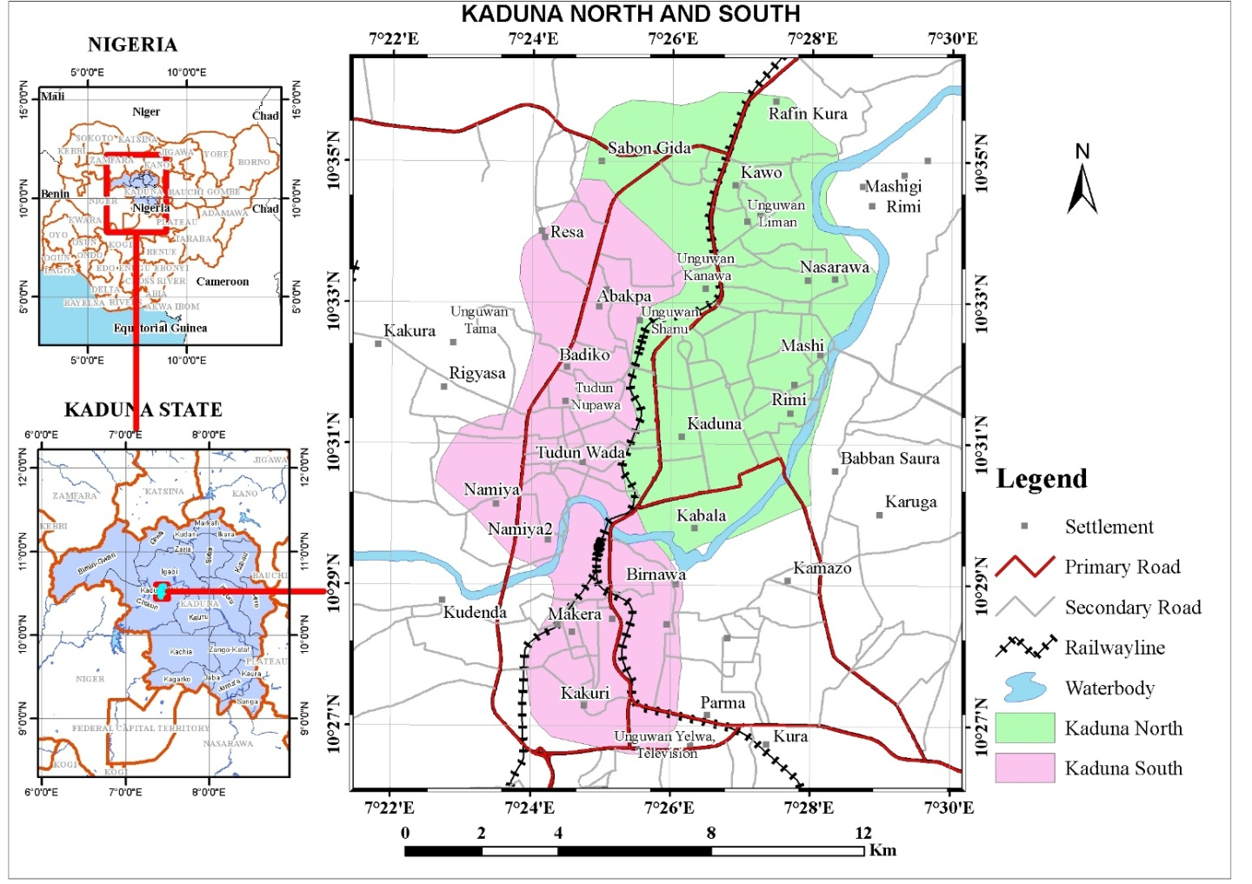
Fig 1. The location of study area (Sources; GIS Analysis Departmentof Geography Gombe State University).

Data Collection
Ethnobotanical survey was carried out in August– October 2023. Data were collected from herbal practitioners residing in Kaduna north and south local government areas of Kaduna state. The herbal practitioners were comprised of traditional birth attendants, local herbalists, farmers, herb sellers, and old people of who have practiced and used medicinal plants to alleviate health challenges. Information obtained from herbal practitioners through administration of questionnaire and by oral interview have proven to be a balance approach to obtaining a more accurate data in such study (Dunoma et al., 2023).

Statistical Analysis
Frequencies and percentages were used to analyzed the socio-demographic data of the people and Relative Frequency of Citation (RFC) was used for analyzing the Ethnobotanical information as indicated by Kankara et al., (2015).

FINDINGS
The demographic data in table 1 reveal that the respondents were predominantly male (69.35%) while females constituted 30.65%. The table also showed the average age range of the respondents. Respondents with the age range of 31-40 years constituted the majority (37.09%), those between 20-30 year (17.74%) while between those 41-50 years (24.19%), 51- 60years (16.13%). The level of education of the respondent showed that 41.94% had secondary and (33.87% had basic education while 11.29% had tertiary education. In terms of occupation, most of the respondents were local herbalist (32.26%) while 19.35% were farmers. Similarly, while 19.35% were herbs sellers, 11.29% were TBAs and 17.74% were herb enthusiast in other related profession. Overall, the respondents were generally matured, enlightened, traditional and close to the grassroots.

Table 1: Data of the respondents.

BIODATA. FREQUENCY(N). PERCENTAGE (%)

GENDER
Male 43 69.35%
Female 19 30.65%

AGE
20-30. 11 17.74%
31-40 23 37.09%
41-50 15 24.19%
51-60 10 16.13%
Above 60 3 4.84%

EDUCATION
None 8 12.90%
Basic 21 33.87%
Secondary 26 41.94%
Tertiary 7 11.29%

OCCUPATION
Local herbalist 20 32.26%
TBAs 7 11.29%
Herb sellers 12 19.35%
Farmers 12 19.35%
Others 11 17.74%

TBAs = Traditional Birth Attendants

Table 2 showed the medicinal plants species found in the survey area, Scientific name, local name (Hausa Language), Family, habitat and their relative frequency of citation with respect to their used. Majority of the plant were trees (48.39%), few were herb (32.26%) and very few shrubs (12.90%) while three were climbers (4.84%). Mangifera indica, Psidium Guajava, Senna occidentalis, eucalyptus camadulensis and Securidaca longepedunculata have the highest RFC of 0.05, 0.05, 0.05, 0.03 and 0. 03 respectively.

Table 2. Identification of Some Medicinal Plants Survey Collected from the Study Area kaduna North and South.

S/N SCIENTIFIC NAME FAMILY NAME LOCAL NAME HABIT RFC

1. Adansonia digitata L. Anacardiaceae Kuka Tree 0.02
2. Acanthospermum Asteraceae kashinyawo Herb 0.02
3. Acacia nolitica Fabaceae Bagaruwa Tree 0.02
4. Anacardium occidentale Linn. Anacardiaceae Kashu Tree 0.02
5. Aleo vera. Asphodelacea Alobera Herb 0.02
6. Anisopus mannu. Apocynaceae kashezaki Tree 0.02
7. Anogeissusleio carpus Combretaceae. Market. Tree 0.02
8. Azadirachta indica A jus. Meliaceae Maina Tree 0.02
9. Annona senegalensisPers. Annonaceae Gwandandaji Tree 0.02
10. Balaniteaegyptiaca(L)Delile Balanitaceae Aduwa Tree 0.02
11. Boswellia delziellii Hutch Burseraceae Ararrabi Tree 0.02
12. Carica papaya L. Caricaceae Gwanda Shrub 0.02
13. Calotropis procera (Aiton) Apocynaceae Tumfafiya Shrub 0.02
14. Citrus aurantifolia Roxb. Rutaceae Tsami Tree 0.02
15.Cacciana indica Cucurbitaceae Bimba Tree 0.02
16. Cola millemii. Malvaceae. Nil Shrub 0.02
17. Combretum micranthum. Combretaceae. Geza Shrub 0.02
18. Cocos nucifera. Aracacese. Kwakwa. Tree 0.02
19. Curculigopiloza. Hypoxidaceae. Doyan kurege. Herb 0.02
20. Cucubita maxima Cucubitaceae Kabewa. Climber 0.02
21. Cymbopogon citratus. Poaceae. Ciyawanshayi Grass 0.02
22. Diospyros mespiliformis Ebenaceae Kanya Tree 0.02
23. Euphobia hirta Euphobiaceae Nononkurciya Herb 0.02
24. Eucalyptus camaldulensis Myrtaceous Turare Tree 0.03
25. Emilia coccinea. Compositeae. Odundum. Herb 0.02
26.Ficus polata Vahl. Moraceae Dirimi Tree 0.02
27. Ficus thonningii Flickr Moraceae Chediya Tree 0.02
28. Ficus platyphylla Pers Moraceae Gamji Tree 0.02
29. Guiera senegalensis Combretaceae Sabara Shrub 0.02
30. Hibiscus sabdariffa L. Malvaceae Soborodo Herb 0.02
31. Hypoxia nyasila. Hyapxidaceae leggalbali Tree 0.02
32. Ipoemoea batatas Convulvulaceae Dankali Climber 0.02
33. Khaya senegalensis (Desr.) Meliaceae Madaci Tree 0.02
34. Lawsoniainnermis L. Lythraceae Lalle Shrub 0.02
35. Leptadenia hastate (Pers.) Asclepiadaceae Yadiya Climber 0.02
36. Mangifera indica L Nacardiaceae Mangoro Tree 0.05
37. Mitragynainnermis Rubiaceae Giyayya Tree 0.02
38. Moringa oleifera Lam. Moringaceae Zogale Shrub 0.02
39. Monoonlongifolium Annonaceae Dogonyaro Tree 0.02
40. Musa sapientium. Musaceae Ayaba Herb 0.02
41. Nymphaea lotus Nymphaeaceae Bado Herb 0.02
42. Olea europaea. Oleaceae. Zaitun Shrub 0.02
43. Parkia biglobosa Fabaceae Dorawa Tree 0.02
44. Psidium gaujava L. Myrtaceae Gwaiba Tree 0.05
45. Sesamum indica. Pedaliaceae Noni Herb 0.02
46. Securidaca longepedunculata. Polygalaceae Sanya Herb 0.03
47. Senna occidentalisL. Fabaceae Majanfari Herb 0.05
48.Tamarindus indicaL. Fabaceae Tsamiya Tree 0.02
49. Vitex donianaL. Verbenaceae Dinya Tree 0.02
50. Vernonia amygdalina. Asteraceae Shuwaka Herb 0.02
51. Zingiber officinale. Zingibaraceae Citta Herb 0.02
52. Ziziphus mauritiana Lam. Rhamnaceae Magarya Tree 0.02

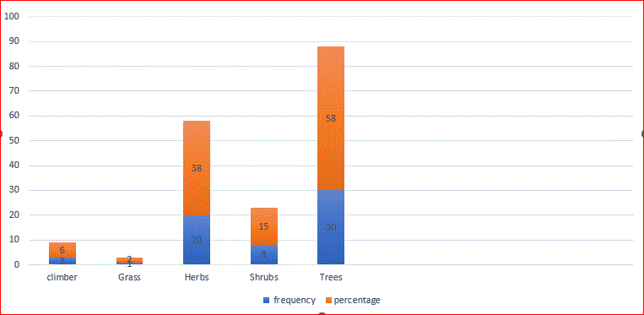
Figure 1: Range of the Medicinal Plants Identified In kaduna north and south LGA.

DISCUSSION
Most of the respondents, according to Demographic data information were males (69.35%), this may be because in Nigeria, males most commonly participate in the outdoors activities like trading among, farming, traveling, others. This also agrees with findings of Ogunkalu et al. (2022) which indicated that majority of traditional medicinal practitioners were male with (78.4%).
Many of the respondents have secondary education with (43.1%) and (48.3%) traders,

civil servants, while (17.2%) each were artisans and farmers.
Fifty-Two (52) plant species of medicine were surveyed, identified and majority of the plants were trees belong to the family of Fabaceae species (11%) and their traditional uses were provided by the traditional healers interviewed. Majority of the plant’s species from Thirty-seven (37) families. This corresponds with the finding of Dunoma et al., (2023) which reported that the family, Fabaceae has the highest frequent of 12 species from twenty-nine (29) families used in management common ailments in seven local governments area of zone A Yobe state, Nigeria. Most common ailments treated with medicinal plants were; pile, jaundice, malaria, typhoid diarrhea, and ulcer. Guiera senegalensis, Senna occidentalis, Mitragyna innermis and acacia nilotica were the most frequently used plants. In most studies, leaves and bark were the most frequently used plant parts.

Findings from this study showed that barks and leaves were the most used parts of plant in management of some diseases in the study area. Other parts of plants used include the whole plant, roots, and seed/fruits. This is similar to the findings of Olatokunbo and Akinjagunla. (2020) and Mudansiru et al. (2016) which indicated that stem barks and leaves are the most reported species part of plant used in the preparation of various ailment in indigenous people of Bayelsa and Gumel town of Jigawa State. This could be because they are easier to obtain and processed in a desired form of medication and may also be used in any mode of administration. The plant root and leaves are the important ingredient in traditional treatment of various ailment as it features as a component of herbal preparations (Ukwuani et al.,2021).
The common ailments observed in this study for which medicinal plants are used include; jaundice, pile, malaria, typhoid, diabetes and ulcer. This also corresponds to the findings of Sodimu et al. (2020) which indicated malaria; fever; diabetics dysentery; diarrhea; joint pains; etc. as the most common ailment managed with medicinal plant.

CONCLUSION
The study affirmed that medicinal plants are used for the alleviation of some common ailments affecting the people of the study area. Some of these ailments include typhoid fever, malaria, ulcer, pile, Rheumatism, and jaundice. The study also showed that Mangifera indica, Musa sapientium, Senna occidentalis and Psidium guajaba, were the most frequently used plants in the management of these diseases among residents of the communities in the study area. It is therefore important to carefully document these indigenous medicinal plants for future use of some, further study and possible extraction of the active ingredients for the preparation of orthodox medications to alleviate these ailments.

REFERENCES
Abdullahi Rabiu Abubakar, Abubakar Sadiq
Wada, Umar Sharif Abdulsalam, Ibrahim
Haruna Sani, Mustapha Abdullahi Huguma,
Adamu Bello Shuaibu, Abdullahi Balarabe
Nazifi, Sani Malami, Abdullahi Hamza
Yaro, (2023). Ethnobotanical survey of
medicinal plants used for the treatment of
neuropsychiatric disorders in northwest
Nigeria, Trends in Science & Technology
Journal, ISSN: 24085162; p-ISSN:
20485170; April, 2023: Vol. 8 No. 1 pp. 158
– 169. www.ftstjournal.com.

Abdurrahman Dunoma, Gabriel A. Ajibade and Victoria Moltong Yilwa, (2023). Ethnobotanical survey of medicinal plants in seven local government of zone A. Yobe state, Nigeria Eastern journal of agriculture and biological science (EJABS) 3(2), 24-44. Retrieved from https://qabas journals.com/headsIndex.php/EJABS/article/view/177.

A. I. Sodimu1, M. B. Usman1, J. Appah2, O. Osunsina1, R. A. Suleiman, S. Maikano1 and L. G. Lapkat, (2020); Ethnobotanical Survey of Medicinal Utilization and Phytochemical Composition of Baobab Tree (Adansonia digitata L.) in Zaria Local Government Area of Kaduna State, Nigeria. European Journal of Medicinal Plants, 31(5): 1-10, 2020; Article no.EJMP.54421, ISSN: 2231-0894, NLM ID: 101583475. http://www.sdiarticle4.com/review-history/54421.

Alipour, M., Jafari, H., & Alizadeh, K. (2021); The effect of cultivation of medicinal plants on the economic development of rural settlements Case study: Villages of Kalat city. Propósitos y Representaciones, 9 (SPE2), e957. Doi: http://dx.doi.org/10.20511/pyr2021.v9nSPE2.957

Ekeopara, Chike Augustine, Rev. Ugoha, Azubuike M.I. (2017); IOSR Journal Of
Humanities And Social Science (IOSR-JHSS) Volume 22, Issue 5, Ver. 4 (May 2017) PP 32-43 e-ISSN: 2279-0837, p-ISSN: 2279-0845. www.iosrjournals.org

Geographical information system (2023) Nigeria.

Kankara SS, Tukur K, Bello A, Lawal U, Bindawa K A. (2020); Medicinal Plants used for Complementary and Alternative Cancer Therapy in Katsina State, Northwestern Nigeria. Tropical Journal of Natural Production Resources.;4(9):621-629. doi.org/10.26538/tjnpr/v4i9.21

Mudansiru, A. M. Haidara, S. Ibrahim, U. Zaharaddeen, and A. M. Darma. (2016); “Ethnobotanical survey of some medicinal plants of Gumel town, Jigawa State. Journal Drug Design and Medicinal Chemistry. 3(4), 60-66.

M. Shuaiba, F. Hussainb, A. Raufc, F. Janc, M. Rommand, R. Parvezc, A. Zebc, S. Alic, S. Abidullahi, S. Bahadurf, A. A. Shahg, N. Azamh, S. Dilbari, K. Begumj, H. Khank, S. Sajjadl I. Muhammadj, and N.A. Shahl, (2021); Traditional knowledge about medicinal plant in the remote areas of Wari Tehsil, Dir Upper, Pakistan. Brazilian Journal of Biology, 2023, vol. 83, e246803 | https://doi.org/10.1590/1519-6984.246803.

National Population Commission [NPC] (2006); Official Result for 2006 House and Population Census Figures. Bureau for National Statistics, Abuja, Nigeria.

Odebunmi, C.A.; Adetunji, T.L.; Adetunji, A.E.; Olatunde, A.; Oluwole, O.E.; Adewale, I.A.; Usman, M., & Abdulrahman, M.D., & Emere, M.C., & Ajibade, G.A. (2021); Ethnobotany of Medicinal Plants with Antidiabetic Potentials in Northern Nigeria. Eurasian Journal of Science & Engineering, 7(1), 46-58

Ogunkalu, Adelani, Ariyo, Ogunsanwo & Odeyale, (2022); Ethnobotanical survey of plants used for the management of diabetus mellitus in kaduna metropolis, Kaduna Nigeria., Nigerian agricultural journal ISSN: 0300-368X, V: 53. NO:2, Pg. 262-273.

Smruti Sohan, (2021); Role of Medicinal Plant in Human Health Perspective, Acta Scientific Agriculture 5.6: 65-68.

Ukwuani-Kwaja AN, Sani I, Kindzeka LS, Gudu GJ. (2021); Ethnobotanical survey of
medicinal plants used as antiulcer in Gwandu Emirate, Kebbi State, Nigeria. Hist Philos Med.;3(3):15. doi:10.53388/HPM20210713005

