OIL PRICE SHOCKS, STOCK MARKET RETURNS AND VOLATILITY IN NIGERIA: A DISAGGREGATED APPROACH

BY
¹TYONA TIMOTHY, ²YUA HENRY AND ³TEMITOPE ABIODUN OJE
¹Joseph Sarwuan Tarkaa University, Makurdi-Benue staste
²Department of Banking and Finance, Federal Polytechnic Wannune, Benue State
³Scholar, College of Business and Leadership, Eastern University, St Davids, Pennsylvania

CORRESPONDING AUTHOR
YUA HENRY
Department of Banking and Finance,
Federal Polytechnic, Wannune
Benue State. Nigeria

ABSTRACT
This study examined empirically, the returns and volatility spillover effects between oil price and sectoral stocks in Nigeria using high frequency daily data on oil price and eleven sectors namely Agriculture, Conglomerates, Construction/Real Estate, Consumer Goods, Financial Services, Health Care, ICT, Industrial Goods, Natural Resources and Oil & Gas. The main objective of which is to examine the return and volatility spillover effects between the sectors and oil price. The study is anchored on three theories; the Discounted Cash Flow Model, the Capital Assets Pricing Model and the Arbitrage Pricing Theory. The data on the variables listed above were obtained from Nigerian Stock Exchange Group and US Energy Information Administration. The study utilized the Vector Autoregressive Moving Average-Generalized Autoregressive Conditional Heteroskedasticity (VARMA-GARCH) multivariate volatility model for estimation where findings indicate bidirectional return and volatility spillover effects, between oil market and majority of the stock sectors. Additionally, results indicate low Constant Conditional Correlations (CCC) coefficients between oil and stock prices. The study concludes that there exist both return and volatility spillover effects, and that both return and volatility in both markets are fueled by own return and volatility effects and therefore recommends among others construct hedge ratios and portfolio weights to as a guide to minimize loses, as well as factor in their decision making own short- and long-term shocks.

Keywords: Disaggregated approach, Oil price, Stock returns, Varma-garch model, volatility

INTRODUCTION
The Nigerian capital market is seen as one of the fastest growing in Africa and indeed other emerging market economies (EMEs) worldwide, making it the only three frontier markets in Africa since 2002. This provides opportunities for investors both domestic and foreign to earn high return on their investments culminating in large capital inflows into the economy.
However, the activities of the stock market have not been without challenges, leading to decline in stock returns. For instance, daily stock prices on the floor of the NSE show that between 2008 and 2010, prices decreased by 25%, leading to the decline in market capitalization to 9.7 trillion naira from 12.5 trillion naira in a space of 6 months, as reported by CBN (2009, 2011). The NSE All Share Index in January, 2020 decreased to about 13% and further dropped below 11% by December of the same year. Also, almost all the industrial sectors’ indices drastically declined between March and July, 2020, especially oil and gas, industrial goods and banking sectors. In order to stem these dwindling fortunes, the authorities took measures such as the introduction of the Central Securities Clearing System (CSCS) to aid computerization, introduction of a single clearing house for all shares traded on the exchange, reclassification of industrial sectors into 11 sectors from 33, to conform to global best practices, opening up the market to attract foreign participation, etc.

Oil, a source of energy, play a strategic role in the performance or otherwise of global economies, as it affects the consumption and investment decision of households and business firms at various times. An important discourse in the financial economics literature of recent is the understanding of the complex dynamics that explains the volatility of oil prices over time as it is critical for the growth and development of any economy. It is pertinent to note that almost all issues of production had to do with oil (Malik and Rashid, 2017; Mansoor, 2020; Castro and Rodroguez, 2024). Oil is said to occupy an important place in the world economy since it is considered as an important source of energy in the world, not just as fuel and source of energy for heating, but also as raw material in various production processes (Al-Quduh, 2015). Ordue et al (2024) thus averred that fluctuations in the prices of oil have over bearing influence on other economic activities of a nation.
Oil price have witnessed large volumes of fluctuations beginning from the big downward trend in oil prices of 1970 (Hamilton, 1983). Empirical evidence from previous studies like Abeng (2017); Killian and Park (2009); Yua, H., Epor, S.O., and Utor V., (2023), linked changes in oil prices with weak financial systems, stunted growth of the economy, increasing inflation, high interest rates depreciating exchange rate and downward trend in unemployment situations. The price of oil was below $10 in 1986, and around $23 in the 1990s. It peaked at $145 in 2008 before declining to $76 in 2010. This decline continued till 2014 when the price rose to about $127. However, due to the outbreak of covid-19, oil prices went down to as low as $12 around the middle of 2020 before averaging to $68 as at the first quarter of 2021. As at January, 2024, oil prices averaged $98 per barrel. Since crude oil was discovered in large quantities in Nigeria in 1956, it (oil) has dominated the entire economy by accounting for more than 90% of the export earnings, contributing 25% of the GDP and about 80% of public revenues as reported by Kumeka, Adeniyi & Orekoya, (2017); and Ajekwe, Yua, & Tyona, (2024). In the early nineties, there was an increase in oil prices globally by about $1. This led to increased public revenue of over 300 billion dollars and foreign exchange earnings of over 600 million dollars.
As important as oil prices are, they are prone to fluctuations; otherwise known as price shocks which according to Hamilton (1983) occurs as a result of changes in demand or supply conditions in the international oil markets. One of the areas through which oil prices exert considerable effect worldwide according to Abdalla (2014); Tule, et al (2019); Omale, et al (2024) has to do with stock market development.
The stock market is considered worldwide as a market where elements that feed into the development of a nation’s economy is said to operate. In both developed and developing economies, stock markets, which are part of the financial system plays a pivotal role in the development process. A well-functioning economy is one which is hinged on a sound financial system in which the stock market is a major player. Stock markets are often seen as a place for accessing long term securities comprising both the primary and secondary market for the issuance of new securities and trading of existing share respectively. Stock markets, as posited by Adenuga (2010); Yua, Epor, & Ajekwe, (2025) supports resource allocation to spur growth by reducing transaction costs, affecting the average productivity of capital mobilizing savings and altering the rate of investment, promoting and improving resource allocation among others. On the other hand, stock market also has some degree of influence on the oil market. For instance, a boom in the stock market will induce an increase demand for more production which will require listed firms using more inputs from oil which may likely affect the oil prices.
Oil price shocks are considered to be among the factors that effects stock market performance in Nigeria considering its predominance both as a source of public revenue and foreign exchange. Due to the glaring effect of oil prices shocks on real economic activity, especially on a stock market return, several scholars have probe into the oil prices stock return nexus. Studies such as Olufisayo (2014), Abraham (2016), Ajekwe, et al (2024), Lawal, Somoye and Babajide (2016) maintained that oil price shocks affect stock returns negatively, while other studies reported by Adebuji, et al (2009) expressed contrary opinion. However, as Kumar (2014) discovered, emerging markets are more vulnerable or prone to negative news and events happening elsewhere like the global economic crises of 2008/2009 usually results in institutional investments flowing into or out of the market, creating an environment of high volatility and uncertainty. Against this background, therefore, this study intends to examine the impact of the return spillover from oil prices to sector specific stock returns, stock indices, stock returns to oil prices, conditional correlation between oil prices and each of the sectors in Nigeria.

CONCEPTUAL PERSPECTIVE
Oil price shocks are unexpected changes in global demand and supply due to economic or geopolitical events. Demand-side shocks, such as the Iranian invasion of the U.S. embassy in 1978 and Iraq's invasion of Kuwait in 1980, disrupted oil production and led to higher prices. Demand-side shocks, like China's economic growth and the 2007-2009 financial crises, also resulted in oil price collapse. Killian (2009) thus identified three types of oil price shocks: supply-side shocks, aggregate demand shocks, and precautionary demand shocks.

- Concept of Stock Returns
Investors invest resources for earnings and income, often focusing on profits from shares or dividends. Stock returns, measured by changes in firm prices on the Nigerian stock exchange, are influenced by various economic risk factors and global economic events.
For this study the daily returns of the series will be calculated as
$R_{it}=log\frac{ρ_{i t}}{ρ_{i t-1}}=logρ_{i t}-logρ_{i t-1}$
Where;
$ρ_{i t}$ is the daily close price of oil, and the eleven (11) sector-indices namely; Agriculture, Conglomerates, Construction /Real Estate, Consumer Goods, Financial Services, Health Care, ICT, Industrial Goods, Natural Resources and Oil & Gas on the Nigerian Exchange Group.
- Concept of Stock Market
Volatility is a key concept in financial markets, indicating an asset's riskiness over time. It can be classified as conditional volatility, which changes over time, or unconditional volatility, which doesn't depend on time. Asset returns show features like serial correlation, volatility clustering, and asymmetry. Conditional volatility is negatively correlated, aligning with the LeBann effect. During economic downturns, stock price falls cause increased market volatility, leading to the 'lover age effect', increasing financial leverage and making stocks riskier.
- Concept of Stock Volatility Spillover
The notion of the volatility of stock returns can be traced back to the pioneer work of Engle, Ng and Rothshid (1990). They emphasized that own and cross spillover are two types of volatility spillover. While own spillover refers to the volatility of an asset based on past volatility, cross spillover focuses on the current volatility of the same asset and other assets.

THEORETICAL PERSPECTIVE
- Capital Asset Pricing Model (CAPM)
The capital asset pricing model was pioneered by notable authors including Sharpe (1964), Umer (1965), and Mossin (1960). The CAPM is a single factor model, quantifies the expected rates of return of an asset with level of market systematic risk. The CAPM has variously been used among others by Chen (2003) and Kim and Moser. (a) 2017.
As opined by Nguyen and Nguyen (2017), the model assumed that in competitive financial markets, investors plan to invest over the same time horizon, no discretionary taxes or transaction costs, and unlimited borrowing and lending. Investors like overall portfolio reward and dislike risk.
Algebraically, the Capital Assets Model is presented as
R_{i} = RFR + β_{i} (Rm – RFR) 2.1
Where;
Rm = Expected return on portfolio
RFR = risk free return
R_{i} = Return on asset
β_{i} = $\frac{COV (RI,RM)}{δ^{2}M}$ 2.2
βis called the beta of the asset i and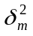 is the variance of the market portfolio. For any portfolio < = (<1----<n) of risky assets, its beta can be constructed as a weighted average of individual asset betas as follows:
E(rd) = RFR+βλ(RM) – RFR 2.3
βλ = $\sum_{i=1}^{p}{∝iβi}$ 2.4

The Beta value indicates a measure of risk for individual assets/portfolio. It measures the non-diversifiable or transferable part of risk known as systematic risk. According to this model, the expected return of an asset depends on its stand-alone risk. However, the CAPM model assumes a perfect competitive market environment, but this is unrealistic due to factors like demand and supply, tax liabilities, and borrowing rates, which differ from individual investors.
- Arbitrage Pricing Theory (APT)
Arbitrage pricing theory involve selling and buying assets at lower prices due to market failure. The Arbitrage Pricing Theory (APT) is an augmented version of CAPM that incorporates macroeconomic factors, allowing researchers to generate returns without specifying factors driving expected asset returns. Diversifiable markets require security-specific risk, while multi-factor models generate returns influenced by macroeconomic factors, using betas for each factor tested against stocks. Factors can be firm-specific, macroeconomic, or any author's opinion on stock returns.
A multi-factor APT model as expressed as follows:
Rit = Ѱ_{it}+β_{1i}+F_{1t}+β_{2i}F_{2t}+β_{3i}F_{3t}+β_{4i}F_{4t}……….+…….+………+E_{it} 2.5
Where
R_{it} = Return on Asset i at time t.
Ѱ_{it} = Risk Free Rate
β_{i} = Security of the factors
F = Risk Factors
- Discounted Cash Flow Model (DCF)
The relationship between oil price shocks and stock market return can also be theoretically explored or viewed through the discounted cash flow model (equity pricing

model) developed by Huang, Masallius and Stold(1996). The model has been adopted in several literature (Sek, 2015; Basher, 2014; Zakanya and Abdala, 2013; Abeng, 2017; Degiannakis, 2017). According to this model, macroeconomic variables including commodity prices can exert a significant effect on stock returns of firms. According, the price of equity at a given point in time is equal to the expected present value of the discounted future cash flows as follows:
P = $\frac{E(C)}{E(r)}$ 2.6
Where;
P = Stock price
C = cash flow
r = Discount rate (interest rate)
E(1) = expectation operator
The realized stock returns R can be expressed approximately as
R = $\frac{CE(C)}{E(C)}$ = $\frac{dE(r)}{E(r)}$ 2.7
Where d(.) is the difference operator.
Stock returns, R, Oil prices can impact expected cash flows and discount rates, which are determined by the systematic movements in these variables. Rising oil prices increase production costs, dampening cash flows and reducing stock prices. The discounted rate, which consists of expected inflation and expected real interest rate, can also be affected by oil price changes. Higher oil prices can negatively affect trade balances, leading to higher inflation and lower stock returns.
EMPIRICAL PERSPECTIVE
Modeling the effect of oil price shocks on energy sector stock returns in Nigeria was examined by Ebechidi and Nduka (2017). The study analyzed oil prices and stock returns of energy firms from 2000 to 2015 using GARCH modeling. The study revealed a negative 74% effect on energy

sector stock returns, with an increase in oil prices leading to a margin increase in stock return. Also, in a study by Abdala (2013) modeling the impact of oil price fluctuations on the stock returns in an emerging market like Saudi-Arabia, the study analyzed aggregate stock index and oil prices from 2007 to 2011, and reported that crude oil price fluctuations increased stock market returns volatility.

Sek, Ng and Har (2015) further compared, the effect of oil prices across stock markets of China, India, South Korea, Singapore and Italy, using data from January 2009 to December 2013. The study found detectable spillover effects between crude oil price and stock returns for all countries using the Baba, Engle, Kroner (BEKK) multivariate volatility model though a panel Garch or panel ARDL methodology should have been used.

Again, Abdala (2014) analyzed oil price fluctuations on Sudanese stock market performance from 2008 to 2014, and reported that past oil price values significantly influenced KSE returns, with crude oil shocks positively impacting returns.

Sector responses of GCC stock market returns to international oil price changes was the topic of study conducted by Khamis and Handen (2016). A study on GCC stock markets reveals that oil price changes affect sectors differently, but fails to account for return and volatility spillover effects due to financial linkages.

A sector analysis of asymmetric nexus between oil prices and stock returns was examined by Salisu, Raheem and Ndako (2017). The study on the US stock market, using monthly data from 1999-2017, found that oil price shocks significantly impact sectoral stock returns. However, the findings may not be applicable to developing countries like Nigeria or with higher frequency data.
In a study conducted by Waheed, Wei and Sarwar (2017) using industry-wise analysis to examine the impact of oil prices on stock returns of listed firms on the Karachi stock exchange from 1998-2014 in Pakistan findings indicated a significant positive effect. The impact of oil prices on stock markets from Gulf Cooperative Council financial markets was also examined by Alqattan and Alhaykay (2016). The study, using monthly data on oil prices and stock returns from GCC countries, found no evidence of cointegration, except for Oman, and the use of monthly data may affect consistency.
Alaali (2017) analyzing the impact of oil price shocks on asset price of UK firms reported that responses to oil price shocks using the Fama-French four factors asset pricing model. showed that transportation sector returns were insensitive, while travel, tourism, airlines, and oil and gas showed asymmetric responses. The study's main drawback is its use of monthly financial series data. In the vein, Jafarian and Safari (2015) examined the impact of oil price fluctuations on Malaysia's stock market returns from 2000 to 2014 and reported positive effects on consumables and energy sectors, while utilities and telecom sectors were negatively affected. However, the study's main drawback is its use of monthly data.
Volatility spillover between oil price and the stock market under structure breaks was examined by Ewing and Malik (2015). The study used the MGARCH model to analyze oil price volatility and US stock market returns from 1996 to 2014. Results showed no spillover, but strong evidence of volatility spillover when structural breaks are included.
The impact of oil price shocks on Amman Stock Exchange Real return was conducted by Al-Qudah (2015). The study examines the impact of oil prices, stocks, and interest rates on stock returns in Jordan from 2000 to 2014. Results from the study showed a significant negative effect on Amman stock exchange returns, with a unidirectional casualty between oil price shocks and short-term interest rates.
Oil price and stock markets in Europe was evaluated by Arouri, Fouliquier and Fouquan (2009). The study explores the long-term relationship between oil prices and European sector stock market returns. Results showed a significant response in automobiles, oil & gas, financials, and technology sectors, but the study's drawback is its over-ten-year history.
An empirical analysis of oil price and stock market performance in Nigeria was examined by Ogiri, Amadi, Uddin and Dubon (2013). The study used data on oil prices, GDP, EXP, and market capitalization to explore stock price movements and their links to market performance, highlighting the importance of oil price changes.
Oil prices and stock market behavior in Nigeria was examined by Adavanola (2012). The study examined the dynamic effects of oil prices on stock markets from 1985 to 2009 using quarterly data. Results showed a positive short-run response to oil price shocks, but a reverse long-run effect, indicating causality. The effect of oil price shocks on stock returns of energy firms in Nigeria was also investigated by Soyemi, Akingunola and Ogebe (2017). The study, analyzing oil prices and stock market returns from 2007-2014, found a direct positive effect of oil shocks on company stock returns, with an indirect relationship through market returns. However, the study limited to energy firms and did not consider asymmetries.

METHODOLOGY
- Nature and Sources of Data
This study covers the period 4th January, 2011 –8th January, 2022 where data was retrieved on daily frequency level making a total of about 3000 observations. Stock market data was sourced from the Nigeria stock exchange, for the oil price, data was sourced from United States Energy Information Administration (EIA).
- Variable Definitions and Measurements
The study made use of two (2) variables, oil price and stock returns disaggregated into 11 sectoral indices listed on the Nigerian Exchange Group. The daily return of each series is computed as;
$R_{it}=log\frac{ρ_{i t}}{ρ_{i t-1}}=logρ_{i t}-logρ_{i t-1}$
Where $ρ_{i t}$ is the sum of daily mean closing price of brent crude oil, and the eleven (11) sector indices on the Nigerian Stock Exchange namely Agriculture, Conglomerates, Construction/Real Estate, Consumer Goods, Financial Services, Health Care, ICT, Industrial Goods, Natural Resources and Oil & Gas.
- Model Specification
The study specify the conditional mean, variance and covariance of a bivariate VARMA (1,1) – GARCH (1,1 as in Salisu and Isah (2019), Malik and Rashid (2017), Tule et al (2017) Yaya, Lukman, Akinlana, Tumala and Ogbonna ( 2017), Lin Wesseh and Appiah 2014 as follows:
- VARMA – GARCH MODEL
In financial literature, the (APT) theory assumes that specifically the return on assets can be generated as
$$R_{i}=ϑ+β_{i}ρ+ε_{i}$$
Where $R_{i}$ is volatility of stock returns, $ϑ$ is expected (unconditional) stock return volatility, $β_{i}$ measures the coefficient of oil price shock, $ρ$ is oil price shock and $ε_{i}$denotes error/residual effect. In line with the (APT) above, and following Yaya et al 2017, Malik and Rashid 2017, Fasanya, Oyewole and Agbatogun 2019, the CC-VARMA GARCH model for the mean (return), the variance equation and the covariance equations are specified as follows:
$\begin{matrix}{R_{oil}}_{t}= \\ {R_{s}}_{t} =\end{matrix}A\left(\begin{matrix}γ_{oil} \\ γ_{s}\end{matrix}\right)+B\left(\begin{matrix}φ_{oil}φ_{oil,s} \\ φ_{s,oil }φ_{s}\end{matrix}\right)\left(\begin{matrix}R_{{oil}_{t-1}} \\ R_{s_{t-1}}\end{matrix}\right)+C\left(\begin{matrix}ε_{{oil}_{t}} \\ ε_{s_{t}}\end{matrix}\right)$ $\begin{matrix}{R_{oil}}_{t}= \\ {R_{s}}_{t} =\end{matrix}\left(\begin{matrix}γ_{oil} \\ γ_{s}\end{matrix}\right)+\left(\begin{matrix}φ_{oil}φ_{oil,s} \\ φ_{s,oil }φ_{s}\end{matrix}\right)\left(\begin{matrix}R_{{oil}_{t-1}} \\ R_{s_{t-1}}\end{matrix}\right)+\left(\begin{matrix}ε_{{oil}_{t}} \\ ε_{s_{t}}\end{matrix}\right)$ 3.1$R_{st}=φ_{1}+φ_{11}R_{st-1}+φ_{12}R_{ot-1}+ε_{st}$

Where;
A is a matrix of coefficients of returns on each series
B is a matrix of coefficients allowing for cross sectional dependence of conditional retunes between oil and stock markets conditioned on t – 1
C is a matrix vector representing error terms.
These coefficients are denoted as follows
${R_{oil}}_{t}$$γ_{oil}$and ${R_{s}}_{t}$ are the daily return of sectors specific stock index and oil prices respectively, $φ_{s}$and $φ_{oil}$$φ_{22}$ are the coefficients of own past lag effect of sector stock returns and oil price returns respectively. $φ_{s}$and $φ_{oil}$ both measure the return spillover effect of oil on the stock returns and stock on oil returns respectively.
The conditional variance equation for the oil stock series for objective three and four is specified as follows:
$\left({{δ^{2}}_{oil,t} \atop {δ^{2}}_{s,t}}\right)= D\left({ω_{oil} \atop ω_{s}}\right)+E\left({λ_{oil}λ_{oil,e} \atop λ_{s,oil}λ_{s}}\right)\left({{ε^{2}}_{oil t-1} \atop {ε^{2}}_{s t-1}}\right)+ F\left({β_{oil}β_{oil,s} \atop β_{s,oil}β_{s}}\right)\left({{δ^{2}}_{oil,t-1} \atop {δ^{2}}_{s,t-1}}\right)$ 3.2
Where;
D is matrix of coefficients of constants
E is matrix of coefficients of short-run shock or ARCH effects conditioned on past innovations.
F is matrix of coefficients of long-run volatility or GARCH effects conditioned on past innovations.
The coefficients are denoted as follows
${δ^{2}}_{oil}$ and ${δ^{2}}_{s}$ are the variance of the two series. $ω_{oil}$ and $ω_{s}$ are the non-negative constants of the model, 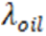and $λ_{s}$ measures the short run persistence or ARCH effects of the past shocks of both oil and sector stock return respectively at time $t-1$ on the present conditional variance series capturing the impact of direct transmitted shocks. ${ε^{2}}_{oil t-1}$ and ${ε^{2}}_{s t-1}$
$β_{oil}$ and $β_{s}$ measure long run persistence or GARCH effects of past shocks of oil and stock return at $t-1$ respectively, on the transmitted conditional volatility series capturing the direct impact of the effects of the transmitted conditional volatility series ${δ^{2}}_{oil,t-1}$ and ${δ^{2}}_{s,t-1}$ .
$λ_{oil,s}$ and $λ_{s,oil}$ measures the cross value of the error terms ${ε^{2}}_{s t-1}$ and ${ε^{2}}_{oil t-1}$ on current conditional variance series for oil and sector stock respectively. Thus, these parameters and shock spillover or volatility spillovers coefficients that measure the effects of volatility shocks between oil and stock markets such that $λ_{oil,s}$ measure the impact of sector stock shocks (volatility) on oil market, whereas $λ_{s,oil}$ measure the impact of oil market volatility shocks on sector stock volatility. In the same vein, volatility spillover between oil prices and sector stock returns are measured by $β_{oil,s}$ and $β_{s,oil}$, i.e $β_{oil,s}$ measures the impact of volatility spillover from stock to oil market while $β_{s,oil}$ measures the impact of volatility spillover from oil to sector stock market returns.
To accommodate the asymmetries in the model, McAleer Hoti and Chan (2009) introduced the VARMA- AGARCH version. The authors adopted the GJR style of asymmetry to uncover the asymmetry impact of unconditional shocks on the conditional variances. In line with their works and following Yaya, Luqman, Akinlana and Tumola (2017); Yaya, Luqman and Vo (2021) and Ogbonna (2017) the VARMA-AGACH model is specified as follows:

$\left({{δ^{2}}_{oil,t} \atop {δ^{2}}_{s,t}}\right)= D\left({ω_{oil} \atop ω_{s}}\right)+E\left({λ_{oil}λ_{oil,e} \atop λ_{s,oil}λ_{s}}\right)\left({{ε^{2}}_{oil t-1} \atop {ε^{2}}_{s t-1}}\right)+ F\left({β_{oil}β_{oil,s} \atop β_{s,oil}β_{s}}\right)\left({{δ^{2}}_{oil,t-1} \atop {δ^{2}}_{s,t-1}}\right)+ G\left({ϕ_{oil}I\left(ε_{oil,t}\right)ε_{oil t-1}^{2} \atop ϕ_{s}I\left(ε_{st}\right){ε^{2}}_{s t-1}}\right)$ 3.3
Where;
D is matrix of coefficients of constants
E is matrix of coefficients of short-run shock or ARCH effects conditioned on past innovations.
F is matrix of coefficients of long-run volatility or GARCH effects conditioned on past innovations.
G is matrix of coefficients of asymmetric (leverage) effects
Note that the only difference between the VARMA – GARCH and the VARMA – AGARCH model is the inclusion of the leverage effect parenthesis $ϕ_{oil}$ and $ϕ_{s}$ which measure the asymetic impact of volatility of oil and stock markets respectively using the indicator variable $I\left(ε_{oil,t}\right)$ and $I\left(ε_{st}\right)$ conditioned such that $I\left(ε_{oil,t}\right)=1$ for $I\left(ε_{st}\right)≤0$ and is otherwise, same as $I\left(ε_{s,t}\right)=1$ when $I\left(ε_{s,t}\right)≤01$.
The Covariance Equation which can either be dynamic conditional correlation (DCC) or constant conditional correlations (CCC) is specified as follows:
First, The CCC model is specified as
$ρ_{s,o,t}=ρ^{so}\sqrt{h_{st},}\sqrt{h_{ot}}$ 3.4

Where;
$ρ^{so}$ is constant conditional correlation between stock and oil price returns.
Secondly the Direct Conditional Coloration (DCC) between the stock and oil market returns is specified as:
$Q=\left(1-л_{1}-л_{2}\right)Q_{O}+л_{1}n_{t-1}n_{t-1}^{1}+л_{2}Q_{t-1}$ 3.5

Where;
$$n_{t-1}=\left[{ε_{oil t-1}}/{\sqrt{h_{oil t-1}}}{ε_{st-1}}/{\sqrt{h_{st-1}}}\right]$$
The $л_{1}$ and $л_{2}$ are the effects of previous shocks and previous conditional correlation on the current conditional correction respectively.
- Pre-Estimation/Preliminary Analysis
Before estimating the model parameters, the following pre-estimation analysiswere conducted and the results reported in chapter four.
Summary (Descriptive) statistics was carried out to uncover the historical properties of the twelve variables of the study. Such statistics include mean, median, skewness and kertosis, Jarque-Bera, etc.
The unit root properties of the variables were examined. This is because, most economic and financial series exhibit episodes of non-stationarity. The study tests for the order of integration of the variables using the Augmented-Dickey Fuller test. The test regression for variable say y is specified as follows:
▲y_{t}= ᵦ₀+ᵠy_{t-1} +$\sum_{i=1}^{P}{ὡ▲yt-1+ul.}$ 3.6
The null hypothesis is
H_{o} ᵠ = 0
While the alternative hypothesis is
H₁ ᵠ<0
The series y_{t} is stationary if the null hypothesis is rejected, otherwise the series has a unit root.
The twelve (12) variables were subjected to virtual (graphical) analysis in order to have firsthand information on the series in question.
The ARCH-LM test for the existence or otherwise of ARCH effects in the residuals was also carried out, to test the null hypothesis that there are no ARCH effects up to lag order q in the residual. The test regression is specified as;
$ε_{t}^{2}=φ_{t}+ \left(\sum_{j=1}^{n}{φ_{t-j}^{2}}\right)+vt$ 3.7
$φ_{t-j}$are the residuals from the ARCH model $φ$₀ is the intercept while $φ_{j}$ are the coefficients.
- Sign and size biased tests
It is important and necessary to uncover the presence or otherwise of asymmetric effects before deciding to adopt either VAR-GARCH or its asymmetric version the VAR-AGARCH model. The Engle and Ng (1993) sign and size bias test was carried out to verify the presence or otherwise of asymmetric effects.
These tests determine the significance of volatility changes when a negative or positive return shock occurs by regressing the squared residual term on a dummy variable reflecting the sign of the residual term.
Using ԑ_{it, i}= stock and oil return toindicate the residual of asset iat time t, the following tests will be estimated.
Sign biased test $ԑ_{it}^{2}=a+bS_{i, t-1}^{-}+ui,t$ 3.8
Negative Size biased test $ԑ_{it}^{2}=a+bS_{i, t-1}^{-}ԑ_{i,t-1}+ui,t$ 3.9
Positive size biased test $ԑ_{it}^{2}=a+bS_{i, t-1}^{+}ԑ_{i,t-1}+ui,t$ 3.10
The sign bias test is the t statistic for testing $H_{o}b=0$, in equation 3.11 and the negative size bias test is the t statistic of testing $H_{o}b=0$, in equation 3.12 these tests can be jointly carried out using the joint bias test.
Joint Biased Test $ԑ_{it}^{2}=a+b_{1}S_{i, t-1}^{-}+b_{2}S_{i, t-1}^{-}ԑ_{i,t-1}+ b_{3}S_{i, t-1}^{+}ԑ_{i,t-1}+uit$ 3.11
$S_{i, t-1}^{-}$ and $S_{i, t-1}^{+}$ are dummy variables that take a value of 1 for negative and 0 for positive residuals of irespectively. The LM test statistic for the null hypothesis is $H_{o}$: $b1=b2=b3=0$ which has a Chi squared distribution. Rejecting the null hypothesis imply using the VARMA-AGARCH model and vice versa. However, Engle and Ng (1993 cited by Salisu 2009 advises that the joint test be considered to determine asymmetric effects where there is a conflict among the individual tests.
- The Engle-Sheppard CCC x² Test
Though VARMA-GARCH class of models assume constant conditional correlations, it is still necessary to conduct a formal test. For this, the Engle-Sheppard (2001) CCC test was conducted to enable us choose between the CCC or DCC GARCH variant to use. The null hypothesis of CCC is tested against the alternative of DCC both earlier outlined in equations 3.5 and 3.6
Thus, the rejection of the null implies adopting the DCC model while the non-rejection of the null favours the CCC model and its variant such as the VARMA-GARCH model.
- Estimation Technique
The estimation of the parameters in 3.2was carried out using numerical maximizations of the joint likelihood function under the distributional assumptions of the models. For a sample of N observation, as outlined in Yaya et al 2017, the log-likelihood function to the maximized with respect to the parameters set Ɵ is
$\left(\left(Ɵ\right)\sum_{t=1}^{N}{l_{t}}\left(Ɵ\right)=-NI_{n}2π-1/2\sum_{t=1}^{N}{{I_{n}}/{H_{t}}}\left(Ɵ\right)-1/2\sum_{t=1}^{N}{ε_{t}^{/}}\left(Ɵ\right)H_{t}^{-1}ε_{t}^{/}\left(Ɵ\right)\right)$ 3.12
Where N is the size of the return series, and Ɵ is the parameter set of the model estimated. The Quasi-maximum likelihood estimation function is therefore optimized and implemented using RATS 10.2 and Oxmetrics 8.0 softwares.
- Post Estimation/Diagnostics
Post estimation and diagnostics tests was also conducted to determine the adequacy or otherwise of the models. Two prominent tests were conducted as follows:
- Serial Correlations
For this, Ljung Box test for serial correlation was carried out to determine if the estimated model is free for serial correlation.
- ARCH Effects.
To determine the existence of remaining ARCH effects in the model, the study conducted ARCH LM serial correlation test and the McLeod – Li test.

FINDINGS AND INTERPRETATIONS

Stationarity Tests
Though the study uses return series, which are already stationary nonetheless, stationarity tests are conducted on the price data just for confirmatory reasons. The result is reported as follows:

Table 1 Unit Root Tests Results
Variable | ADF Stat | PV | Decision | PP stat. | PV | Decision
Oil Price | 63.59203 | 0.0001 | 1(1) | 61.2311 | 0.0000 | 1(1)
Agriculture | 47.24475 | 0.0001 | 1(1) | 28.1000 | 0.0001 | 1(1)
Conglomerates | 46.85522 | 0.0001 | 1(1) | 36.1007 | 0.0000 | 1(1)
Consumer goods | 47.14081 | 0.0001 | 1(1) | 50.0611 | 0.0000 | 1(1)
Construction/Real Estate | 50.17499 | 0.0001 | 1(1) | 51.3171 | 0.0000 | 1(1)
ICT | 39.03502 | 0.0000 | 1(1) | -36.0179 | 0.0001 | 1(1)
Industrial Goods | -50.27804 | 0.0001 | 1(1) | -39.1311 | 0.0001 | 1(1)
Health care | -32.60718 | 0.0000 | 1(1) | -48.2910 | 0.0000 | 1(1)
Natural Resources | -33.31252 | 0.0000 | 1(1) | -46.0017 | 0.0000 | 1(1)
Oil and Gas | -48.36656 | 0.0001 | 1(1) | -39.1874 | 0.0001 | 1(1)
Financial Services | -45.98963 | 0.0001 | 1(1) | -34.1217 | 0.0000 | 1(1)
Services | -49.47295 | 0.0001 | 1(1) | 58.8181 | 0.0000 | 1(1)

As we can see from the ADF and Philip Peron (PP) stationarity test above, all the series are stationary after been differenced once. Consequently, the series are adequate for analysis using appropriate volatility models.
Time Plots for Return Series
The time plots of the return series are presented on figure 1.

Figure 1: Time plot for return series

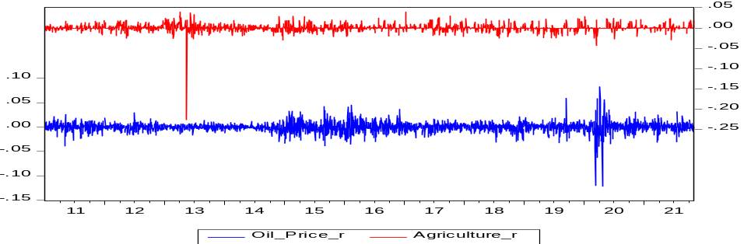

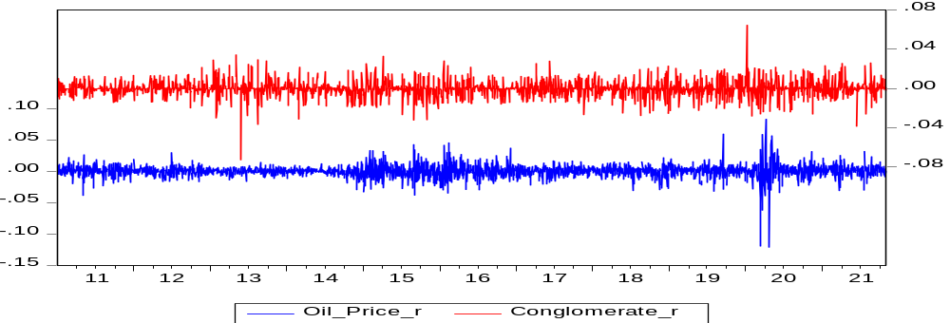

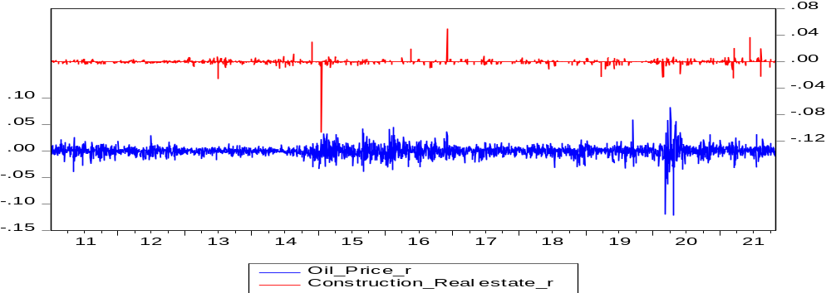

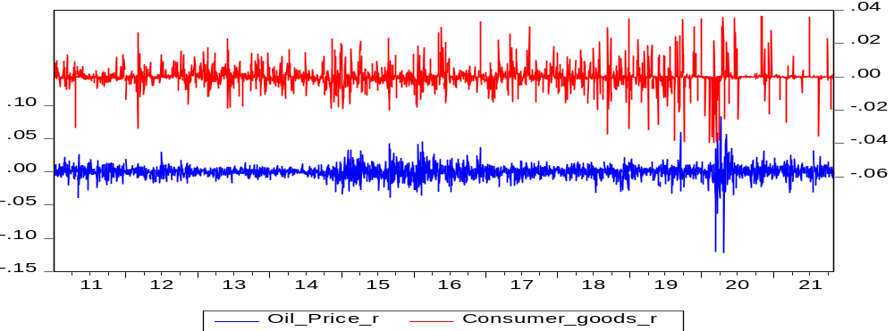

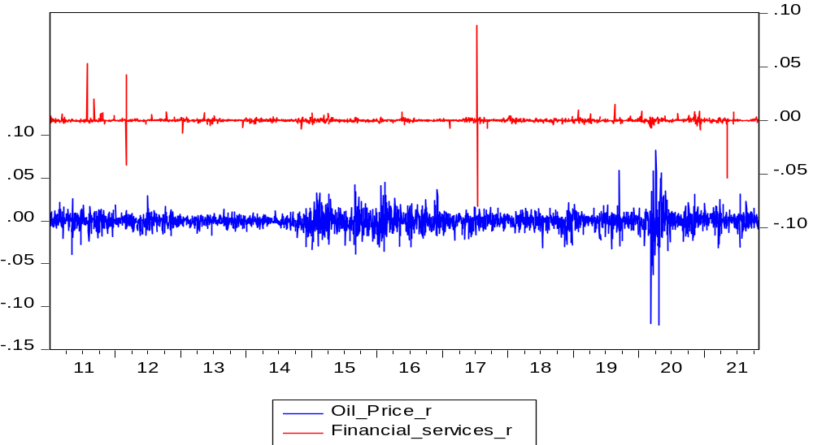

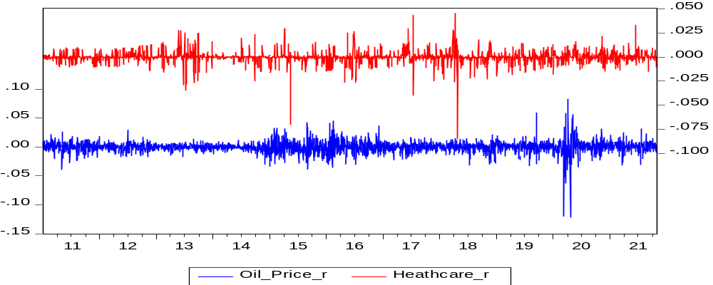

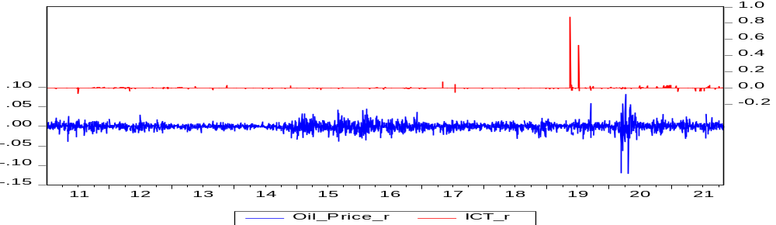

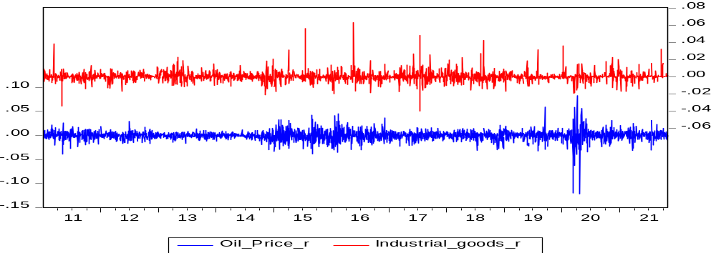

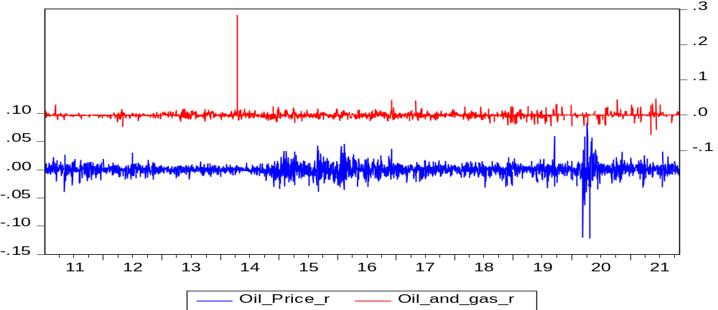

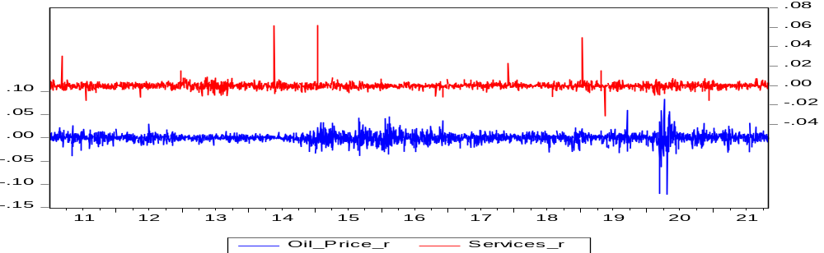

The time plots of oil and the eleven sectoral indices are as presented above. For the agriculture sector we observed spikes in oil return around late 2012, while return on agriculture sector was stable from 2011 to 2014. However, as observed by 2020, there was a sharp spike in returns perhaps due to the COVID 19 Pandemic. We can also observe that all the return series exhibited volatility clustering which gave rise to excess kurtosis with very high values as evidenced in the table 1 on descriptive statistics. Volatility clustering indicates that large positive changes in volatility are likely to be followed by negative changes in volatility. Thus, the scenario suggested the positivity of return and volatility spillover effects between the series which makes GARCH based models ideal for estimation as indicated by Fracq and Zakoian (2010), and cited by Abdala (2014).
- ARCH and Serial Correlation Tests
Evidence from the stationarity tests, Jarque-Bera and Kurtasis supported the adoption of GARCH model, however, the ARCH test serial correlation test was conducted. The Engle (1982) ARCH tests were conducted where results reveal existence of ARCH effects and serial correlation in the series. This is reported on table 2.

Table 2: ARCH Test Result.
Variable | ARCH LM
Oil Price | 6.7606
Agriculture | 3.646
Conglomerates | 4.3863
Consumer goods | 2.8613
Construction/Real Estate | 32.5634
ICT | 590.3996
Industrial Goods | 19.6183
Health care | 2.7309
Natural Resources | 28.559
Oil and Gas | 3.9690
Financial Services | 6.0223
Services | 2.4601
Significant figures in bold.

- Asymmetry Sign and Size Biased/Engle-Sheppard CCC X² Tests
The results of the sign biased and the Engle-Sheppard CCC X² tests are presented on table 3.

Table 3: Asymmetry Sign and Size Biased/Engle-Sheppard CCC X² Tests
Variable | Sign Bias Test | -ve size bias test | +ve size bias test | Joint bias test | Eagle-Sheppard CCC X² test
Agriculture | 1.1869  (0.235368) | 2.1448  (0.032060) | 0.3301  (0.74133) | 13.9861  (0.002924) | 1.530652 (0.465182)
Conglomerates | 0.08428  (0.9328) | 0.58831  (0.5564) | 1.36576  (0.1721) | 3.52104  (0.3188) | 1.453491 (0.48348)
Construction and Real Estate | 1.699  (0.0596) | 1.489  (0.36682) | 2.659  (0.00688) | 15.603  (0.00136) | 2.293520 (0.029352)
Consumer Goods | 1.70426  (0.08833) | 0.76213  (0.44598) | 1.25435  (0.20972) | 7.58415  (0.07544) | 0.87052 (0.64709)
Fin. Services | 0.78937  (0.42989) | 0.07919  (0.93668) | 0.20487  (0.93608) | 0.77341  (0.85582) | 5.993539 (0.05990)
Health care | 0.83198  (0.4055) | 0.02822  (0.9775) | 0.08515  (0.9321) | 0.73317  (0.8654) | 1.650715 (0.438078)
ICT | 1.1863  (0.23568) | 0.3833  (0.70152) | 2.0564  (0.03984) | 8.4404  (0.03773) | 0.029403 (0.998648)
Industrial goods | 0.835213  (0.4037) | 0.003808  (0.9976) | 0.087349  (0.9304) | 0.758233  (0.8594) | 0.037844 (0.981255)
Natural resources | 0.4332  (6.649e-1) | 2.3155  (2.066e-02) | 4.5577  (5.405e-06) | 26.4730  (7.592e-06) | 0. 22862 (0.891979)
Oil and Gas | 0.69921  (0.4845) | 0.07271  (0.9420) | 0.19427  (0.8460) | 0.57841  (0.9014) | 0.088905 (0.956520)
Services | 0.66369  (0.5069) | 0.06218  (0.9504) | 1.12457  (0.2609) | 2.30726  (0.5111) | 8.369742 (0.0582417)
Oil | 1.1265  (0.2600) | 0.4485  (0.6538) | 0.3311  (0.7406) | 1.3004  (6.7290)

From the results of Asymetric and sign bias tests we observed that the null hypothesis of constant conditional correlation (CCC) cannot be rejected as all the series show probability values greater than 0.05 as evidence in Yaya, et al (2016) Uzonwanne 2021 and Tule et al 2018. Turning to the bias tests, we observe that the null hypothesis of symmetry was not rejected for the series except, for agriculture, construction/real estate, ICT. This means that negative news (unexpected price increases), has the ability to increase volatility in these sectors than positive news.

- CCC VARMA (A) GARCH Results
Overall, forty-four MGARCH models were estimated for oil and the eleven sectors, including CC-VARMA-GARCH, Asymmetric CCC-VARMA-GARCH, DCC-VARMA-GARCH and the Asymmetric DCC-VARMA-GARCH i.e., 4 × 1 pairs (oil with each of the eleven stock sectors totaling 44 models).
Based on the result of the Engle-Sheppard $χ^{2}$ and the sign and size biased tests, the CCC- VARMA-A-GARCH model is chosen as the best among the estimated models for oil-agriculture, oil-Construction and Real estate, and Oil-ICT Nexus, while the symmetric version, the CCC-VARMA-GARCH is estimated for the remaining pairs of oil-conglomerates, oil-consumer goods, oil-financial services, oil-health care, oil-industrial goods, oil-natural resources, oil-oil and gas and oil-services. The result is presented on table 4.

Table 4 CCC-VARMA–(A) GARCH MODEL RESULTS
Mean Equation
Parameters→  Variables↓ | Oil-  Agriculture  Coef. PV |  |  | Oil  Conglomerates  Coef. PV |  |  |  | OilConstruction and Real Estate  Coef. PV |  |  | Oil-Consumer Goods  Coef. PV |  | Oil-Financial Services  Coef. PV |  |  |  |  | Oil-  Health care  Coef. PV
$$φ_{oil}$$ | 0.043 | 0.000 |  | 0.289 | 0.000 |  |  | 0.057 | 0.000 |  | 0.027 | 0.000 |  | -0.021 | 0.110 |  |  |  | 0.029 | 0.080
$$φ_{s}$$ | 0.091 | 0.000 |  | 0.008 | 0.000 |  |  | -0.017 | 0.000 |  | 0.022 | 0.000 |  | 0.317 | 0.000 |  |  |  | -0.020 | 0.000
$$φ_{{oil}^{s}}$$ | 0.029 | 0.000 |  | 0.002 | 0.000 |  |  | -0.011 | 0.000 |  | 0.034 | 0.000 |  | 0.013 | 0.000 |  |  |  | -0.009 | 0.000
$$φ_{s^{oil}}$$ | 0.113 | 0.000 |  | 0.065 | 0.000 |  |  | 0.148 | 0.000 |  | 0.150 | 0.000 |  | 0.272 | 0.000 |  |  |  | 0.049 | 0.000
Variance Equation
$$ω_{oil}$$ | 0.000 | 0.099 |  | 0.000 | 0.091 |  | 0.000 |  | 0.066 |  | 0.000 | 0.089 |  | 0.000 | 0.811 |  |  |  | 8.056 | 0.176
$$ω_{s}$$ | 0.000 | 0.100 |  | 0.000 | 0.100 |  | 0.000 |  | 0.075 |  | 0.000 | 0.116 |  | 0.000 | 0.916 |  |  |  | 1.644 | 0.086
$$λ_{oil}$$ | 0.033 | 0.000 |  | 0.100 | 0.000 |  | 0.014 |  | 0.000 |  | 0.110 | 0.000 |  | 0.108 | 0.000 |  |  |  | 0.107 | 0.000
$$λ_{s}$$ | 0.911 | 0.000 |  | 0.135 | 0.000 |  | 0.217 |  | 0.000 |  | 0.116 | 0.000 |  | 0.126 | 0.000 |  |  |  | 0.081 | 0.000
$$λ_{{oil}^{s}}$$ | 0.029 | 0.000 |  | 0.033 | 0.000 |  | 0.021 |  | 0.000 |  | -0.007 | 0.175 |  | -0.003 | 0.000 |  |  |  | -6.995 | 0.071
$$λ_{s^{oil}}$$ | 0.290 | 0.000 |  | 0.045 | 0.000 |  | 0.108 |  | 0.000 |  | 0.002 | 0.000 |  | 0.010 | 0.000 |  |  |  | 0.020 | 0.000
$$β_{oil}$$ | 0.893 | 0.000 |  | 0.846 | 0.000 |  | 0.898 |  | 0.000 |  | 0.686 | 0.000 |  | 0.885 | 0.000 |  |  |  | 0.879 | 0.000
$$β_{s}$$ | 0.045 | 0.000 |  | 0.365 | 0.000 |  | 0.406 |  | 0.000 |  | 0.221 | 0.000 |  | -0.049 | 0.000 |  |  |  | 0.859 | 0.000
$$β_{{oil}^{s}}$$ | 0.064 | 0.000 |  | 5.794 | 0.000 |  | 0.700 |  | 0.000 |  | 23.429 | 0.000 |  | -0.098 | 0.099 |  |  |  | 0.453 | 0.000
$$β_{s^{oil}}$$ | 0.017 | 0.000 |  | 5.165 | 0.000 |  | 1.356 |  | 0.000 |  | 17.587 | 0.000 |  | 0.019 | 0.076 |  |  |  | 0.256 | 0.000
Leverage Effects
$$∅_{oil}$$ | 0.456 | 0.000 |  | x |  |  | 0.127 |  | 0.000 |  | x |  |  | x |  |  |  |  | x
$$∅_{s}$$ | 0.073 | 0.000 |  | x |  |  | 0.849 |  | 0.000 |  | x |  |  | x |  |  |  |  | x
CCC
$$ρ^{so}$$ | -0.000 |  |  | 0.015 |  |  | 0.060 |  |  |  | 0.015 |  |  | -0.002 |  |  |  |  | 0.040
Residual Diagnostics
Ljung-Box (PV) | 0.4068 |  |  | 0.5142 |  |  | 0.1890 |  |  |  | 0.6281 |  | 0.6034 |  |  |  |  | 0.4464
Mcleoid–Li (PV) | 0.2713 |  |  | 0.1287 |  |  | 0.2143 |  |  |  | 0.4887 |  | 0.1272 |  |  |  |  | 0.0908
Vol Persistence (oil) | 0.92 |  |  | 0.94 |  |  | 0.91 |  |  |  | 0.80 |  | 0.99 |  |  |  |  | 0.93
VolPersistence (stock) | 1.33 |  |  | 0.50 |  |  | 0.62 |  |  |  | 0.33 |  | 0.08 |  |  |  |  | 0.94

Table 4 CCC-VARMA–(B) GARCH MODEL RESULTS
Mean Equation
Parameters→  Variables↓ | Oil-ICT  Coef. PV |  | Oil-Industrial Goods  Coef. PV |  |  | Oil Natural resources  Coef. PV |  |  | Oil- Oil and  Gas  Coef. PV |  |  | Oil-  Services  Coef. PV
$$φ_{oil}$$ | 0.035 | 0.000 | -0.03 |  | -528 |  | 0.000 | 0.032 |  |  |  | -0.014 | 0.000
$$φ_{s}$$ | -0.005 | 0.000 | 0.044 | 0.000 | 0.046 |  | 0.000 | -0.004 |  |  |  | 0.050 | 0.000
$$φ_{{oil}^{s}}$$ | -0.005 | 0.000 | 0.007 | 0.000 | 0.012 |  | 0.000 | 0.038 |  |  | 0.000 | 0.028 | 0.000
$$φ_{s^{oil}}$$ | -0.004 | 0.000 | 0.040 | 0.000 | -0.074 |  |  | 0.043 |  |  | 0.000 | 0.070 | 0.000
Variance Equation
$$ω_{oil}$$ | 1.119 | 0.060 | -0.000 | 0.081 | 1.059 |  | 0.065 | 0.000 |  |  | 0.150 | 0.000 | 0.100
$$ω_{s}$$ | 2.378 | 0.070 | 0.000 | 0.910 | 1.975 |  | 0.095 | 0.000 |  |  | 0.151 | 0.118 | 0.651
$$λ_{oil}$$ | 0.034 | 0.000 | 0.109 | 0.000 | 0.110 |  | 0.000 | 0.108 |  |  | 0.000 | 0.003 | 0.000
$$λ_{s}$$ | 1.686 | 0.000 | 0.297 | 0.000 | 0.041 |  | 0.000 | 1.329 |  |  | 0.000 | 0.003 | 0.000
$$λ_{{oil}^{s}}$$ | 1.412 | 0.000 | -0.031 | 0.000 | -4.914 |  | 0.000 | -0.015 |  |  | 0.000 | -0.080 | 0.000
$$λ_{s^{oil}}$$ | -0.050 | 0.000 | 0.055 | 0.000 | -0.127 |  | 0.000 | -0.001 |  |  | 0.000 | -0.011 | 0.000
$$β_{oil}$$ | 0.899 | 0.000 | 0.842 | 0.000 | 0.885 |  | 0.000 | 0.879 |  |  | 0.000 | 0.869 | 0.000
$$β_{s}$$ | 0.423 | 0.000 | 0.179 | 0.000 | 0.074 |  | 0.000 | 0.008 |  |  | 0.000 | 0.816 | 0.000
$$β_{{oil}^{s}}$$ | 0.038 | 0.100 | 14.080 | 0.000 | -0.010 |  | 0.000 | 0.127 |  |  | 0.000 | 1.361 | 0.000
$$β_{s^{oil}}$$ | 0.012 | 0.000 | 18.372 | 0.000 | -0.052 |  | 0.000 | 0.000 |  |  | 0.100 | 0.036 | 0.000
Leverage Effects
$$∅_{oil}$$ | 0.106 | 0.000 | x |  | x |  |  |  | x |  |  | x
$$∅_{s}$$ | -0.088 | 0.000 | x |  | x |  |  |  | x |  |  | x
CCC
$$ρ^{so}$$ | 9.020 |  | 0.007 |  | 0.037 |  |  |  | 0.019 |  |  | 0.006
Residual Diagnostics
Ljung-Box (PV) | 0.5382 |  | 0.2689 |  |  | 0.8051 |  |  |  | 0.4507 |  | 0.7351
Mcleoid–Li (PV) | 0.2469 |  | 0.9397 |  |  | 0.1438 |  |  |  | 0.1268 |  | 0.0549
Vol Persistence (oil) | 0.93 |  | 0.95 |  |  |  |  |  |  | 0.98 |  | 0.99
Vol Persistence (stock) | 0.42 |  | 0.48 |  |  |  |  |  |  | 1.33 |  | 0.81
Source: Author’s Computation based on Oxmetrics and RATS Output

Conditional return (mean equation)
Evidence from the mean (return) equation from table 5 showed that lagged returns are included in the conditional mean equation, the purpose and reason for which is to remove serial correlation and to ensure that spillover effects are not mistaken for serial dependence. This is in line with Tule et al (2018, 2017), Uzonwanne (2021), Yousuf (2020) among others. It was observed that own lagged returns are statistically significance and positive for most of the sector stocks except few. For instance, the lagged return for the pair of agricultures, conglomerates, consumer goods, health care, natural resources and services were positive, but not significant while that of Construction and real Estate, financial services ICT, Industrial goods, Oil and Gas were all statistically significant indicating evidence of short-term predictability in prices for these sectors. Own lagged returns for oil in the oil-stock pain was statistically significant for the sectors except oil-conglomerates, oil consumer goods and oil Health care.
Turning to the return cross effects, we observe positive and significant return spillover from some stock sectors to oil. For example, the return spillover from agriculture sector to oil is significant at 0.0000; Construction and real estate significant at 0.0000, Consumer goods (0.0000) Financial services (0.0000) ICT (0.0000) Natural Resources (0.0000) oil and gas (0.0000) and services at 0.0000.
Results from the return (mean)equation also reveal high return spillovers from the oil to stock sectors except conglomerates whose return is positive, though not significant. For instance, the return spillover from oil market to agriculture sector -0.1135, Construction and real estate at 0.148099. We can infer from the result that the highest return spillover is from the oil market of 0.272896 is to financial services sector, while the lease (lowest) return spillover from oil of 4.146E-03 is to information and communication technology; ICT sector.
Conditional Variance Equation
Estimated results of the conditional variance equation is as reported on table 5 a and b above. Results show that the coefficients of Autoregessive conditional heteroeadoshaty (ARCH) and the generalized autoregressive conditional heterecasdesticity (GARCH) are all significant for the eleven sectors. Similar to the work of Umm and Zatang (2020), evidence further indicates current volatility of sectorial returns depends on their past shocks and past conditional volatility. For instance, the conditional volatility of agriculture sector depends strongly on its own past unexpected shock ($λ_{s}$) and own past volatility ($β_{s}$) all at significant levels.
The volatility of all the stock sectors depends on their own lag shocks (ARCH) and lag volatility (GARCH) going by their significant coefficient values. For instance, the own ARCH effect of natural resources is 0.2419, while its response to own volatility is about 0.7431. For financial services, its own short term shock effect was 0.1265 while it’s own volatility was low at -0.0492, though significant indicating it’s non-sensitivity to own volatility. Overall, it can be observed that the highest own shock (ARCH) is absorbed by the oil and gas sector followed by the agriculture sector, with the ICT sector absorbing the least indicating that volatility of the ICT was not driven by its own shocks. For the GARCH effects we observe that the services sector volatility was heavily driven by its own volatility at 0.01604 with low ARCH effects; the conglomerates, construction, and natural resources and ICT sectors were all driven by their own volatility or GARCH effects going by the magnitudes.
Turning to the volatility of brent oil, we observe that it’s estimated coefficient values of ARCH coefficients are very though significant, while the long-term volatility or GARCH coefficients are very high and significant in all the oil – stock pairs. This indicates that unexpected stocks in the oil market have little effect on the volatility is driven more by its own volatility. Volatility in the oil returns ranges from 0.68% to about 0.9% in different pairs of oil – stocks sectors with the highest been that of ICT sector at 0.9% and the lowest 0.68% for the oil consumer goods sector. Turning to the cross effects, we observed cross spillover among oil stock pairs. For instance, the shock spillover from stock sectors to oil ($λ_{oil, s}$) is significant for agriculture and oil and gas sectors only, while for the remaining nine sector, it’s not significant.
For instance, the shock spillover from agriculture to oil is about 0.29% while for oil and gas rector, its negligible at less than one percent. The shock spillover from oil to each of the rectors is however significant for all oil-stock pairs as expected. The highest shock spillover from oil of 0.29% goes to the agriculture rector while the services sector has the least. For the long term (volatility spillover effects, we observe volatility spillover from stock sectors to oil market, though surprisingly. The volatility spillover from conglomerates as consumer goods to oil show high values while the least is from natural resources. Conversely, the volatility spillover from oil to each of the sector show significant values in all sectors. High values are observed from oil to conglomerates, constructions and real estate, industrial goods and health care result indicates bidirectional volatility spillovers between oil-stock repairs. Concerning the asymmetric effects, we observe that the coefficient of leverage (asymmetry) is significant for crude oil returns among the three oil-stock parts. In a similar view, asymmetric coefficient is significant and positive for agriculture and construction sectors and negative for the ICT sect
Conditional Co-variance Equation
Findings revealed that the CCC estimate for all the oil- shock, validated the assumption of constant correction among and between the oil-stock pairs. The highest CCC is between construction/real estate this impact is due to the fact this sector is sensitive to oil price changes. Low conditional correction is an indication of the existence of potential gains by investors from investing in both oil and stock markets. These findings can therefore be used to construct portfolio weight and hedge ratios to guide investor and investment decision. The diagnostic tests on table 4 are for the remaining ARCH effects and serial correction. Results of the Mcleod-Li test was used to test for the presence of ARCH effect and we observed that going by the p values, there are no remaining ARCH effects of our Ljung-Box test show that is no more evidence of serial correction the returns series.
DISCUSSIONS
Following is the discussion of findings from the results. From the return (mean) equation results, the parameters of interest are φoil^{s}, and φ_{s}^{oil} the return spillover effects between oil market and the sector returns, nonetheless, as is conventional with financial times series of high frequency dimension, we include own lagged returns φoil, and φ_{s}in the conditional return (mean) equations to make sure that spillover effects are not mistaken or confused for serial dependence. Salisu (2019) Yaya et al (2016), Tule et al (2018). Results from table 4.5 shows that own lagged oil returns for the oil stock pairs are statistically significant for oil-agric, oil-construction, oil-financial services, oil-ict, oil-natural resources, and oil-services pairs. This indicates that investors take into consideration the immediate past information of individual market returns in their investment decision making process. However, the own lagged oil returns does not have any significantly effect on the remaining oil-stock pairs for oil-conglomerates, oil-consumer goods, oil-healthcare, oil-industrial goods and oil-oil/gas pairs which means that immediate past returns have no effect on investment behaviour at present.
Turning to the industrial sectors, we observe significant effect of own lagged returns on current returns in construction/real estate, financial services, Ict, industrial goods, and oil and gas sectors indicating that the present returns on these sectors can be predicted based on their past returns. This is in line with Abdalla (2014) Abeng (2017). This also means that returns are predicted from past realizations and thus are not informationally efficient according to the weak-form efficient market hypothesis as evidenced in the works of Elder and Serlites (2008), Arouri et al, (2011). However, the own past returns on the remaining sectors are not statistically significant, going by their probability values. The results of the main equation also indicate evidence of short-term price predictability in sector price changes which is consistent with existing literature; Arouri and Nguyen 2010, Arourietal (2012), Malik and Rashid (2017). This means that returns on these sectors can be predicted using the immediate previous returns Regarding to return spillover effects, we observe significant returns spillover from each of the sector indices to oil market for agriculture, construction, consumer goods, financial services, ICT, natural resources, oil and gas and the services sector. This means that the returns on the oil market were influenced by the returns in these sectors, though magnitudes of the estimated parameters were very low suggesting very weak spillovers. The return spillover from conglomerates Health care, Industrial goods however, does not have any significant effect on oil market returns going by the respective probability values. These findings suggested that a boom in the Nigerian stock market may lead to increase in return in the oil market. This also indicates a signal to investors, to plan their investment decisions ahead.
In the same vein, the return spillover from oil market to the sector stock indices indicated significant results. This means that the return on investment on the oil market significantly affect the returns on the sector on the Nigerian stock market. Very significant values were for specific sectors such as agriculture, consumer goods, financial services and construction and real estate. For instance, a one unit change in returns in the oil market will cause the financial service sector return to rise by about .03%, while that of the consumer goods is 0.2%. This result was not however surprising due to the reliance of these stocks on oil. Also, sector stock returns can be predicted by looking at the returns in the oil market going by the results we have seen. From the table 4, findings from the variance equation indicated that the estimated values of the ARCH and GACH coefficients (short- and long-term distortions) are all significant for the brent oil in all the oil-stock pairs. This indicates that volatility of the oil market is driven by its own stock and volatility. Volatility persistence is very high for the oil market compared to the stock market. This suggests that future volatility in the oil market can be predicted from its past volatility up to about 0.98%. This is in line with Kalu (2015) Malik and Rashid (2017), as well as Unm and Zhang (2020).
For the volatility of the stock sectors are fueled by their own stocks (ARCH) in all sectors with the highest been agriculture 0.91%, oil and gas over 1% industrial goods 0.29% etc. Also, the sectors responded significantly to own volatility or (GARCH) effects, though with low GARCH estimates. This means that sudden fall and rise in prices (price fluctuations) respond to the immediate past fluctuations in the previous period. Conversely, it can be seen that volatility of the stock market as represented by their sectors is influenced more by their own price distortions than their long-term volatility because the ARCH (short term) effects are far larger than the GARCH (long term) effects. This further suggests that investors, fund managers, portfolio advisors take into account, long term effects of price movements when making investment decisions rather than short term effects.
Turning to interdependence of shocks, we observe significant short term shock spillover from agriculture, oil and gas sector to oil market. This indicates that a shock (unexpected short term price movements) originating from these two sectors have the ability to affect a shock in the oil market. However, the coefficients are very low at 0.2% for agriculture and less than 0.01% for oil and gas. The shock spillover from the other sectors to the oil market is however not significant. It means therefore that in the short run, the oil market has in place strategies to withstand any shock from the Nigerian stock market. Conversely, the short-term spillover from oil to the sectors is significant for 8 out of the 11 sectors of agriculture, construction/real estates, financial services, healthcare, ICT, natural resources, and services. A shock originating from oil market has the potential to cause a shock in these sectors. This means that an unexpected price movement in the oil market will elicit a corresponding sudden price change in these sectors. This conforms with findings from Arouri et al (2011), Lin, Wesseh & Appiah (2014). For example, a shock in oil price will cause the agriculture sector to move by about 0.29%.
However, we observe that the short-term shock spillover from the oil market to the conglomerates, consumer goods, industrial goods and the oil and gas sectors is not statically significant. In other words, these four sectors in the short term are not responding to shocks originating from the oil market. We therefore observe bidirectional shock spillovers between oil and agriculture sector, no shock spillover between oil and conglomerates sector, unidirectional spillover from oil to construction and real estate sector, no shock spillover between oil and consumer goods sector, uni-directional spillover from oil to financial services sector, oil and health care sector, oil and ICT sector, oil and natural resources sector, oil and services, unidirectional shock spillover from oil to oil and gas and no shock spillover between oil and industrial goods. Turning our focus to long term spillovers, among the oil-stock nexus, we observe bi-directional spillover between oil and agriculture, oil and conglomerates, oil and construction, oil and consumer goods, oil and healthcare, oil and industrial goods, oil and natural resources and oil and gas and oil and services. This indicates that unexpected sudden long term price movements from the oil market affect those of the stock sectors and vice versa. This is in line with Arouri et al (2011). Unidirectional volatility spillover is observed from oil to ICT, while there is a volatility spillover between oil and financial services.
The long-term volatility spillover from conglomerates, consumer goods, industrial goods and services to oil indicates high significant values. This indicates that volatility in the oil market is fueled by the volatility originating from the stock market in those sectors. For instance, a 1% volatility in the stock market (conglomerates) cause the oil market to move by about 0.57%. This can be explained by the fact that a boom in the stock market will elicit demand for output, which will lead to increase demand for input (oil) will ultimately, put pressure on the demand for crude oil, thereby causing a shock in the market. Also considering the fact that Nigeria is one of the leading oil producers in the world; this result is not surprising. Overall, the vol. spillover from the stock sector appears significantly across sectors. Apart from the financial services sector the long term, volatility spillover from the oil market to the ten (10) sectors show significantly estimates with the most significant being conglomerates 5.1%, construction/real estate 1.35%, health care 0.25%, industrial goods 1.83% and services 0.36%. A 1% volatility in the oil market will cause the conglomerates sector to move in the same direction by 5.1%, construction sector by 1.35%, healthcare 0.28%, and industrial goods 18.3%. This is the suggestive of the fact that these sectors reliance on oil is high. This agrees with results from Lin et al (2014), Arourietal (2012).
These high figures are evidence of the fact that that as indicated in Arouri et al (2012). Rising financial stock price is often indicative of high oil consumption occasioned by increased productive activities. These results are therefore indicative of the fact that individual investors, portfolios managers and investment analyst take into their account volatility spillovers in their decision-making process as to mitigate risk and uncertainty involved in investing in financial assets. The coefficient of asymmetry or the leverage effect is as reported on table 4.5. The parameters of oil are all statistically significant for the three oil-stock pairs for agriculture, construction and real estate and the ICT sectors. This shows that increases in oil prices tend to increase its volatility up to about 0.13% for agriculture, construction and the ICT sectors. In a similar vein for the stock sectors, asymmetric coefficients are significant for three sectors. For instance, the leverage effect is very high for construction of real estate at 0.85% which indicates that negative unexpected shock (increases in oil prices) has the ability to increase volatility of this sector by 0.85% as compares to a positive shock. This aligns with Malik and Rashid (2017).
The result of constant conditional correlation (CCC) as reported on table 4. indicates low positive coefficients upholding the use of the CCC model. Low CCC values indicate that investors can invest in oil and stock markets at the same time. This contrasts the findings of Kalu (2015) but it’s in line with Rashid and Malik (2017). Nest is the analysis of long run shock persistence. Result of the long run persistence of shock to the oil and stock market indicate that shock to the stock market in sector such as financial service, conglomerate of consumer goods seems to dissipate after a short while. The persistence estimates for the remaining sectors are however, high. As a whole volatility tends to revert to it mean in the sectors except agriculture and oil and gas where the persistence estimate was above 1 in which case policy action must be taken to correct this. For the oil market, volatility persistence is high though less than 1 implying slow reversion to mean.
Tests of Hypotheses
The hypotheses of this study are tested based on the probability values of coefficients. The decision rule is that p probability value of less than 0.05 indicates that the coefficient is significant while those above 0.05 indicates insignificant values. The result of the CCC –VARMA-GARCH model is used for this purpose.

- Hypothesis One
The return spillover from oil to sector specific indices on the Nigerian exchange limited is not significant: From the result on table 4.5, we observe that the return spillover effects from oil to the eleven industrial sectors are all significant except the conglomerates sector whose probability value is above the threshold of 0.05. This study therefore, disagree with the hypothesis and concluded emphatically that the return spillover from oil to industrial sectors on the NGX are significant except the conglomerates rector in which case, the hypothesis is accepted.

- Hypothesis Two
There is no significant return spillover from sector specific stocks on the NGX to oil prices. From the results reported on table 4, we noticed that the return spillover from the stock sectors, agriculture, construction, consumer goods, financial services ICT, natural resources, oil & gas as services to oil are significant going by their probability values, while the return spillover from conglomerates, health care and industrial goods to oil were not significant. The hypothesis is accepted for conglomerates, health care and industrial goods, and rejected for the rest.

- Hypothesis Three
The volatility spillover effects from oil to sector specific stock returns on the NGX is not significant. Based on our bench mark results, we observed that all the prob. Values from the estimated results are significant, we can therefore reject the hypothesis and conclude that the volatility spillover from oil to each of the eleven industries sectors is significant.

- Hypothesis Four
The volatility spillover for sector specific returns on the NGX to oil is not significant. From the results of the estimated coefficient, we observed that the probability values for the industrial sectors are significant except for financial services and the ICT sectors. We therefore, reject the hypothesis and conclude that the volatility spillover from sector specific returns to oil is significant, except for financial services and the ICT sector in which case, the hypothesis is accepted.

- Hypothesis Five
There is no conditional correlation between oil market and each of the sectors on the NGX. From the result of the Constant Conditional Correlation (CCC) estimates, we observed that the correlation between oil market and each of the industrial sectors is significant for all the sectors except the agriculture sector. We therefore, reject the hypothesis and conclude that conditional correction between oil market and each of the sectors on the ngx are significant except for agriculture where the hypothesis is accepted.

CONCLUSION
The study investigated the impact of oil prices on sector-specific stock returns indices on the Nigeria Exchange Group (NGX) using a disaggregated approach. It aimed to assess the effects of return spillover from oil prices to sector-specific stocks, volatility spillover from oil prices to sector-specific stocks, and the conditional correlation between oil prices and each stock sector on the NGX. Data from 2011 to 2022 was sourced on Brent oil price and eleven stock sectors.

This study examined effect of return and volatility spillover effects between oil prices and stock return at the disaggregated level in Nigeria using high frequency data. Vector Autoregressive moving average generalized autoregressive conditional heteroscedacity (VARMA-GARCH) was used to estimate the parameters of the model. Based on the results obtained, the various analyses carried out, this study conclusions as follow:
i. That investors’ decision to invest their resources in the stock market, represented by different sectors is significantly based or influenced by the benefits they obtain previously.
ii. Investors look at the signs from the oil market based on the returns, to expect what will likely happen to their investment.
iii. Most of the investors who invest in the oil market do not necessarily worry themselves on what happens in the stock market.
iv. Short-term instability in oil market will affect investors in the capital market very significantly. However, short term instability in stock market will not cause any worry to those investing in oil market.
v. Instability in the oil market that lasts longer than necessary will affect investors who invest in the capital market as this will affect their returns or profits, they intend to earn.

This study examined the effects of return and volatility spillover between oil prices and sector stock returns in Nigeria. Based on the findings and the conclusion, the study recommends as follows:
i. Investors, fund managers, portfolio managers should build accurate asset pricing and forecasts of the return from both oil and stock.
ii. Investors should regulate their actions to avoid risk in the events of market shocks.
iii. Investors, policy makers should continually monitor return in both markets in order to predict and forecast prices in the short term as to minimize shocks.
iv. Investors, portfolio managers also should factor into their decision making own short term (ARCH) and long term (GARCH) effects to minimize risks associated with their investment.
v. Due to high level of volatility persistence, investors should construct portfolio weights and hedge ratios to minimize risks without affecting gains.
vi. Investors should invest simultaneously in both oil and stock sectors with the aim of getting higher returns because of the low conditional correlations.
vii. Policy makers should adopt policies for very high oil dependent firms to seek alternative source of inputs in their production activities.

REFERENCES
Abdala, S. Z. (2013) Modeling the Impact of oil price fluctuation on the stock return in an emerging market: The case of Saudi-Arabia: Interdisciplinary Journal of Research in Business, 2(10) 10 – 20.
Abraham T.W (2016) Exchange rate Policy and Facility Crude oil prices, Effects on the Nigerian stock market. CBN journal of Applied Statistics, 1(7), 111 – 113.
Adenuga, A, O. (2010). Stock Market Development and Economic Growth in Nigeria: An Empirical Investigation. CBN Economic and Financial Review, 48(1) 33 – 67.
Akomolafe, J. & Danladi, J. (2014) Oil price dynamics and the Nigeria stock market. an industry level Analysts. International Journal of Economics, Finance, and Management, 3(6), 18-26.
Ajekwe T., Yua H. and Tyona T. (2024). Alternative Securities Market and Long-Term Capital Market Financing in Nigeria, International Journal of Development and Economic Sustainability, 12(2), 1-26
Ajekwe, T., Yua H., Epor S.O. and Victor U. (2024). Exploring the New Financing Initiative for SMEs: The Role of Nigeria’s Alternative Securities Market (ASeM). International Journal of Economics and Financial Management, 9(3), 26-37
Alaali, F. (2017) Analysis the Effect of Oil price shocks on Asset Prices: Evidence from UK Firms. International Journal of Economics and Financial Issues, 7(4), 418 – 432.
Chen Y, Li W, and Jin X. (2018). Volatility spillovers between crude oil prices and energy stock price in China. Romania Journal of Economic Forecasting XXI (2) 2018.
Ebechidi, S. & Nduka, E. (2017) Modeling the Impact of Oil Price Shocks on Energy Stock Returns. Economics bulletin,37 (4).
Elder J. and Sertilis A. (2008) Long memory in energy futures prices: Review of Financial Economics. 17, 146 – 155.
Engle, R.; Ng, V. &Rottshild (1990) Asset Pricing with factor-ARCH: Empirical estimates with TBs, Journal of Econometrics, (45), 213-238.
Ewing & Malik (2015) Volatility Spillover between Oil Prices and the Stock Market under Structural Prices. Global Finance Journal, 1 – 12.
Jafarian & Safai (2015) Impact of Oil Price Fluctuation on Returns of Different Sectors of Malaysia Stock Market, 1(11), 159 – 167.
Johansen, S. (1995) A statistical analysis of cointegration for 1(2) variables: economic theory, 11:25-59.
Kang, W. Ratti, R. & Yoon, K.H. (2015) The Impact of Oil Price Shocks on the Stock Market Returns and Volatility Relationship. Journal of International Financial Market, Institutions and Money, 41-54.
Khamis, R. &Handar, A. (2016) Sectoral Response of GCC Stock Markets to International oil Price Changes: Source not stated.
Koop, G. (2006) Analysis of Financial Data. John Wiley and Sons Ltd England.
Kroner K.F. & Sultan, J.M. (1993) Time Varying Distributed and Dynamic Trading Foreign Currency Fitness. Journal of Financial and Qualitative Analysis, (28) ,535-551.
Kumeka, T., Adenuji, O. &Orekoya, A. (2017) Empirical Analysis of the Oil Shocks – Stock Return Relationship: A Sector Disaggregation for Nigeria. West African Financial and Economic Review 17(1) 18 – 31.
Nguyen, T. & Nguyen, C. (2017) Analyzing dependence Structure of Equity, Bond and Money Markets. International Journal of Economics and Finance. 6(3).
Ogiri, I.H.; Amadi, S.N.; Uddin, M.M. & Dubon, P. (2013) Oil Price and Stock. American Journal of Social and Management Sciences, 4(1), 20-41.
Opschoor, A. (2013) Understanding Financial Market Volatility: Timbergen Institute Research Series. Rotterdam.
Ordue J.A., Yua H., Ityavyar D.V. and Tarnongo, T.J. (2024) Evaluating the Nexus between Macroeconomic Indicators and Stock Market Performance in Nigeria, International Journal of Developing and Emerging Economies, 12(1), 67-93
Omale, E.A., Yua, H., and Azubuike, P.E. (2024). Effect of Money Market Instruments on Banking Soundness in Nigeria, Journal of Business and African Economy, 10(2), 77-100
Salisu, A.A.; Swaray, R. &Oloko, T.F. (2017) US Stocks in the Present of Oil Price Risk: Large Cap US Small Cap. Economics and Business Letters, 6(4), 116-124.
Sarwar, S.; Shabaz, M.; Anwar, A. & Tiwari, A.K. (2019) The Importance of Oil Assets for Portfolio Optimization: The Analysis of Firm Level Stocks. Energy Economics, 78; 217-234.
Sek, S.K.; Ng, Z.J. & Har, W.M. (2015) Comparing the Impacts of Oil Price Shocks Across Stock Markets. Journal Teknologi, 77(2), 1-7.
Tiwari, A.K.; Jena, S.K. Mitra, A. & Yoon, S. (2018) Impact of Oil Price Risk on Sectoral Equity Markets: Implications on Portfolio Management. Energy Economics, 1-45.
Tsay R. S. (2010) Analysis of Financial Time Series. 2e Willey Publishers.
Tule, M. K., Akuns, J. S., Balakeffi, L. R., Chemeke, C. C. & Abdulsalam, S. A. (2019) Volatility spillovers between oil and stock market: Evidence from Nigeria and South Africa. West African Financial and Economic Review 19(2) 105-140.
Uzonwanne G. (2021) Volatility and Return Spillover between stock market and crypto currencies. The quarterly review of Economic and Finance 82 (2021) 30 – 36.
Waheed, R.; Wei, C. &Sorwar, S. (2017) Impact of oil prices on Stock Markets; Evidence form Gulf Cooperation Council (GCC) Financial Markets, 1(1), 1-8.
Yaya S., Tumula M. and Udomboso C. (2016) Volatility Persistence and Return Spillovers between oil and gold prices: Resources Policy 49 (2016) 274 – 281.
Yaya, O.S.; Lukgma, S.; Akimlama, D.; Tumala M.M. & Ogbonna A.E. (2017) Oil Price vs. Dollar-Exchange Returns and Volatility Spillover in OPEC Countries. African Journal of Applied Statistics, 4 (1), 191-208.
Yua, H., Epor, S.O., and Utor V., (2023). The Sway of Financial Markets on Economic Growth: Evidence from Nigerian Stock Exchange, Development Multidisciplinary international Journal 7(1), 84 – 92
Yua, H., Epor, S.O., & Ajekwe, (2025). Risk effects on bank stability measures in Nigeria: Exploring the role of risk weighted, assets of selected deposit money banks in Nigeria. International Journal of Business Systems and Economics, 9(8), 89-105

