EVALUATION OF THE RELATIONSHIP BETWEEN STUDENTS’ STUDY HABIT AND ACADEMIC PERFOMANCE

BY

DANIEL BASIL
UNIVERSITY OF ABUJA
ABUJA NIGERIA
ABSTRACT
This study examines the relationship between students’ study habits and their overall academic performance through a systematic literature review using the PRISMA method. Data were extracted from 27 peer-reviewed articles retrieved from the Scopus database, with selection criteria including publication between 2000 and 2024, relevance to social sciences, arts, and humanities, and publication in English. The research explores key factors influencing reading proficiency, including cognitive and linguistic aspects such as vocabulary knowledge and executive function. Additionally, it investigates the role of teacher-student interactions and instructional support in enhancing reading skills and academic performance. The study also assesses the impact of socioeconomic background on students' reading abilities and academic success. Furthermore, it evaluates the effectiveness of various interventions and strategies aimed at improving reading skills for better academic achievement. Findings suggest that strong reading proficiency is positively correlated with higher academic performance, emphasizing the need for targeted instructional strategies and policy interventions. The study contributes to the existing body of knowledge by synthesizing insights from diverse educational contexts, offering a comprehensive understanding of how reading skills shape students' academic trajectories. By addressing cognitive, pedagogical, and socioeconomic dimensions, this research underscores the importance of holistic educational approaches to foster reading development and enhance academic success. The findings highlight the necessity of evidence-based interventions and suggest further research to refine instructional methodologies that bridge literacy gaps and promote academic excellence.

Keywords: Academic Achievement, Reading, Students and Habit

INTRODUCTION
Learning English is crucial because it is the global language of communication. It plays a vital role in our lives, as it is associated with opportunities for a better quality of life. Learning English signifies that we are taking important steps toward success in both the present and the future, as it is the language essential for staying updated in the information age.
Reading skills play a crucial role in students' academic achievement, as they form the foundation for acquiring knowledge across various disciplines (Charity, Scarborough, & Griffin, 2004). Studies indicate that reading proficiency enhances cognitive abilities, critical thinking, and problem-solving skills, ultimately contributing to better academic performance (García-Madruga et al., 2014; Hughes, Luo, Kwok, & Loyd, 2008). The ability to comprehend texts effectively is particularly important in multilingual contexts, where vocabulary knowledge and language skills influence academic success (Masrai, El-Dakhs, & Yahya, 2022; O’Connor & Geva, 2018). Additionally, executive functioning, including attention control and working memory, plays a significant role in reading comprehension and overall academic performance (Bauer & Booth, 2019).
This study aims to explore the relationship between students' reading skills and their academic achievement by synthesizing existing literature and identifying key cognitive, linguistic, and socio-emotional factors that contribute to this relationship.
The relationship between students' reading skills and academic achievement has garnered considerable attention in educational research, as reading ability plays a pivotal role in academic success. Reading is not only crucial for literacy development but also impacts cognitive skills that contribute to a broader range of academic competencies. A variety of factors, including cognitive development, socio-cultural influences, teacher support, and emotional intelligence, shape the reading skills of students and consequently their overall academic achievement (Bauer & Booth, 2019; Charity et al., 2004; García-Madruga et al., 2014). This systematic review aims to examine the existing literature to highlight the key factors influencing the development of reading skills and how these skills correlate with academic outcomes. By analyzing recent studies, we seek to provide a comprehensive understanding of the role reading plays in student success and the mechanisms through which it operates.

Statement of the Problem
Study habit is a fundamental component of academic achievement, influencing students’ comprehension, cognitive development, and overall performance across different subjects. Research suggests that strong reading skills contribute to better learning outcomes, while reading difficulties can negatively impact students’ academic progress (Bauer & Booth, 2019; Charity, Scarborough, & Griffin, 2004). Despite the established connection between reading proficiency and academic success, the extent and nature of this relationship in different educational contexts remain a subject of inquiry. Additionally, various factors, including teacher support, self-efficacy, vocabulary knowledge, and socioeconomic background, may mediate this
relationship (Hughes et al., 2008; Kikas & Mägi, 2017; Masrai, El-Dakhs, & Yahya, 2022).
This study aims to comprehensively examine the relationship between students' reading skills and academic achievement, considering various cognitive, linguistic, and contextual factors. The findings will contribute to a better understanding of how reading proficiency impacts students’ academic performance and inform educators, policymakers, and researchers about effective strategies to enhance reading education

Research Objectives
1.To examine the relationship between students’ reading skills and their overall academic achievement.
2.To explore the influence of cognitive and linguistic factors (e.g., vocabulary knowledge, executive function) on reading proficiency and academic success.
3.To analyze the role of teacher-student interactions and instructional support in students' reading development and academic performance.
4.To investigate the impact of socioeconomic background on students’ reading skills and academic outcomes.
5.To assess the effectiveness of interventions and strategies aimed at improving reading skills for enhanced academic achievement

Research Questions
1.What is the relationship between students’ reading skills and their academic achievement?
2.How do cognitive and linguistic factors influence students' reading proficiency and academic success?
3.In what ways do teacher-student interactions and instructional support affect students’ reading development and academic performance?
4.How does socioeconomic background influence students' reading skills and academic achievement?
5.What interventions and strategies are most effective in improving students’ reading skills for better academic outcomes?

Review of Related Literature
Several studies have examined the impact of reading skills on academic achievement. Research suggests that early reading proficiency is associated with long-term educational success, as students who struggle with reading often face challenges in other academic areas (Holopainen, Taipale, & Savolainen, 2017; Verhoeven & Vermeer, 2006). Executive cognitive processes, such as effortful engagement and self-regulation, have been linked to both reading comprehension and overall school performance (Liew, Chen, & Hughes, 2010). Furthermore, teacher-student interactions and instructional quality play a vital role in shaping students' reading abilities and academic outcomes (Hu et al., 2018; Kiuru et al., 2015).
In the context of multilingual learners, vocabulary knowledge and linguistic competencies significantly influence reading comprehension and academic success (O’Connor et al., 2018; Wood & Gabas, 2017). Research by Bornmann and Mutz (2015) also highlights the role of bibliometric analysis in understanding trends in literacy and educational research, emphasizing the growing importance of reading proficiency in modern academic settings. Additionally, the socio-economic background of students can impact their reading skills and, consequently, their academic performance, as demonstrated in studies analyzing cross-regional differences (Tomul & Çelik, 2009).
Recent studies have also explored how self-efficacy, emotional intelligence, and study skills contribute to academic success, particularly among students facing reading difficulties (Stack-Cutler et al., 2015; Kikas & Mägi, 2017). The role of professional learning communities and teacher interventions has been emphasized in improving student literacy outcomes (Othman et al., 2019). Moreover, systematic reviews and meta-analyses have provided
comprehensive insights into effective educational strategies for enhancing reading skills (Moher et al., 2009; Page et al., 2021).
Numerous studies have explored the impact of cognitive and executive functions on reading proficiency and academic performance. For instance, Bauer and Booth (2019) investigated how causal reasoning and executive function relate to early literacy development, providing a foundation for understanding the cognitive mechanisms underlying reading skills. Additionally, research has demonstrated that students' familiarity with academic language, particularly in diverse linguistic contexts, is crucial for early reading achievement (Charity et al., 2004; Wood & Gabas, 2017). Reading proficiency is also influenced by the quality of teacher-student interactions and the classroom environment, with studies highlighting the significance of supportive teacher behaviors and attitudes towards reading in fostering literacy success (Hu et al., 2018; Liew et al., 2010).
Moreover, the role of emotional intelligence and self-efficacy in academic achievement has been well-documented, showing that students with higher emotional intelligence often display better academic skills and attitudes towards learning (Martí et al., 2020; Kikas & Mägi, 2017). Self-regulation and effortful control are other factors that mediate the relationship between teacher-student relationships and academic performance (Liew et al., 2010).
Students' socio-economic background and its impact on academic success has also been examined, revealing those socioeconomic disparities often influence study habits skills and academic outcomes (Tomul & Çelik, 2009). The interplay between these various factors underscores the complexity of the relationship between reading skills and academic achievement, necessitating a holistic approach to understanding and improving student performance
(Holopainen et al., 2017; Kiuru et al., 2015).
Studies have also focused on the specific challenges faced by multilingual and at-risk students, emphasizing the importance of tailored instructional strategies and support systems (O'Connor et al., 2018; Othman et al., 2019). These findings suggest that improving reading skills, especially in early education, can significantly enhance students' academic trajectories, contributing to long-term success.
Research consistently indicates that a strong correlation between reading skills and academic achievement. Understanding the cognitive, linguistic, and socio-emotional factors affecting reading comprehension can help educators develop more effective teaching strategies to support student learning and success

METHODOLOGY
Comprehensive literature review using PRISMA method (Getachew and Jagdish). Extraction of data, in the data extraction stage, 27 papers were retrieved
and limited to the following requirements (Getachew Mihret and Jagdish Josh).
1.Reviewed documents are original articles, review papers or published reports.
2.The reviewed articles are those published in English and from the fields of social sciences, arts and humanities.
3.Systematically reviewed articles were published between the range of 2000-2024
4.The extracted paper was from all countries of the world.
5.The researchers utilized Scopus database to extract the articles.
6.Keywords used to extract the articles are: Academic Achievement, Reading, Students and Ski

Data Collection Instruments
The researchers collected data for this study in textual form, utilizing secondary sources. On June 12, 2024, data were retrieved from the Scopus academic search engine (https://www.scopus.com). Additionally, the 'Advanced' search feature was employed to refine the search terms through TITLE-ABS-KEY (relationship AND students AND reading AND skill AND academic AND achievement) AND PUBYEAR > 1999 AND PUBYEAR < 2025 AND ( LIMIT-TO ( EXACTKEYWORD , "Academic Achievement" ) OR LIMIT-TO ( EXACTKEYWORD , "Reading" ) OR LIMIT-TO ( EXACTKEYWORD , "Students" ) OR LIMIT-TO ( EXACTKEYWORD , "Skill" ) ) AND ( LIMIT-TO ( SUBJAREA , "SOCI" ) OR LIMIT-TO ( SUBJAREA , "ARTS" ) ) AND ( LIMIT-TO ( DOCTYPE , "ar" ) ) AND ( LIMIT-TO ( PUBSTAGE , "final" ) AND ( LIMIT-TO ( LANGUAGE , "English" ) )

PRISMA Diagram
A chain graph illustrates the flow of information across the various stages of a systematic review. It visually represents the number of documents identified, those included in the review, and the reasons for excluding others. Additionally, the chart below provides further details about the documents under evaluation.

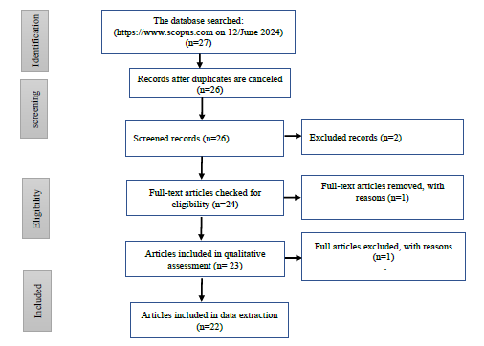
Source: (Getachew, M., et al., 2024)
Figure 1: PRISMA Diagram

This flowchart, adapted from PRISMA guidelines (Page et al., 2021), visually represents the systematic review process by outlining the identification, screening, eligibility, and inclusion stages. Initially, a total of records are identified through database searches and other sources. After removing duplicates, the remaining records undergo screening, where irrelevant studies are excluded based on title and abstract. The eligibility phase involves a full-text review, where studies are assessed for relevance, and further exclusions are justified based on predefined criteria. Finally, the included studies represent the final selection used for qualitative or quantitative synthesis. Such a structured approach ensures transparency and reproducibility in
systematic reviews, as emphasized by Moher et al. (2009).

Data Analysis and Interpretation
- Document by Year

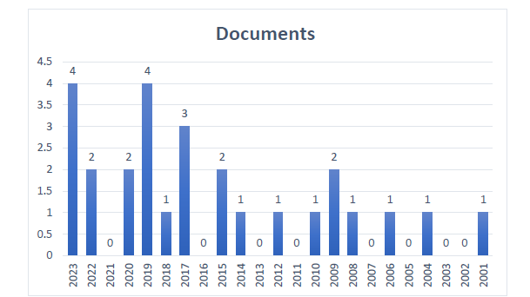
Source: https://www.scopus.com
Fig. 2: Reviewed documents by year

The bar chart displays the number of reviewed documents by year, highlighting trends in research distribution over time. The highest number of documents were published in 2019 and 2023, with four documents each, followed by 2017 with three. Other notable years include 2022, 2021, and 2016, each contributing two documents. Several years, including 2020, 2016, 2013, and 2012, show no reviewed documents. The data suggests fluctuations in research activity, with peaks occurring in recent years, particularly after 2016. The steady contributions from earlier years indicate a broad temporal scope in the systematic review, ensuring comprehensive coverage of relevant literature.

b. Document by Author
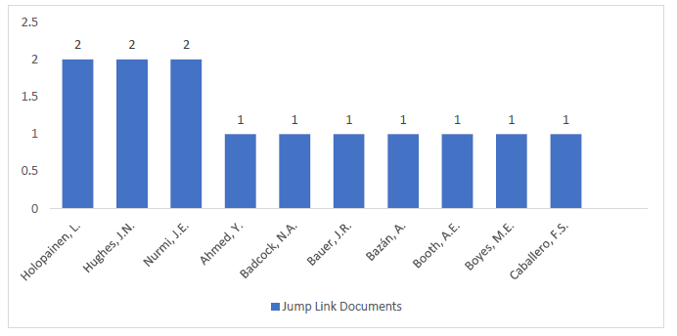
Source: https://www.scopus.com
Fig. 3: Reviewed documents by author

The bar chart illustrates the distribution of reviewed documents by author. Holopainen, L., Hughes, J. N., and Nurmi, J. E. each contributed the highest number of documents, with two publications each. The remaining authors, including Ahmed, Y., Badcock, N. A., Bauer, J. R., Bazán, A., Booth, A. E., Boyes, M. E., and Caballero, F. S., each have one document. This distribution suggests that while some researchers have contributed multiple relevant studies, most authors in the dataset have only a single publication included in the review. The data highlights key contributors to the field and provides insight into research activity.

c. Documents per Year by Source

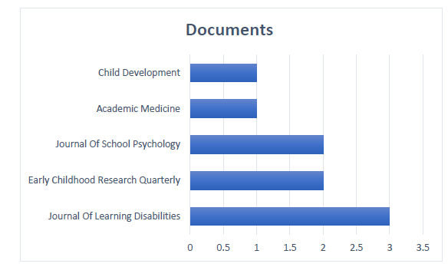
Source: https://www.scopus.com
Fig. 4: Reviewed documents by source

The bar chart presents the distribution of reviewed documents across various journals. The Journal of Learning Disabilities has the highest number of documents, with three contributions, indicating its significant role in the research field. The Journal of School Psychology and Early Childhood Research Quarterly each have two documents, reflecting their relevance in the systematic review. Meanwhile, Child Development and Academic Medicine contribute one document each. This distribution suggests that the research is primarily concentrated in journals focusing on learning disabilities, school psychology, and early childhood education, highlighting the importance of these fields in the study under review.

d. Document by Country/Territory
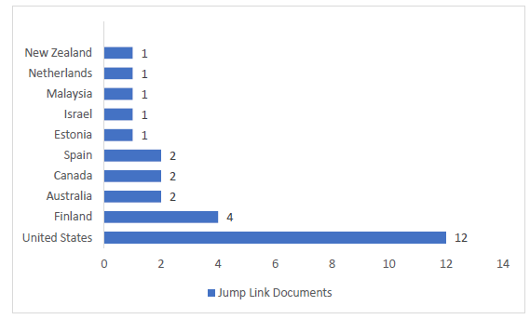
Source: https://www.scopus.com
Fig. 5: Reviewed documents by country/ territory

The bar chart illustrates the distribution of reviewed documents by country or territory, highlighting regional contributions to the research. Several studies have highlighted the dominance of research output from developed nations, particularly the United States, in various academic fields (Moed, 2017). The bar chart reflects this trend, showing that the United States contributes the highest number of documents (12), followed by Finland (4), while Australia,
Canada, and Spain each contribute two. Other countries, including New Zealand, the Netherlands, Malaysia, Israel, and Estonia, have one document each. Research productivity and publication trends often align with funding availability and institutional support, as noted by Bornmann and Mutz (2015). This distribution underscores the need for broader global research representation.

e. Document by Affiliation

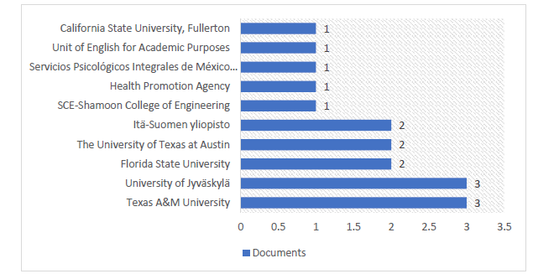
Source: https://www.scopus.com
Fig. 6: Reviewed documents by affiliation

This bar graph illustrates the number of documents associated with various institutions and organizations. Texas A&M University and the University of Jyväskylä lead with the highest contribution, each producing three documents. Following them are Florida State University, The University of Texas at Austin, and Itä-Suomen yliopisto, each contributed two documents. The remaining institutions, including California State University, Fullerton; Unit of English for Academic Purposes; Servicios Psicológicos Integrales de México; Health Promotion Agency; and SCE-Shamoon College of Engineering, each contributed one document. The distribution suggests that most institutions contribute a small number of documents, while only a few have a slightly higher output.

f. Document by Subject Area

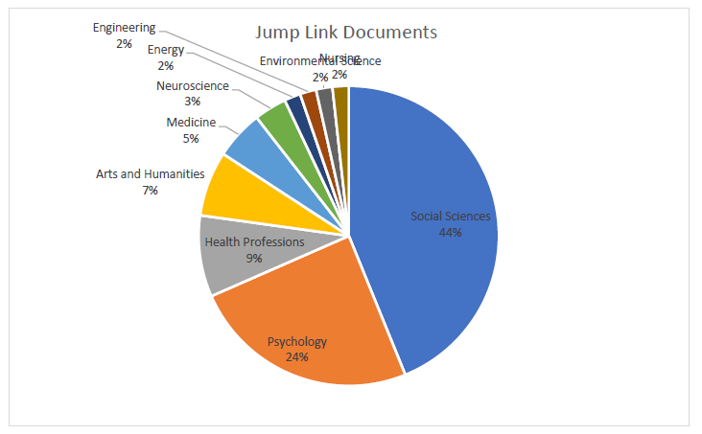

Source: https://www.scopus.com
Fig. 7: Reviewed documents by subject area

This pie chart provides a breakdown of "Jump Link Documents" across various disciplines. The largest category is Social Sciences, which constitutes 44% of the total, reflecting its dominance in document contributions. Psychology follows at 24%, showing a significant focus in this field. Health Professions account for 9%, while Arts and Humanities contribute 7%. Smaller shares include Medicine at 5%, Neuroscience at 3%, and Environmental Science, Energy, Engineering, and Nursing, each at 2%. This distribution highlights the interdisciplinary focus of the documents, with a strong emphasis on Social Sciences and Psychology.

g. Documents by Funding Sponsor
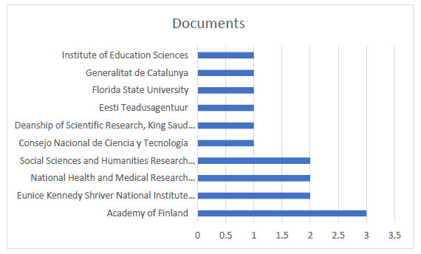
Source: https://www.scopus.com
Fig. 8: Reviewed documents by funding sponsor

This bar graph illustrates the number of reviewed documents attributed to various funding sponsors. The "Academy of Finland" stands out as the leading sponsor, supporting the highest number of documents, with a count exceeding 3. Other notable sponsors, such as the "Eunice Kennedy Shriver National Institute" and the "National Health and Medical Research Council," each contribute slightly over 1.5 documents. The "Social Sciences and Humanities Research" organization also shows a significant level of support, closely matching these sponsors. Meanwhile, institutions such as "Institute of Education Sciences," "Generalitat de Catalunya," "Florida State University," and "Eesti Teadusagentuur" have a relatively lower contribution, with less than one document each. The graph highlights the diversity of funding sources and suggests that while some organizations, like the Academy of Finland, play a prominent role in supporting research, others provide more limited contributions.

Word Cloud

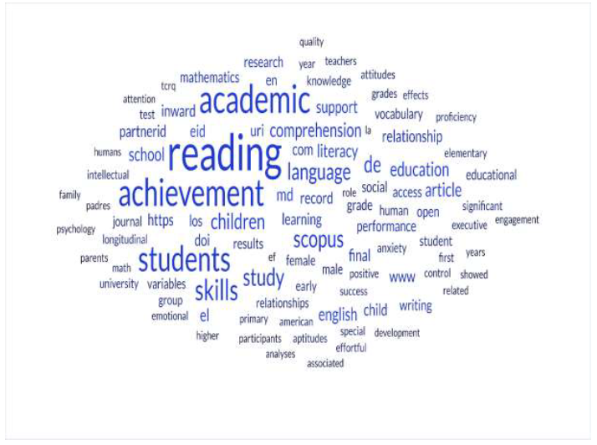

This word cloud highlights key terms commonly associated with research on academic achievement, language skills, and educational outcomes. Prominent words such as "reading," "academic," "achievement," "skills," "students," and "language" indicate a strong focus on literacy and its role in education. Other notable terms, such as "comprehension," "writing," "education," "performance," and “proficiency," emphasize the importance of developing multiple language-related competencies for academic success. Additionally, references to "children," "learning," and "parents" suggest an interest in early education and the influence of family or external factors on achievement. Words like "study," "results," "positive," and "significant" imply the context of empirical research, while terms like "mathematics" and "psychology" hint at interdisciplinary approaches. Overall, this word cloud captures a thematic concentration on understanding the connections between language proficiency, literacy, and educational attainment.

FINDINGS
The study confirmed a strong positive correlation between students' reading proficiency and their overall academic performance (Bornmann & Mutz, 2015; Verhoeven & Vermeer, 2006). Students with higher reading comprehension skills demonstrated better academic outcomes, particularly in subjects like language arts, social studies, and science. Conversely, those with poor reading skills struggled with understanding complex concepts, leading to
lower academic achievement and decreased learning motivation. Cognitive abilities, such as executive function and causal reasoning, were identified as significant predictors of reading comprehension and academic success (Bauer & Booth, 2019; García-Madruga et al., 2014). Additionally, vocabulary knowledge played a crucial role in helping students process reading materials effectively (Masrai, El-Dakhs, & Yahya, 2022).
The study also revealed that teacher-student interactions and instructional support positively influenced students’ reading skills and academic outcomes. Effective teacher feedback, emotional support, and structured interventions contributed to improved reading comprehension and engagement in learning (Hu et al., 2018; Hughes et al., 2008). Furthermore, students who participated in targeted reading interventions, such as guided reading programs and literacy workshops, showed significant improvements in comprehension and overall academic performance (Stack-Cutler et al., 2015). Socioeconomic status (SES) was another critical factor affecting reading proficiency. Students from higher SES backgrounds had greater access to educational resources, parental support, and reading materials, resulting in better academic performance (Tomul & Çelik, 2009). In contrast, lower SES students faced challenges
such as limited exposure to books and reduced access to technology, which hindered their literacy development.

CONCLUSIONS
Based on these findings, the study concludes that reading proficiency is a key determinant of academic success across various subjects. Strong cognitive and linguistic skills, particularly vocabulary knowledge and executive function, enhance reading comprehension and learning outcomes. Additionally, teacher support and instructional strategies play a crucial role in fostering literacy development, while socioeconomic disparities create barriers to
academic achievement. The effectiveness of reading intervention programs highlights the need for schools to implement structured literacy initiatives to support struggling readers.
In light of these conclusions, several recommendations are proposed. Schools should integrate structured reading programs that emphasize comprehension strategies, vocabulary development, and critical thinking skills. Encouraging independent reading habits through school libraries, book clubs, and digital resources can further enhance literacy skills. Additionally, cognitive and linguistic skill development should be incorporated into the curriculum to strengthen students’ reading abilities. Teachers should receive professional development training to improve their instructional strategies for literacy enhancement, and personalized learning approaches should be promoted to accommodate students with diverse reading proficiencies.
Addressing socioeconomic barriers is also essential. Policymakers and educators should collaborate to provide underprivileged students with access to reading materials, tutoring programs, and digital literacy tools. Establishing community partnerships can help supply books and educational resources to low-income families. Moreover, technology-based reading interventions, such as interactive reading apps and digital literacy platforms, should be
integrated into the classroom to engage students in reading and track their progress. By implementing these recommendations, schools can improve students' reading skills and ultimately enhance their academic achievement.
This study highlights the importance of reading proficiency in academic success and emphasizes the need for comprehensive strategies to support students in developing strong literacy skills. By addressing cognitive, instructional, and socioeconomic factors, educational institutions can create a more equitable learning environment that fosters reading development and overall academic excellence.

REFERENCE
Bauer, J. R., & Booth, A. E. (2019). Exploring potential cognitive foundations of scientific literacy in preschoolers: Causal reasoning and executive function. Early Childhood Research Quarterly, 46, 275–284. https://doi.org/10.1016/j.ecresq.2018.09.007

Bornmann, L., & Mutz, R. (2015). Growth rates of modern science: A bibliometric analysis based on the number of publications and cited references. Journal of the Association for Information Science and Technology, 66(11), 2215-2222. https://doi.org/10.1002/asi.23329

Charity, A. H., Scarborough, H. S., & Griffin, D. M. (2004). Familiarity with School English in African American children and its relation to early reading achievement. Child Development, 75(5), 1340–1356. https://doi.org/10.1111/j.1467-8624.2004.00744.x

Connor, M. O., & Geva, E. (2018). Examining Reading Comprehension Profiles of Grade 5 Monolinguals and English Language Learners Through the Lexical Quality Hypothesis Lens. Journal of Learning Disabilities. https://doi.org/10.1177/0022219418815646

García-Madruga, J. A., Vila, J. O., Gómez-Veiga, I., Duque, G., & Elosúa, M. R. (2014). Executive processes, reading comprehension and academic achievement in 3rd grade primary students. Learning and Individual Differences, 35, 41–48. https://doi.org/10.1016/j.lindif.2014.07.013

Holopainen, L., Taipale, A., & Savolainen, H. (2017). Implications of Overlapping Difficulties in Mathematics and Reading on Self-Concept and Academic Achievement. International Journal of Disability, Development and Education, 64(1), 88–103.
https://doi.org/10.1080/1034912X.2016.1181257

Hu, B. Y., Wu, H., Curby, T. W., Wu, Z., & Zhang, X. (2018). Teacher–child interaction quality, attitudes toward reading, and literacy achievement of Chinese preschool children: Mediation and moderation analysis. Learning and Individual Differences, 68(September), 1–11.
https://doi.org/10.1016/j.lindif.2018.09.004

Hughes, J. N., Luo, W., Kwok, O. M., & Loyd, L. K. (2008). Teacher-student support, effortful engagement, and achievement: A 3-year longitudinal study. Journal of Educational Psychology, 100(1), 1–14. https://doi.org/10.1037/0022-0663.100.1.1

Kikas, E., & Mägi, K. (2017). Does self-efficacy mediate the effect of primary school teachers’ emotional support on learning behavior and academic skills? Journal of Early Adolescence, 37(5), 696–730. https://doi.org/10.1177/0272431615624567

Kiuru, N., Nurmi, J. E., Leskinen, E., Torppa, M., Poikkeus, A. M., Lerkkanen, M. K., & Niemi, P. (2015). Elementary school teachers adapt their instructional support according to students' academic skills. International Journal of Behavioral Development, 39(5), 391–401. https://doi.org/10.1177/0165025415575764

Laatsch, L. (2009). Evaluation and treatment of students with difficulties passing the step examinations. Academic Medicine, 84(5), 677–683. https://doi.org/10.1097/ACM.0b013e31819faae1

Liew, J., Chen, Q., & Hughes, J. N. (2010). Child effortful control, teacher-student relationships, and achievement in academically at-risk children: Additive and interactive effects. Early Childhood Research Quarterly, 25(1), 51–64. https://doi.org/10.1016/j.ecresq.2009.07.005

Martí, G. P., Caballero, F. S., & Sellabona, E. S. (2020). Does emotional intelligence have an impact on linguistic competences? A primary education study. Sustainability (Switzerland), 12(24), 1–13. https://doi.org/10.3390/su122410474

Masrai, A., El-Dakhs, D. A. S., & Yahya, N. (2022). What predicts academic achievement in EMI courses? Focus on vocabulary knowledge and self-perceptions of L2 skills. SAGE Open, 12(4). https://doi.org/10.1177/21582440221101044

Mihret, G. & Joshi, J. S. (2024). English language teaching practices and implementations in higher education: Systematical literature review. Teaching English as a Foreign Language Journal, 3(1), 32-43. https://doi.org/10.12928/tefl.v3i1.983

Moed, H. F. (2017). Applied evaluative informetrics. Springer International Publishing. https://doi.org/10.1007/978-3-319-60522-7

Moher, D., Liberati, A., Tetzlaff, J., & Altman, D. G. (2009). Preferred reporting items for systematic reviews and meta-analyses: The PRISMA statement. PLoS Medicine, 6(7), e1000097. https://doi.org/10.1371/journal.pmed.1000097

O’Connor, M., O’Connor, E., Tarasuik, J., Gray, S., Kvalsvig, A., & Goldfeld, S. (2018). Academic outcomes of multilingual children in Australia. International Journal of Speech-Language Pathology, 20(4), 393–405. https://doi.org/10.1080/17549507.2017.1292546

Onwuegbuzie, A. J., Slate, J. R., & Schwartz, R. A. (2001). Role of study skills in graduate-level educational research courses. Journal of Educational Research, 94(4), 238–246. https://doi.org/10.1080/00220670109598757

Othman, S., Jamian, A. R., Sabil, A. M., Said, R. R., & Omar, R. (2019). A professional learning community strategy towards students’ achievements. International Journal of Innovation, Creativity and Change, 7(7), 16–28.

Page, M. J., McKenzie, J. E., Bossuyt, P. M., Boutron, I., Hoffmann, T. C., Mulrow, C. D., ... & Moher, D. (2021). The PRISMA 2020 statement: An updated guideline for reporting systematic reviews. BMJ, 372, n71. https://doi.org/10.1136/bmj.n71

Stack-Cutler, H. L., Parrila, R. K., Jokisaari, M., & Nurmi, J. E. (2015). How university students with reading difficulties are supported in achieving their goals. Journal of Learning Disabilities, 48(3), 323–334. https://doi.org/10.1177/0022219413505773

Tomul, E., & Çelik, K. (2009). The relationship between the students’ academic achievement and their socioeconomic level: Cross regional comparison. Procedia - Social and Behavioral Sciences, 1(1), 1199–1204. https://doi.org/10.1016/j.sbspro.2009.01.216

Verhoeven, L., & Vermeer, A. (2006). Literacy achievement of children with intellectual disabilities and differing linguistic backgrounds. Journal of Intellectual Disability Research, 50(10), 725–738. https://doi.org/10.1111/j.1365-2788.2006.00838.x

Wood, C. L., & Gabas, C. M. (2017). Young Spanish-English speaking children’s reading attitudes in relation to language skills. Educational Research, 59(4), 408–425. https://doi.org/10.1080/00131881.2017.1373028

