DESIGN AND IMPLEMENTATION OF SMART DUSTBIN FOR AUTOMATED WET AND DRY WASTE SEGREGATION

BY
Sujan Banerjee^{1*}; Soumen Ghosh²; Aritra Bera³; Riju Das⁴; Sourav Pal⁵
^{1,2,3,4,5}Department of Electrical Engineering, Swami Vivekananda School of Diploma, Durgapur, India

CORRESPONDING AUTHOR
SUJAN BANERJEE
Department of Electrical Engineering,
Swami Vivekananda School of Diploma,
Durgapur, India

ABSTRACT

The increasing rate of urbanization has significantly contributed to the generation of mixed waste, posing serious environmental and health challenges. Manual segregation is inefficient, labor-intensive, and often hazardous. This paper presents the design and development of a smart dustbin system that automatically classifies waste into wet and dry categories using embedded sensors and microcontroller technology. The proposed system utilizes an Arduino UNO, ultrasonic sensor, soil moisture sensor, servo motor, and relay module to detect waste type and direct it to the appropriate compartment. The implementation aims to assist in effective waste management and promote a cleaner environment through automation.
Keywords: Smart Dustbin, Waste Segregation, Arduino UNO, Wet and Dry Waste, Soil Moisture Sensor, Automation.

INTRODUCTION
Effective waste management is an increasingly critical issue, particularly in urban and semi-urban areas where rapid population growth and industrialization have led to significant waste generation. Improper disposal practices and the mishandling of waste materials contribute to several problems, including environmental pollution, health hazards, and reduced efficiency in recycling efforts. Conventional techniques for segregating waste typically rely heavily on manual labor, which can result in inaccuracies, delays, and higher operational costs.

To address these challenges, the integration of automation into waste management processes has emerged as a promising solution. Automated systems reduce human dependency, enhance accuracy, and ensure faster processing of waste materials.

This project presents a smart dustbin prototype designed to automatically detect and classify waste based on its moisture level. The system employs a combination of sensors and an Arduino-based microcontroller to distinguish between wet and dry waste. By automating the segregation process, the system not only improves efficiency but also provides a cost- effective and practical approach suitable for both household and public environments. Such innovations are essential for building cleaner, smarter cities with sustainable waste management solutions.

LITERATURE REVIEW
Sivakumar et al. introduced an automatic clustered segregation model aimed at minimizing human intervention by employing a GUI-based spot separation technique to classify waste into distinct categories, thus improving operational efficiency in waste handling [1]. Bharadwaj et al. implemented an IoT-based smart waste management system in line with the "Swachh Bharat Abhiyan," which enabled dry and wet waste collection through sensors and embedded systems, offering real-time data transmission via a mobile application [2]. Jayson et al. proposed SmartBin, an automatic segregation and collection system designed to mitigate waste mismanagement issues, particularly in developing nations. It focused on source-level sorting and real-time alerting of waste levels [3]. Pereira et al. enhanced the system by introducing multiple compartments for different waste types and integrating features like ultrasonic sensors and mobile reminders to improve hygiene and usability [4]. Sharma et al. presented a self-sanitizing dustbin that automatically segregated waste while focusing on health safety by minimizing human contact with contaminated materials [5]. Goel et al. took this a step further by introducing a system that not only segregates waste but also converts wet waste into compost, thereby promoting organic farming and reducing landfill overflow through IoT alerts [6]. Shreeshayana et al. designed an ergonomic system to manage dry and wet waste from domestic sources and convert organic waste into compost. Their system was tested successfully across multiple households, showing effective performance [7]. Muneeswaran

et al. developed an Arduino-based system using moisture and ultrasonic sensors for real-time dry and wet waste segregation and monitoring, aiming to improve hygiene and ease recycling in urban environments [8].

COMPONENTS USED
- The system is constructed using the following hardware components:

- Arduino UNO: Serves as the Main Control Unit for Processing Sensor Inputs and Controlling Actuators.
- Soil Moisture Sensor: Determines Whether the Waste is Wet or Dry Based on its Moisture Content.

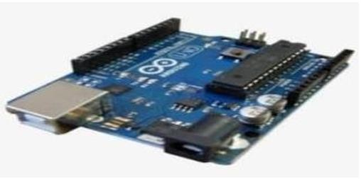
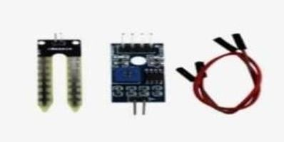
Fig 3 Soil Moisture Sensor

  - Tower Pro SG90 Servo Motor: Controls the Flap Mechanism to Direct Waste into Designated Compartments.

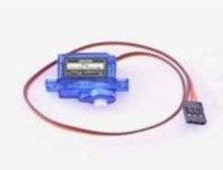
Fig 1 Arduino UNO
- Ultrasonic Sensor: Detects the Presence of Waste when it is Placed Near the Bin Opening.

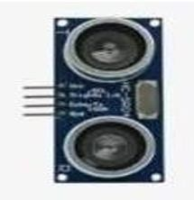
Fig 4 Tower Pro SG90 Servo Motor
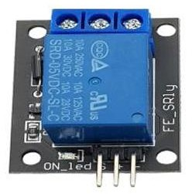
  - 5V 10A Relay Module: Controls the Switching of Connected Devices as Per Control Signals from Arduino.

Fig 2 Ultrasonic Sensor Fig 5 5V 10A Relay Module

- 12V 2A DC Adapter: Supplies Power to the System.

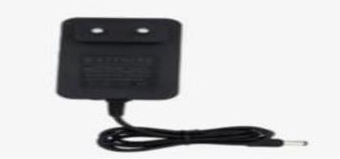
Fig 6 12V 2A DC Adapter
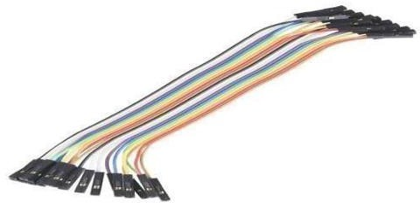
- Jumper Wires: Used for Interconnecting the Components.

Fig 7 Jumper Wires

METHODOLOGY
The operation of the smart waste bin system is structured into several sequential and coordinated functional steps as outlined below:
- Detection of Waste Presence:
When a person approaches the smart bin to dispose of waste, an ultrasonic sensor positioned near the opening of the bin detects the presence of an object. This sensor measures the distance and confirms whether waste has been brought close enough to initiate the sorting process.

- Moisture Content Evaluation:
After detecting the presence of waste, a soil moisture sensor is activated to analyze the level of moisture in the disposed material. This step is crucial to distinguish between wet and dry waste for proper segregation.

- Data Processing and Classification:
The Arduino UNO microcontroller receives input data from the sensors. It processes the readings from the moisture sensor to classify the waste type. If the sensor detects a high level of moisture, the waste is categorized as wet; otherwise, it is considered dry.
- Servo Motor Movement:
Once the classification is completed, the Arduino sends a signal to the servo motor. Based on the waste type, the servo motor rotates the bin’s lid or flap to direct the waste into the designated wet or dry compartment.

- Relay Module Functionality (Optional):
A relay module can be integrated to control additional devices or features, such as LED indicators, buzzers, or external systems, depending on project requirements. This enhances the smart bin’s capabilities and allows for more automation.

- System Reset and Readiness:
After the disposal process is finalized, the servo motor repositions the flap or lid back to its initial position. This reset ensures that the system is ready to process the next piece of waste without any manual intervention.

CIRCUIT DIAGRAM
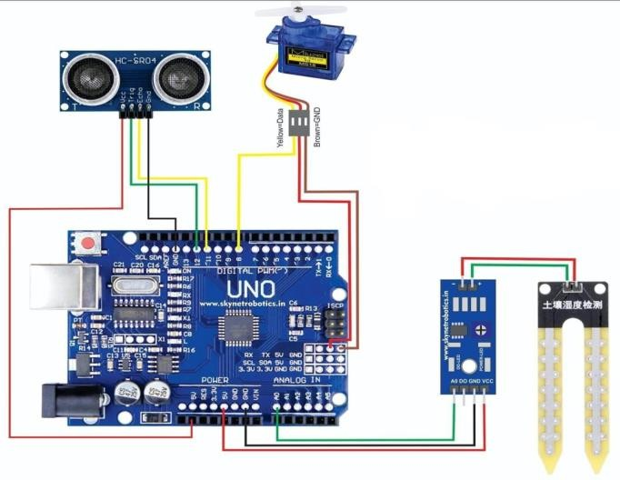
Fig 8 Circuit Diagram

HARDWARE MODEL
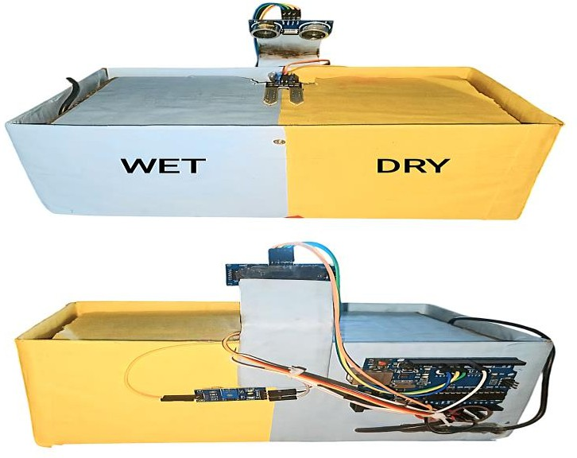
Fig 9 Hardware Model

RESULT & DISCUSSION
The proposed smart waste segregation system was successfully designed and implemented. Upon testing, it effectively differentiated between wet and dry waste by evaluating data received from the moisture sensor. The servo motor operated precisely and efficiently, ensuring proper placement of waste into the assigned compartment.

Response time was notably quick, typically under 1–2 seconds, for both object detection and waste classification, indicating the system's reliability and practical usability. These outcomes validate its potential for real-time and real- environment applications.

Future upgrades can incorporate wireless communication technologies like GSM or IoT platforms. This would make the system more versatile and capable of being scaled up for extensive waste management operations in smart cities or public waste systems.

ADVANTAGES
- Automated Functionality:
The system performs operations with minimal human interaction, reducing the chance of manual error.

- Cost-Efficiency:
Designed using economical and readily available electronic components, making it budget-friendly for implementation.

- Touch-Free Operation:
Users do not need to come into contact with the bin, promoting better hygiene and user safety.
- Environmentally Beneficial:
By ensuring early and proper separation of waste, the system supports more efficient recycling processes.
- Expandable System:
It offers the flexibility to be scaled and customized for larger infrastructure projects such as city-level waste segregation.

APPLICATION
- The Smart bin Model is Suitable for a Wide Range of Real-World Environments, Including:

- Residential Spaces:
Smart homes, flats, and apartment complexes.

- Healthcare Facilities:
Hospitals and clinics where waste segregation is critical for hygiene.
- Commercial and Office Areas:
Corporate buildings and shared workspaces for better waste handling.
- Educational Institutions:
Schools, colleges, and universities to instill responsible disposal habits.

- Municipal Collection Zones:
Can be integrated at local garbage collection centers to support community-level waste management.

CONCLUSION
The smart waste segregation system presents an efficient and automated solution for separating wet and dry waste at the source. By integrating ultrasonic sensing, moisture detection, and servo-controlled actuation, the system ensures reliable and touchless waste disposal. Its performance during testing confirmed fast response times and accurate classification, which highlights its practical potential for real-world use.
This project not only promotes better hygiene and reduces manual effort but also contributes significantly to sustainable waste management practices by enabling early segregation. The modular and cost-effective design makes it ideal for small-scale deployments, with the potential to scale up for smart city infrastructure.

In the future, this system can be further enhanced with IoT connectivity and real-time data monitoring, allowing for centralized control and analytics in municipal or industrial applications. Overall, it serves as a foundational step toward smarter and cleaner urban waste handling solutions.

FUTURE SCOPE
The smart waste segregation system, while functional at the prototype level, offers significant potential for further development and real-world integration. Future enhancements can focus on the following areas:

- IoT and Cloud Integration:
By incorporating Internet of Things (IoT) technology, real-time data about waste levels and bin usage can be transmitted to a centralized dashboard. This would allow remote monitoring, timely waste collection, and improved resource management.
- Solar Power Supply:
Integrating solar panels can make the system energy- efficient and suitable for deployment in areas with limited power access, thereby supporting green energy initiatives.
- Mobile Application Control:
A companion mobile app can be developed to display bin status, alert authorities when bins are full, and allow users to report malfunctions or misuse.

- Advanced Sensor Integration:
Adding gas sensors, weight sensors, or image recognition modules (using cameras and AI) can enhance the accuracy of waste classification, including the identification of hazardous or recyclable items.

- Voice and Gesture Control:
For improved accessibility, especially for the elderly or differently-abled, the system could be upgraded to support voice commands or gesture-based input for bin opening and operation.

- Scalability for Public Use:
The system design can be scaled for integration into public waste collection points, municipal corporations, railway stations, airports, and other high-traffic zones to improve urban waste management.

- Automated Waste Compaction:
A waste compaction unit can be added to reduce the volume of waste, increasing bin capacity and reducing collection frequency.
These future upgrades can transform the smart dustbin from a simple automation project into a critical component of intelligent waste management systems for smart cities.

REFERENCES
[1]. Sivakumar, Narendran, Aditya Raj Kunwar, Sandeep Kumar Patel, Santosh Kumar, and S. Pushpa Mala. "Design and development of an automatic clustered, assorted trash segregation system." In 2016 IEEE International Conference on Recent Trends in Electronics, Information & Communication Technology (RTEICT), pp. 409-413. IEEE, 2016.
[2]. Bharadwaj, B., M. Kumudha, and G. Chaithra. "Automation of Smart waste management using IoT to support “Swachh Bharat Abhiyan”-a practical approach." In 2017 2nd International Conference on Computing and Communications Technologies (ICCCT), pp. 318-320. IEEE, 2017.
[3]. Jayson, Manisha, and Sanket Hiremath. "SmartBin- Automatic waste segregation and collection." In 2018 Second international conference on advances in electronics, computers and communications (ICAECC), pp. 1-4. IEEE, 2018.
[4]. Pereira, Wesley, Saurabh Parulekar, Sopan Phaltankar, and Vijaya Kamble. "Smart bin (waste segregation and optimisation)." In 2019 Amity international conference on artificial intelligence (AICAI), pp. 274-279. IEEE, 2019.
[5]. Sharma, Pratyusha, Praveen Kumar, Ritika Nigam, and Kushagra Singh. "Automatic waste segregating and self sanitizing dustbin." In 2020 2nd International Conference on Advances in Computing, Communication Control and Networking (ICACCCN),
pp. 368-372. IEEE, 2020.
[6]. Goel, Mrigank, Amogh Harsh Goyal, Preeti Dhiman, Vikas Deep, Purushottam Sharma, and Vinod Kumar Shukla. "Smart garbage segregator and IoT based waste collection system." In 2021 International Conference on Advance Computing and Innovative Technologies in Engineering (ICACITE), pp. 149-153. IEEE, 2021.
[7]. Shreeshayana, R., Manjunath V. Gudur, L. Niranjan, and B. Sreekantha. "Ergonomic automated dry and
wet waste segregation and compost production for innovative waste management." In 2022 IEEE 3rd Global Conference for Advancement in Technology (GCAT), pp. 1-6. IEEE, 2022
[8]. Muneeswaran, V., P. Nagaraj, A. Akhila, L. Sudeepthi,
B. Venkateswararao, and B. Vamsi Krishna. "Smart segregation of waste and automatic monitoring system." In 2023 International Conference on Computer Communication and Informatics (ICCCI),
pp. 1-6. IEEE, 2023.

